Revised 1/17
Camden County Open Space, Farmland, Recreation, and Historic Preservation Trust Fund

2021
Application for Recreation Facility Enhancement
Project Funding

I. Applicant Information Date: ____________

- Project Facility Name ______________________________________________

Name of applicant _________________________________________________
(Borough/Organization)

Street Address ____________________________________________________

City ________________________ State ____________ Zip _______________

- Contact Person for this application____________________________________

Title______________________________________________________________

Land Phone # ___________________ Cell Phone # _____________________

Email __________________________________ Fax # ____________________

Best time to contact ________________

- Applicant’s organization status: _____ Municipal Government
_____ Tax-exempt nonprofit organization
(Attach both IRS and New Jersey charitable registration letters.)

If not a designated 501 C (3) organization, explain tax-exempt status:

- If other than a municipality, please provide your organization’s Mission Statement or a brief narrative on the purpose of your organization.
_____________________________________________
_____________________________________________
_____________________________________________
_____________________________________________

- Have you included a copy of the required municipal resolution in support of this application?
___Yes ___ No

If no, is a resolution pending?

___Yes ___ No

F. Source of Applicant’s operating funds. Check all that apply.

___Member Dues/Fee ___ State ___County ___Municipal ___Other

II. Facility Information

A. Project Facility Name ____________________________________________

Address __________________________________________________________

City ______________________ State __________ Zip _____________

Present Zoning _________ Block Number(s) _________ Lot Number(s)________
Block Number(s) _________ Lot Number(s)________
Block Number(s) _________ Lot Number(s)________

Total Acreage __________

Amount of funding requested from the Camden County Open Space Trust Fund (maximum $25,000) _______________

B. Briefly describe the tasks to be completed using these funds, i.e. construction of bike path; installation of lights, etc.
_____________________________________________
_____________________________________________
_____________________________________________
_____________________________________________

C. Does the proposed project serve to advance the goals of the County’s Bicycling and Multi-Use Trail Master Plan or lie within, or proximate to the County Greenway Network?

(You can view both the Camden County Bicycling and Multi-Use Trail Master Plan and the Camden County Open Space and Farmland Preservation Plan at www.camdencounty.com)

___Yes ___ No

If yes, please describe: _______________________________

_____________________________________________
_____________________________________________
_____________________________________________

D. 1) The applicant: (Check all that apply)
____ owns the property
____ leases the property (Attach a copy of the lease)

____ does not own or lease the property

____ municipally owned property

  - Year first owned or leased ____________

  - If leased, years remaining on the lease ____________

  - Owner (if other than applicant):

Name __________________________________________________

Address ________________________________________________

City ____________________ State _________ Zip ____________

Phone # ____________________ Fax # ____________________
  - Lessor (if different from the owner):

Name __________________________________________________

Address ________________________________________________

City ____________________ State _________ Zip ____________

Phone # ____________________ Fax # ____________________

  - Holder of mortgages or liens on the property, if any:

Name __________________________________________________

Address ________________________________________________

City _____________________ State ________ Zip ___________

Phone # ___________________ Fax # ______________________

Amount of mortgage of lien $______________________________

III. Project Budget

Include budget information for only those tasks to be undertaken using Camden County Trust Fund monies. Please indicate if funds have already been secured.

Task Applicant* County Municipal State Other ** Share Share Share Share

_____________ $_____ | $_____ $_____ $_____ $_____
_____________ $_____ | $_____ $_____ $_____ $_____
_____________ $_____ | $_____ $_____ $_____ $_____
_____________ $_____ | $_____ $_____ $_____ $_____
_____________ $_____ | $_____ $_____ $_____ $_____
TOTALS $_____ | $_____ $_____ $_____ $_____

* Organizations other than municipalities; value of in-kind services applies.

** Specify source: Private or group donations, charitable foundation, etc.

IV. Accessibility to the Population

- Does your recreation site have direct access from public roads?
___Yes ___ No

Road name(s)______________________________________________________

- Does public transportation serve the location? ___Yes ___ No

Bus Route # ______________________

- Are there alternative means of access to the site, i.e. bikeway, pedestrian walk, etc.?
___ Yes ___No

Please describe: __________________________________________________

_________________________________________________________________

_________________________________________________________________

_________________________________________________________________

- Is this facility readily available for use by County residents outside the municipality/organization when not in use by the municipality/organization?

___Yes ___ No

Please describe: __________________________________________________

_________________________________________________________________

_________________________________________________________________

_________________________________________________________________

V. Usage by All Age Groups and Users

Does your Recreation Facility Enhancement Project provide recreational opportunities for:

- Children under 12 Yes ______ No ______
- Children 12 - 17 Yes ______ No ______
- Adults Yes ______ No ______
- Seniors Yes ______ No ______
- Handicapped Accessible Yes ______ No ______

VI. Unique Facility

Does your Recreation Facility Enhancement Project provide a unique facility not available elsewhere?
___Yes ___ No

Please describe: _________________________________________________________

________________________________________________________________________

________________________________________________________________________

VII. Environmental Considerations

- Do you provide adequate protection of the environmental resources that are located in proximity to the recreation facility enhancement site (i.e. wetlands, transition areas, stormwater control).
___Yes ___ No

Please describe: (use additional sheets, if needed, marked “Enclosure # 1”):

_______________________________________________________________________________________

_______________________________________________________________________________________

- Does your Recreation Facility Enhancement Project incorporate quality native species or otherwise appropriate landscaping?

___Yes ___ No ___ Not Applicable

(if yes, please include a list of plants and/or a landscape plan marked “Enclosure # 2”)

- Does your Recreation Facility Enhancement Project include green infrastructure/technology? i.e energy efficient lighting, recycled materials, porous paving, water conservation systems, etc.
___Yes ___ No

Please describe: (use additional sheets, if needed, marked “Enclosure # 3”):

_______________________________________________________________________________

_______________________________________________________________________________

_______________________________________________________________________________

VIII. Community and Financial Support

- Is your Recreation Facility Enhancement Project consistent with the adopted Municipal Open Space Master Plan?
___Yes ___ No

(if yes, please provide supporting information marked “Enclosure # 4”).

- Does your Recreation Facility Enhancement Project have community
(non-governmental) support?
___ Yes ___ No

(if yes, please provide Public Hearing statements and/or endorsements by organized
groups marked “Enclosure # 5”)

IX. Narrative

Please provide a project narrative which includes: 1. a summarized description of the proposed enhancement(s); 2. the amount of funding requested from the Camden County Open Space Preservation Trust Fund (based on a certified engineering cost Estimate); and 3. any other pertinent information, i.e. site plan, photos, product descriptions, etc. (Mark this “Enclosure # 6”)

X. Funding History

Have you previously been awarded a funding for a Recreation Facility Enhancement Project from the Camden County Open Space Preservation Trust Fund?

___ Yes ___ No

Name of project ______________________________________

Year(s) awarded/Round ___________________________________________________

TOTAL amount awarded from Open Space funding $ _________________________

Facility funding history (other than Open Space funding)_________________________

__________________________________________________________________________

__________________________________________________________________________

Acting as duly authorized representative for the applying organization, I am submitting this request for assistance from the Camden County Open Space, Recreation, Farmland and
Historic Preservation Trust Fund. (PLEASE NOTE, SIGNATURE MUST BE
NOTARIZED)

______________________________________________ ______________________
Signature of Individual Date

_______________________________________________ ______________________

Name of Individual (typed or printed) Title

NOTARY:

(OP-APPL-REC17)

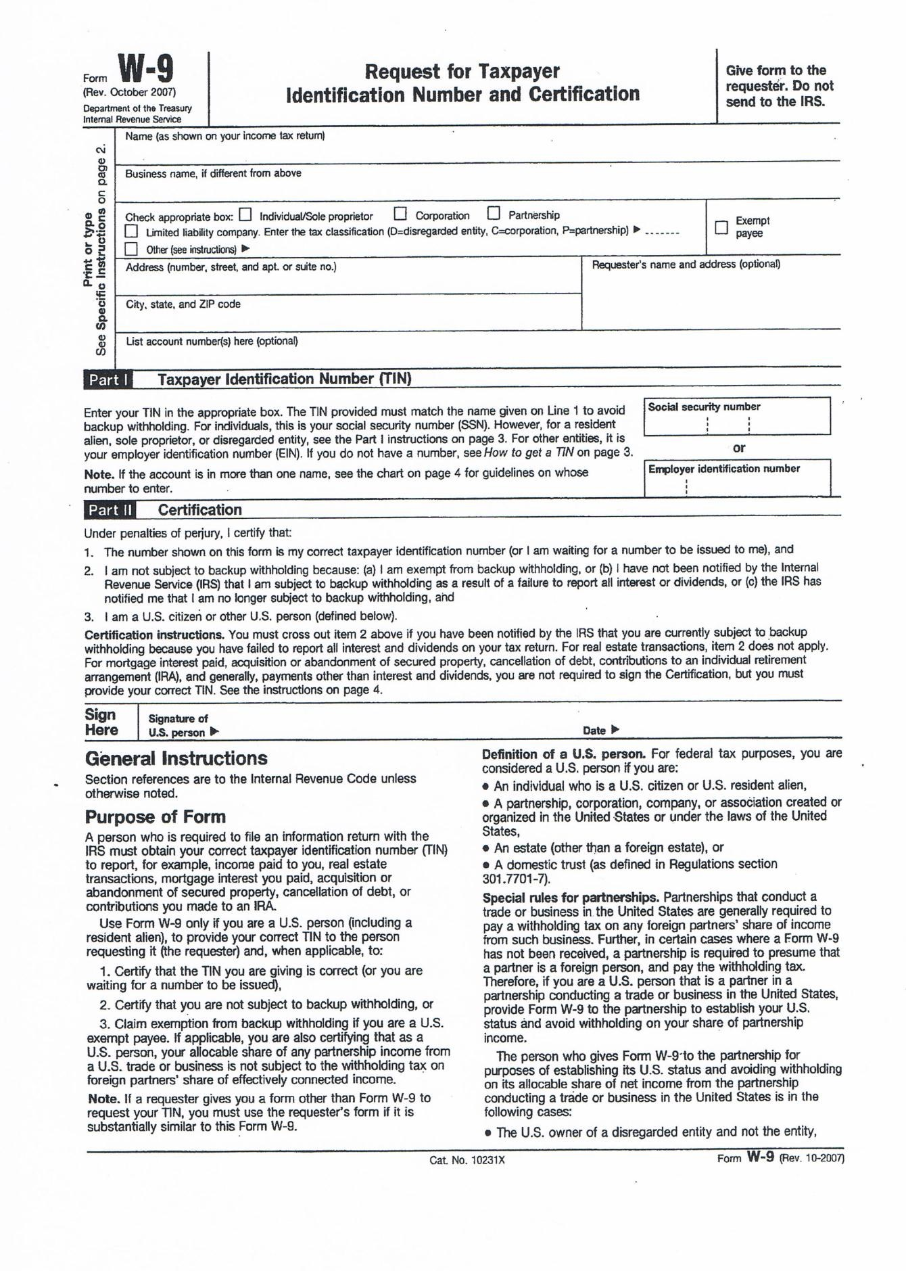

Camden County Open Space, Farmland, Recreation, and Historic Preservation Trust Fund

Please return:
FIVE (5) copies of the attached application:
- 1 application must be signed with an original signature, witnessed and notarized, to:

Camden County
Division of Open Space
1301 Park Blvd.
Cherry Hill, NJ 08002

(856) 858-5241

