Mill and Overlay of Westfield Avenue (CR 610) from Tinsman Avenue (MP 1.57) T0 NJ Route 130 (MP 2.92)
Pennsauken Township, Camden County, New Jersey

Notice to Proceed issued: August 30, 2019
Project Completion: May 10, 2020
Project Substantial Completion: April 10, 2020.
Project start: September 4,2019.

Weekly Progress Report
9-23-2019 through 9-27-2019

Following Construction Activities took place during above period:

Concrete Curb and Sidewalk:
Concrete Vertical Curb and sidewalks were constructed along Westfield Avenue (Eastbound and Westbound) at the following locations:
- Along Lexington Avenue, West.
- Topsoil and Asphalt was placed around Curb and Sidewalk.

Two Week Look Ahead:
- Construction of Concrete Vertical Curb and Sidewalk will continue along Westfield Avenue.
- Construction of Drainage will start.
Biweekly Progress Meeting:
Biweekly Progress Meeting 02 was held on September 27, 2019 in the field.

Prepared By:
Gunvant Mistry
Resident Engineer

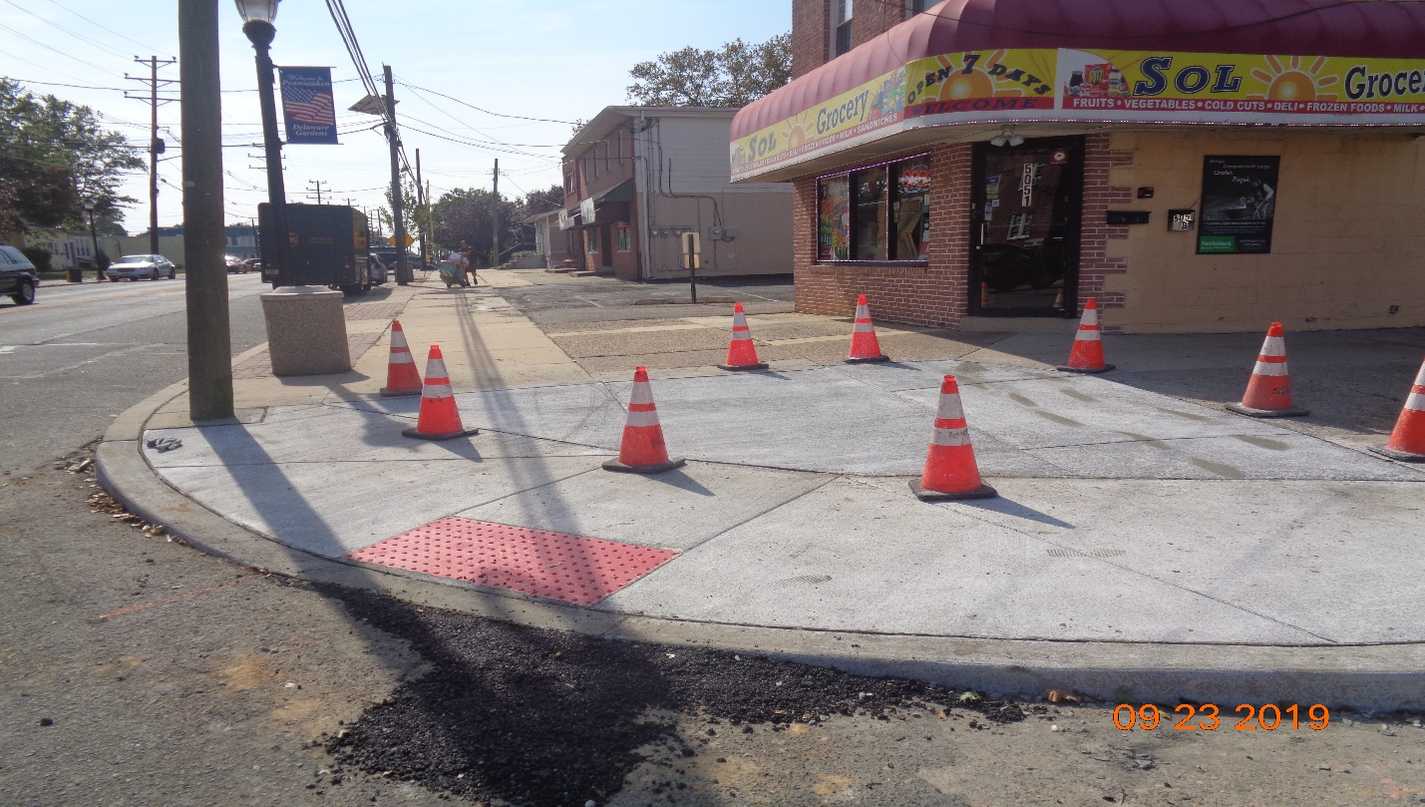
Concrete Placed Today for Proposed Sidewalk
Figure 1: Sidewalk completed along Lexington Avenue West
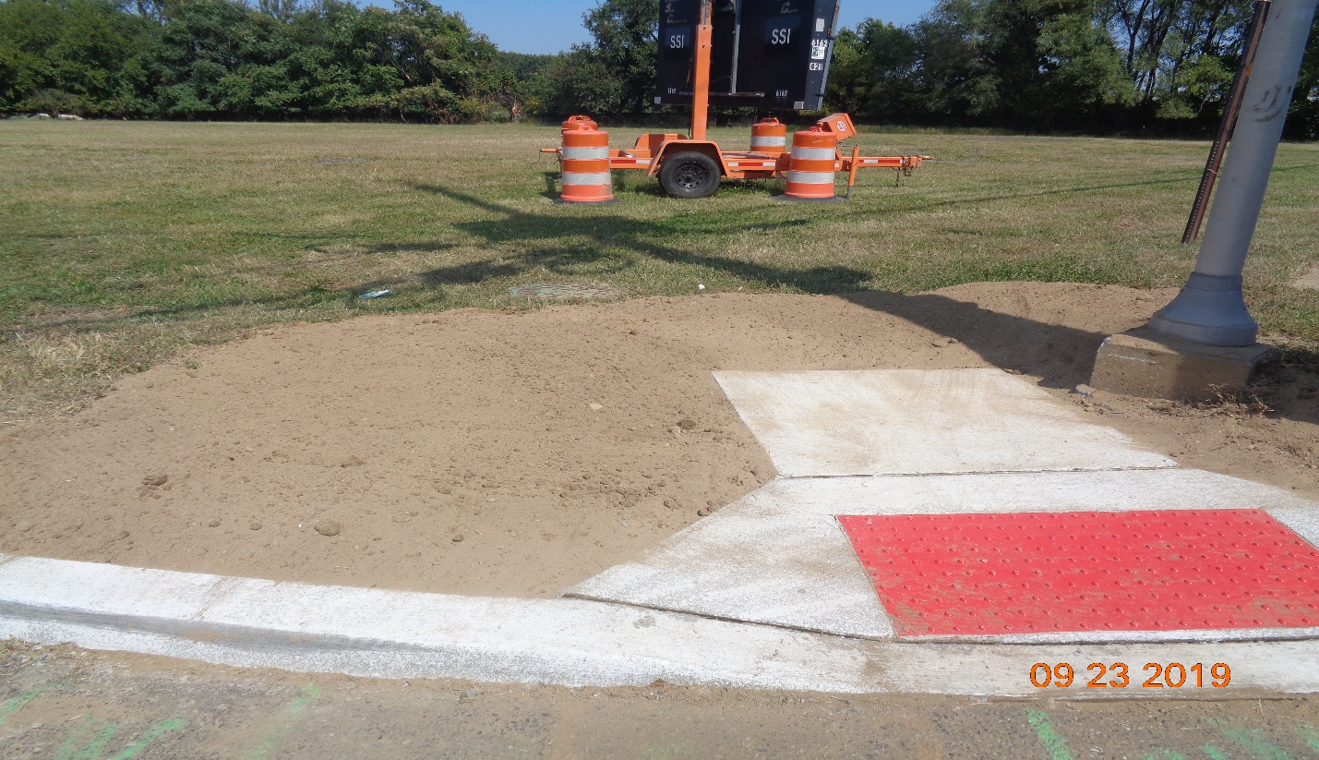
Figure 2: Topsoil placement around Curb and Sidewalk at Derousse Avenue, East

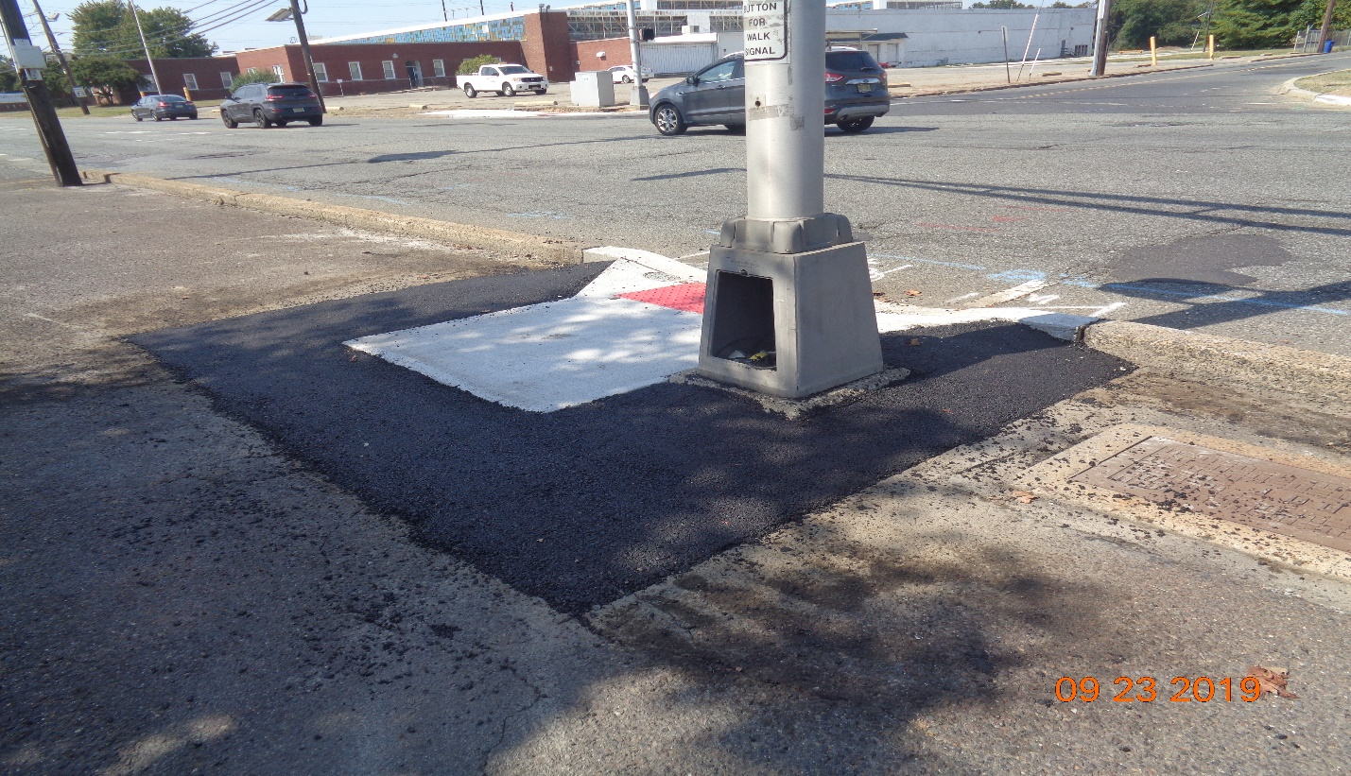
Derousse Avenue
Westfield Avenue
Figure 3: Asphalt at Sidewalk along Westfield Avenue, RT STA 124+75
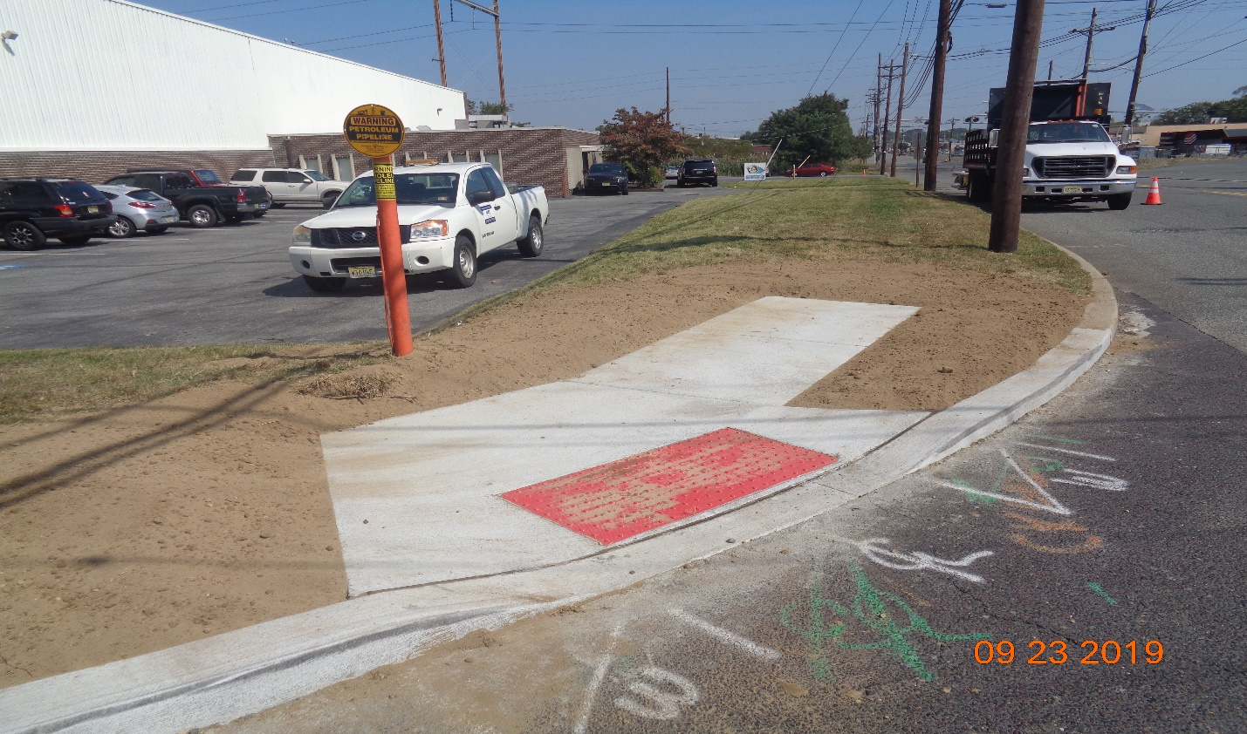
Figure 4: Topsoil placement along Sidewalk and Curb at Sherman Avenue, East
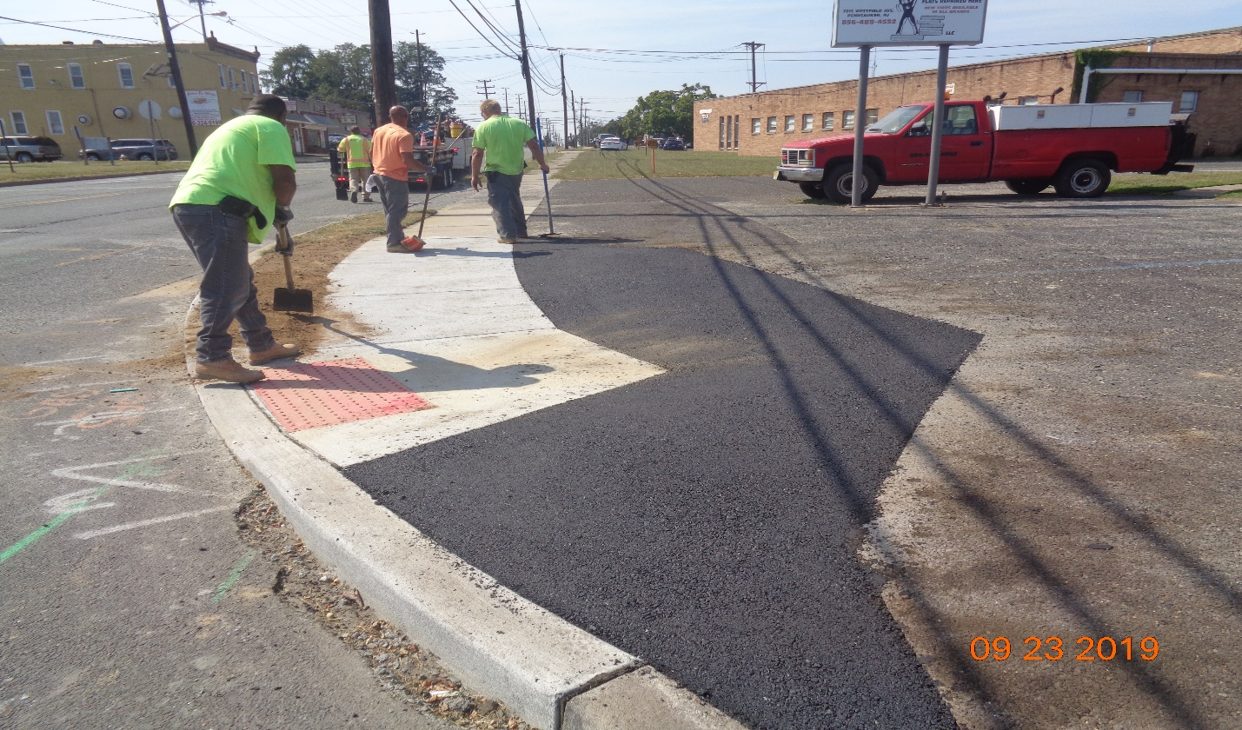
Figure 5: Topsoil and Asphalt along sidewalk and Curb at Sherman Avenue, West
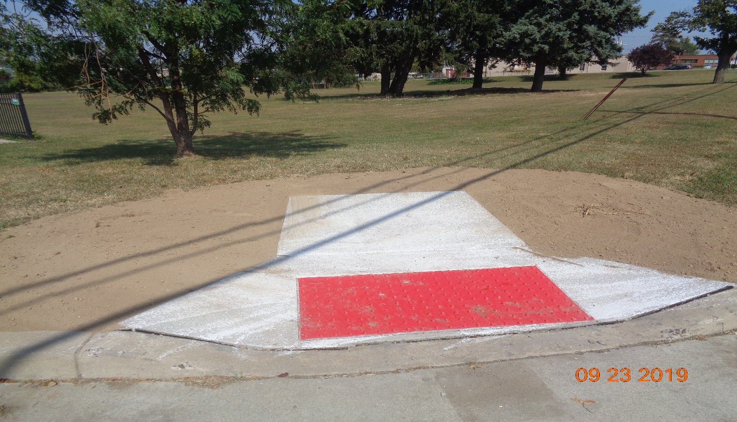
Figure 6: Topsoil around sidewalk at Entrance of MWPC, East
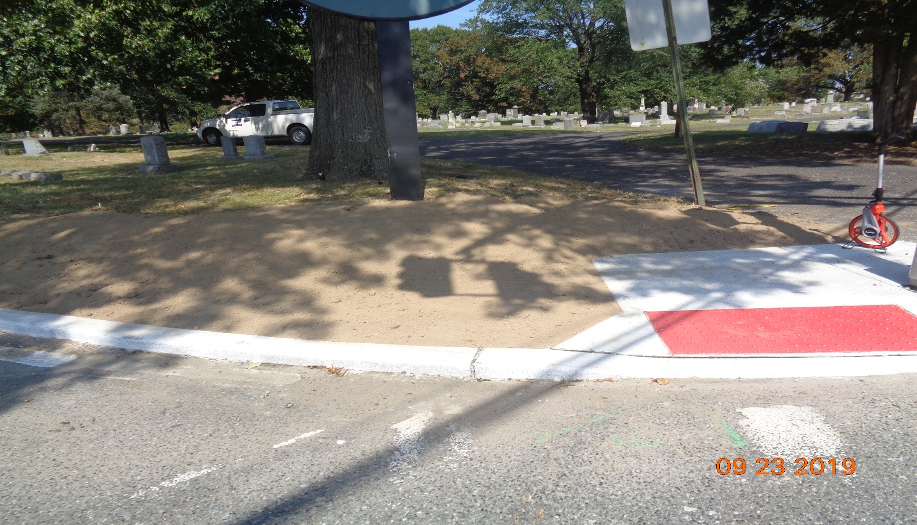
Figure 7: Topsoil around Curb and Sidewalk along Cove Road, East
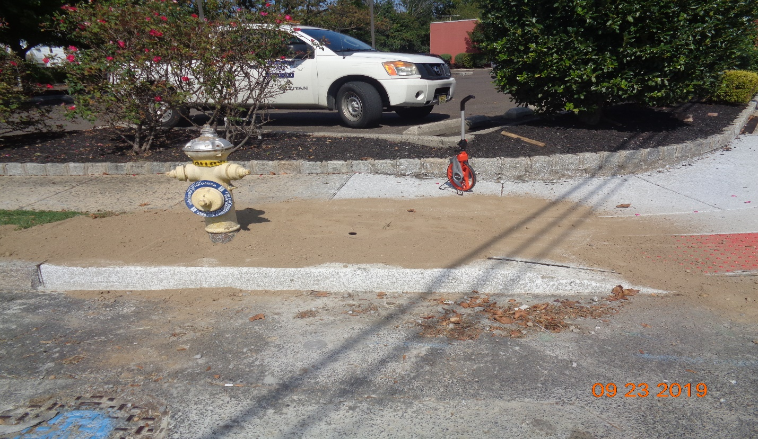
Figure 8: Topsoil around Curb and Sidewalk along Scovel Ave, West
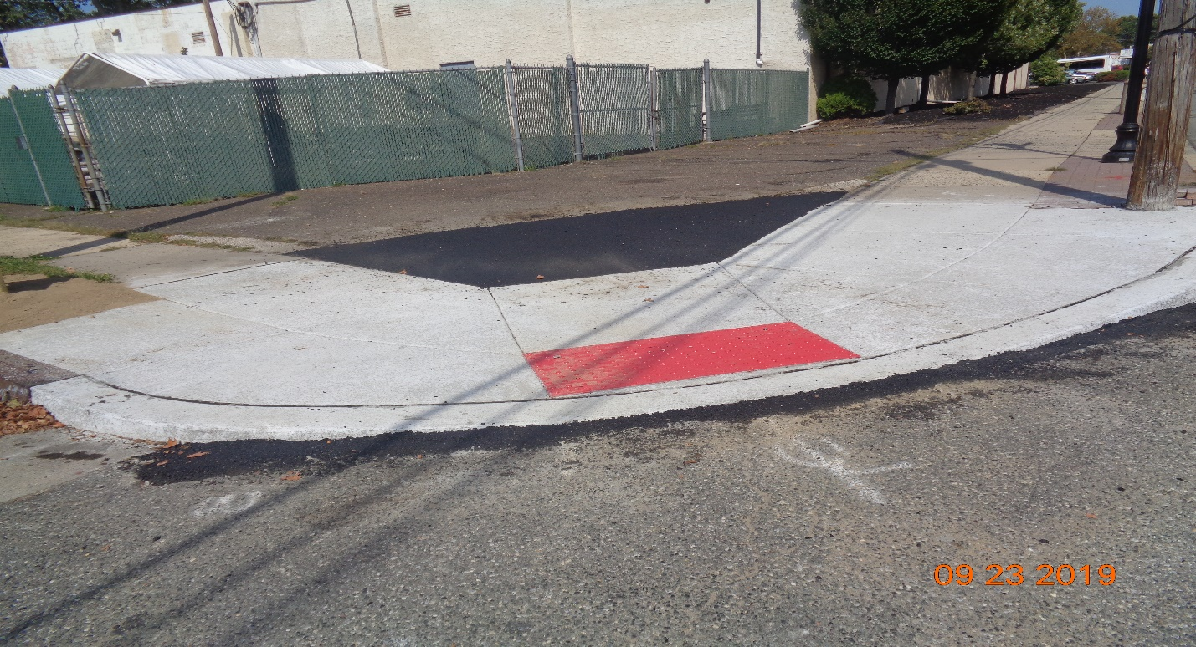
Figure 9: Asphalt around Sidewalk along Horner Avenue, East
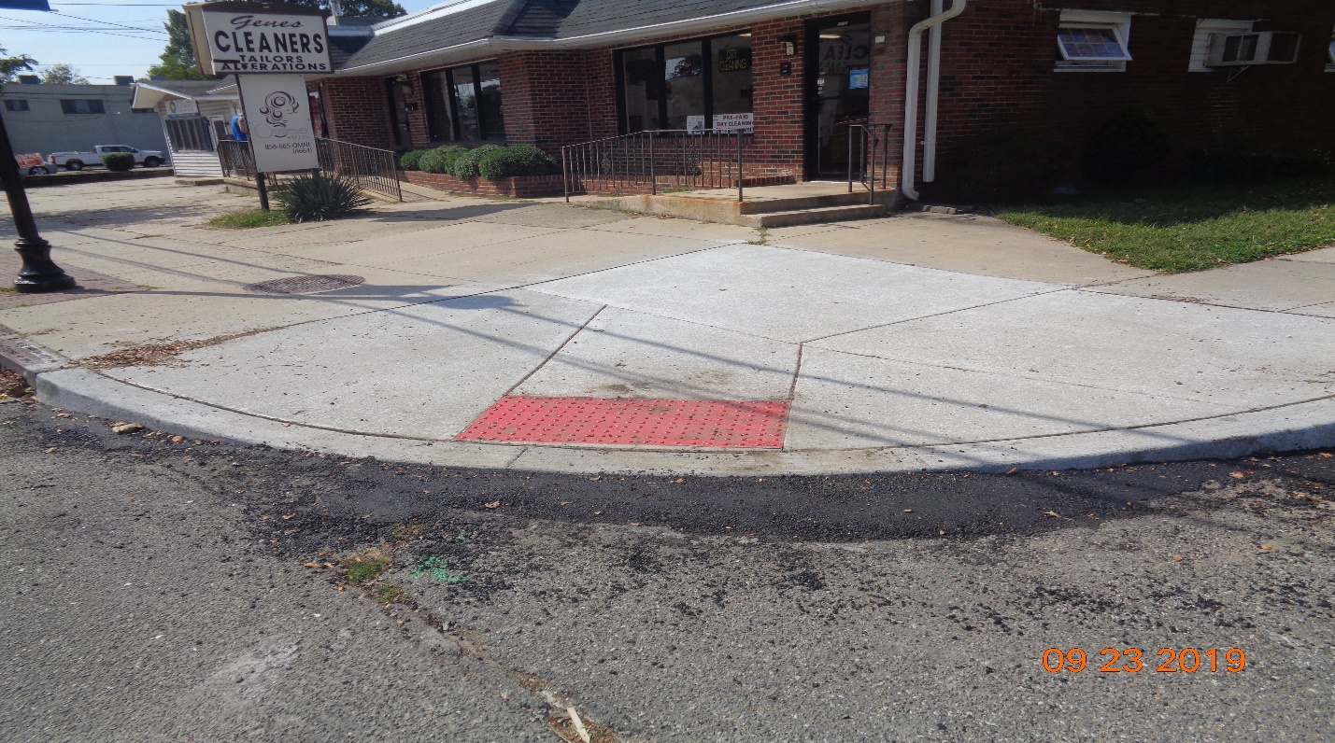
Figure 10: Asphalt around Curb Sidewalk along Horner Avenue, West

