Mill and Overlay of Westfield Avenue (CR 610) from Tinsman Avenue (MP 1.57) T0 NJ Route 130 (MP 2.92)
Pennsauken Township, Camden County, New Jersey

Notice to Proceed issued: August 30, 2019
Project Completion: May 10, 2020
Project Substantial Completion: April 10, 2020.
Project start: September 4,2019.

Weekly Progress Report
9-16-2019 through 9-20-2019

Following Construction Activities took place during above period:

Concrete Curb and Sidewalk:
Concrete Vertical Curb and sidewalks were constructed along Westfield Avenue (Eastbound and Westbound) at the following locations:
- Along Cove Road, West
- Along Hollinshead Avenue, West
- Along Gross Avenue, East and West
- Along Merchantville Avenue, East and West
- Along Springfield Avenue, East and West
- Along Lexington Avenue, East and West

Two Week Look Ahead:
Construction of Concrete Vertical Curb and Sidewalk will continue along Westfield Avenue.

Prepared By:
Gunvant Mistry
Resident Engineer

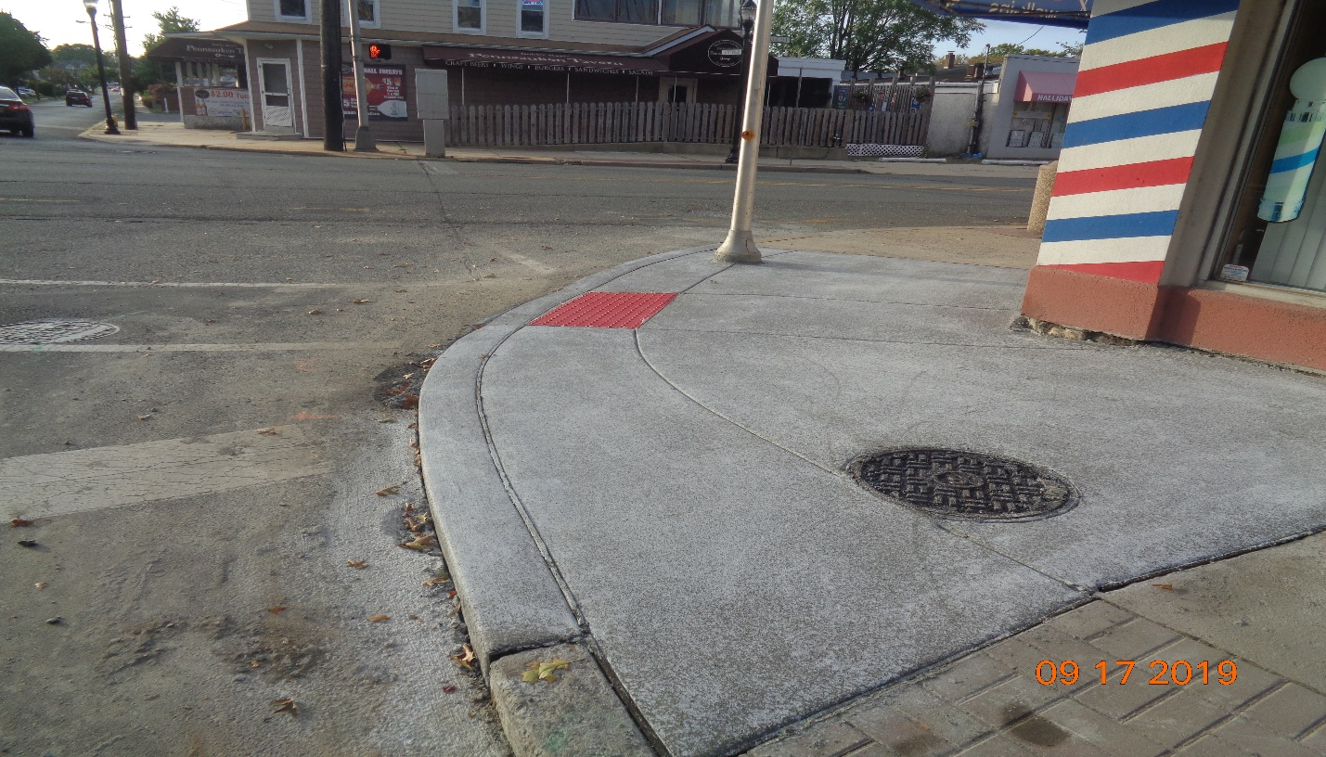
Westfield Avenue
Cove Road
Figure 1: Concrete Curb and Sidewalk along Cove Road, West

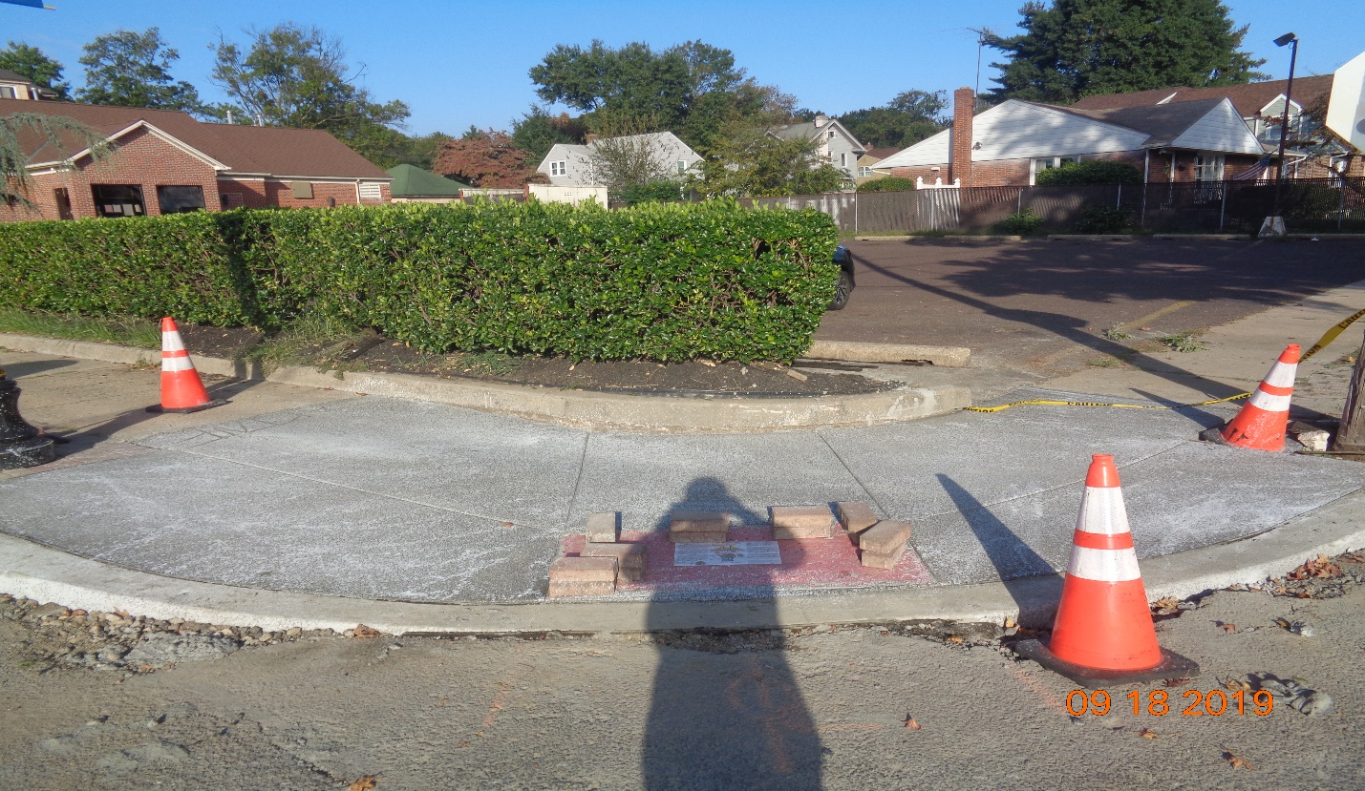
Figure 2: Concrete Curb and Sidewalk along Hollinshead Avenue, Wes
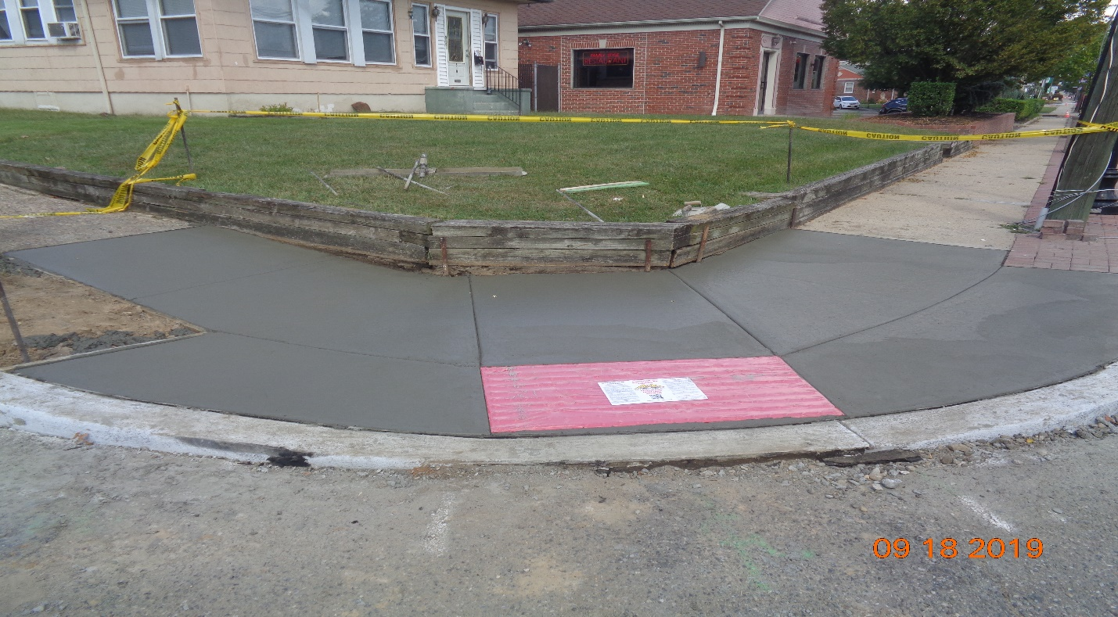
Figure 3: Concrete Curb and Sidewalk along Gross Avenue, East
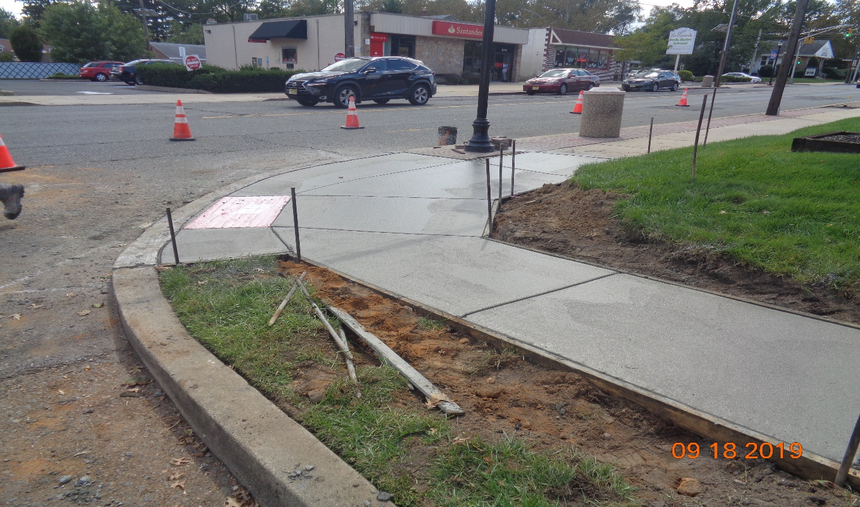
Westfield Avenue
Gross Avenue
Figure 4: Concrete Curb and Sidewalk along Gross Avenue, West
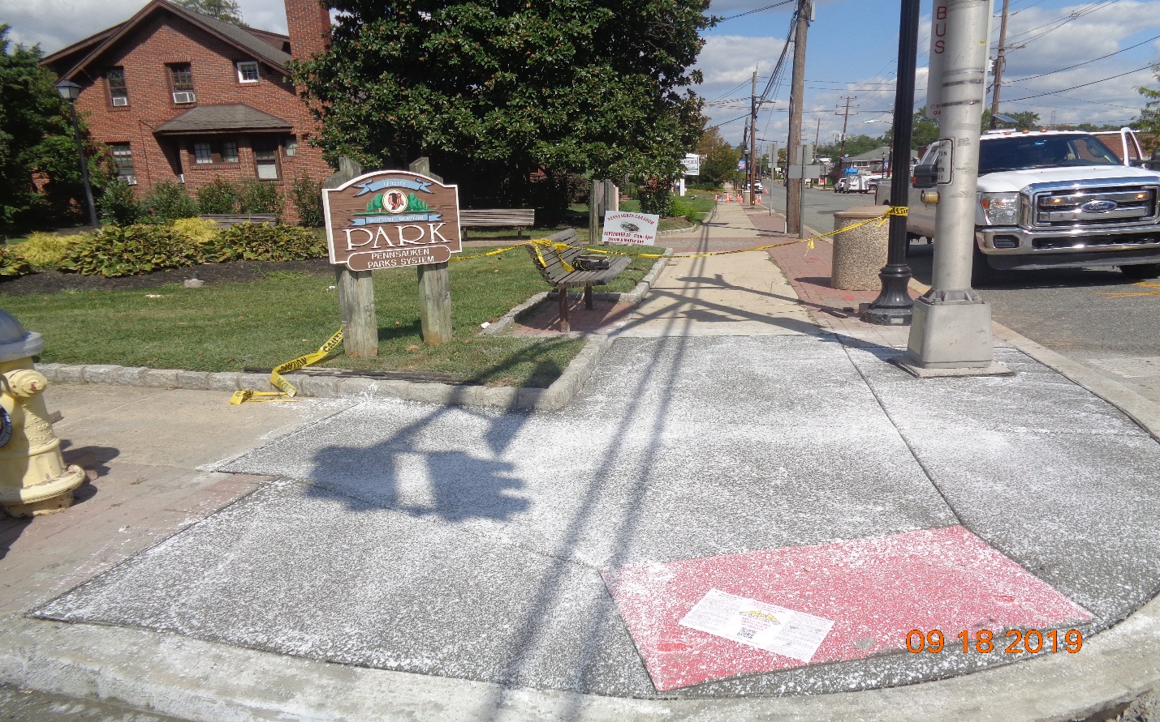
Figure 5: Concrete Curb and Sidewalk along Merchantville Avenue, East
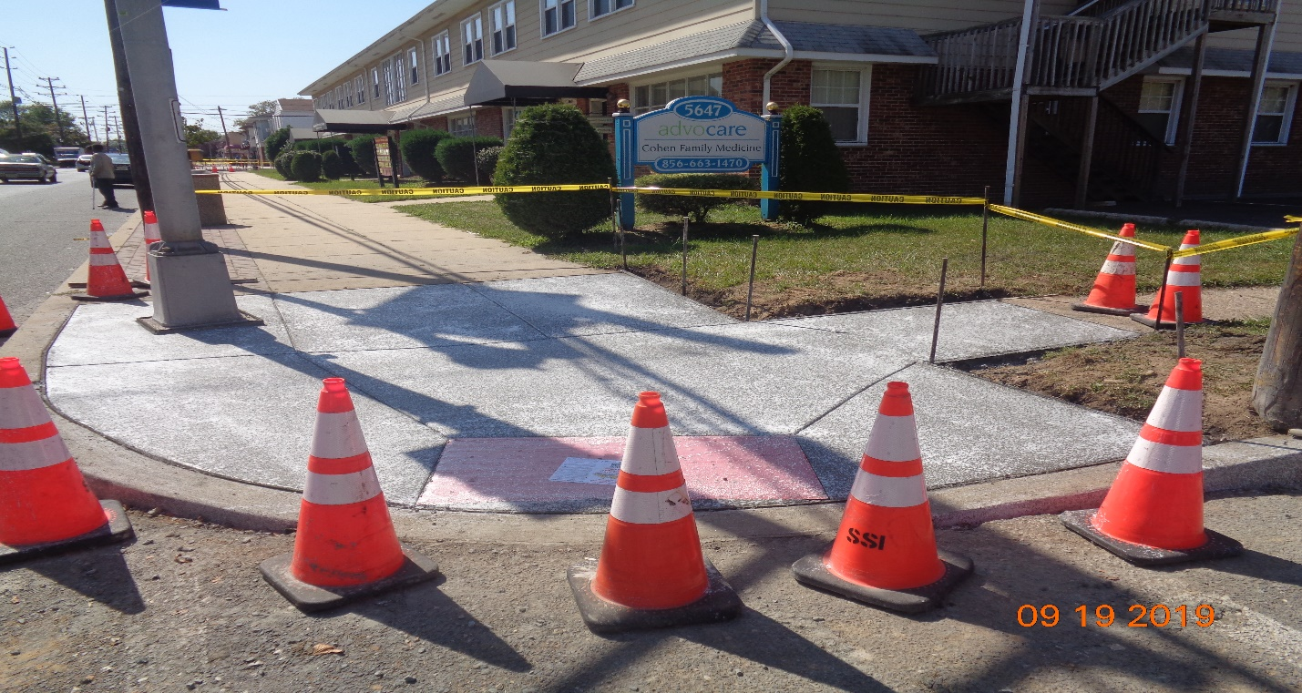
Figure 6: Concrete Curb and Sidewalk along Merchantville Avenue, West
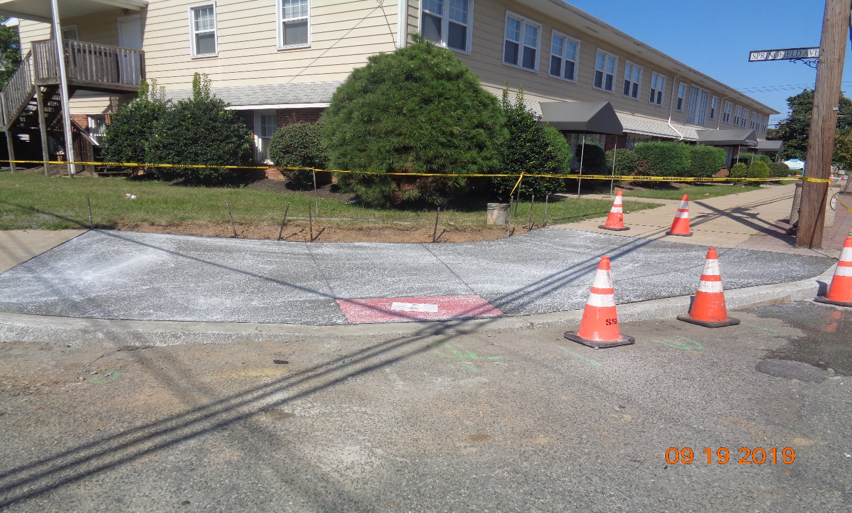
Figure 7: Concrete Curb and Sidewalk along Springfield Avenue, West
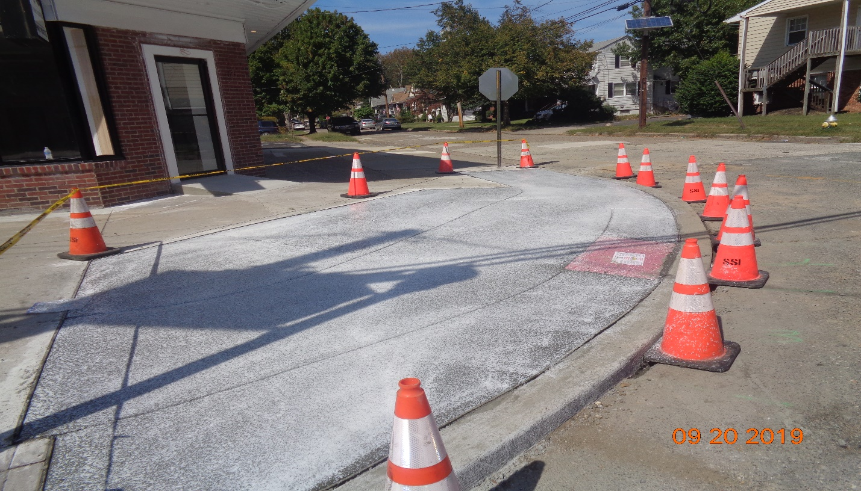
Figure 8: Concrete Curb and Sidewalk along Springfield Avenue, West
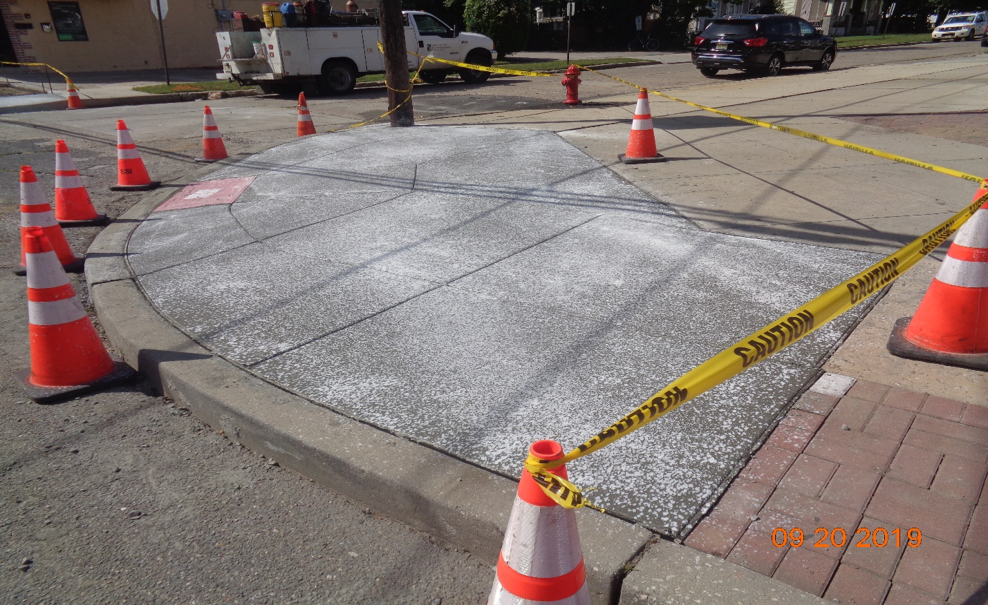
Figure 9: Concrete Curb and Sidewalk along Lexington Avenue, East
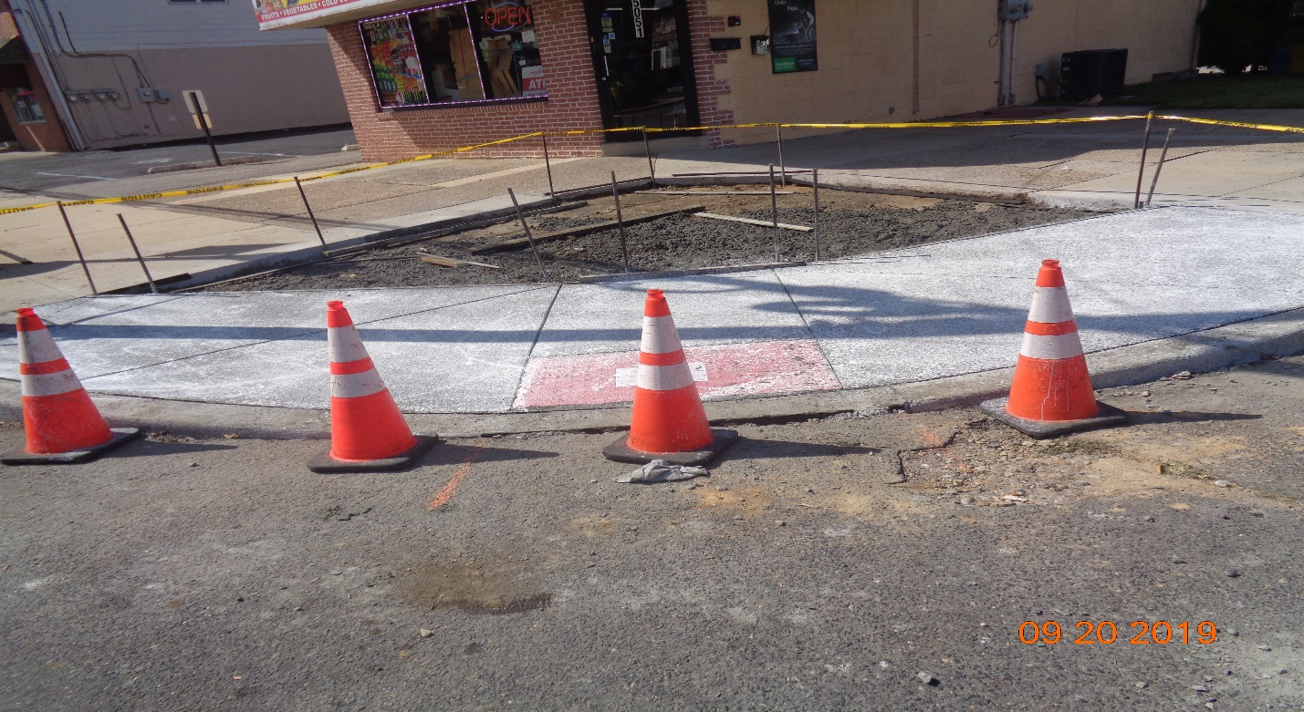
This Portion will be completed on 9/23/2019, Monday
Figure 10: Concrete Curb and Sidewalk along Lexington Avenue, West

