Mill and Overlay of Westfield Avenue (CR 610) from Tinsman Avenue (MP 1.57) T0 NJ Route 130 (MP 2.92)
Pennsauken Township, Camden County, New Jersey

Notice to Proceed issued: August 30, 2019
Project Completion: May 10, 2020
Project Substantial Completion: April 10, 2020.
Project start: September 4,2019.

Weekly Progress Report
10-07-2019 through 10-11-2019

Following Construction Activities took place during above period:

Concrete Curb and Sidewalk:
- Contractor was not present at site therefore construction activities were not performed.

Drainage:
- Drainage structures were delivered at site on 10/10/2019.
- Meeting was held in the field with Drainage installation Team of South State Inc.

Roadway:
- Meeting was held in the field with Steven Squibb (Pennsauken Township Engineer) and locations were marked out along Westfield Avenue within project Limit where there were severe humps or dips

Two Week Look Ahead:
- Construction of Drainage related activities will start from 10/14/2019 and continue for next two weeks.

Biweekly Progress Meeting:
- Biweekly Progress Meeting 03 was held on October 11, 2019 at Pennsauken Township Building.

Prepared By:
Gunvant Mistry
Resident Engineer

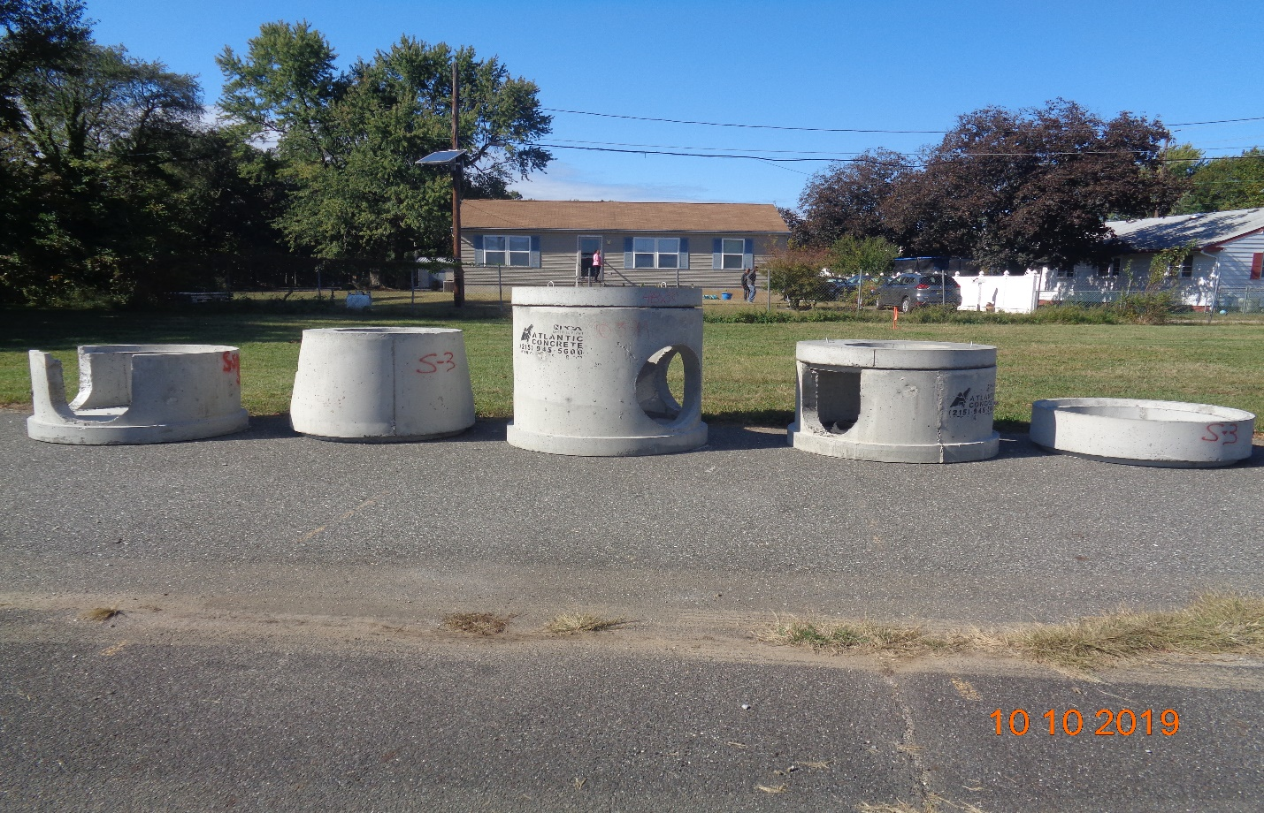
Figure 1: Drainage structures were delivered at site on 10/10/2019.

