Mill and Overlay of Westfield Avenue (CR 610) from Tinsman Avenue (MP 1.57) T0 NJ Route 130 (MP 2.92)
Pennsauken Township, Camden County, New Jersey

Notice to Proceed issued: August 30, 2019
Project Completion: May 10, 2020
Project Substantial Completion: April 10, 2020.
Project start: September 4,2019.

Weekly Progress Report
9-04-2019 through 9-13-2019

Following Construction Activities took place during above period:

Concrete Curb and Sidewalk:
Concrete Vertical Curb and sidewalks were constructed along Westfield Avenue (Eastbound and Westbound) at the following locations:
- Along Derousse Avenue, East and West
- Along Sherman Avenue, East and West
- Along Entrance of MPW, East
- Along Cover Road, East
- Along Scovel Avenue, East and West
- Along Horner Avenue, East and West
- Along Hillcrest Avenue, East – Curb Only
- Along Westfield Avenue STA 124+60, RT – across from Derousse Avenue.

Two Week Look Ahead:
Construction of Concrete Vertical Curb and Sidewalk will continue along Westfield Avenue.

Biweekly Progress Meeting:
Biweekly Progress Meeting 01 was held on September 13, 2019 in the field.

Prepared By:
Gunvant Mistry
Resident Engineer

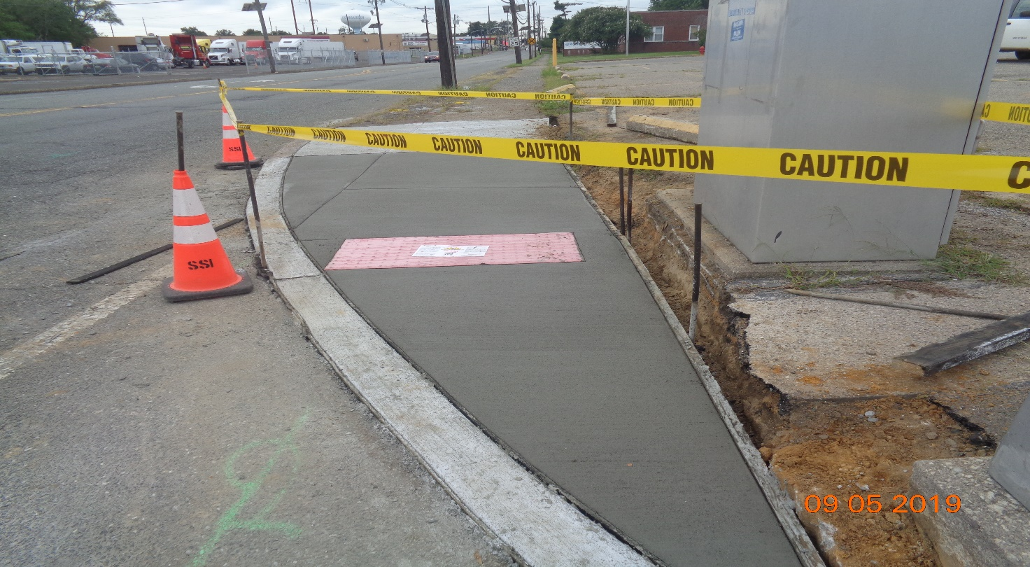
Figure 1: Concrete Curb and Sidewalk Along Derousse Avenue, West
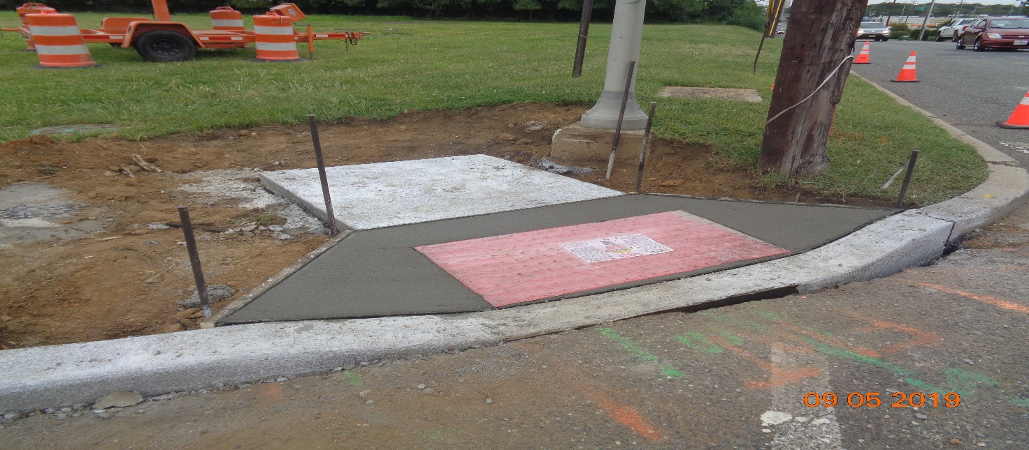
Figure 2: Concrete Curb and Sidewalk Along Derousse Avenue, East

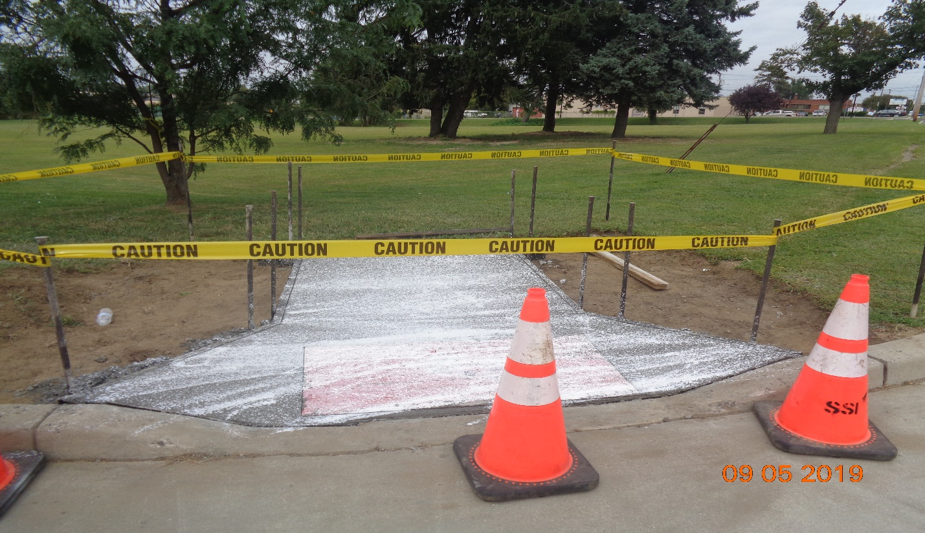
Figure 3: Concrete Sidewalk along Entrance of MPW, East
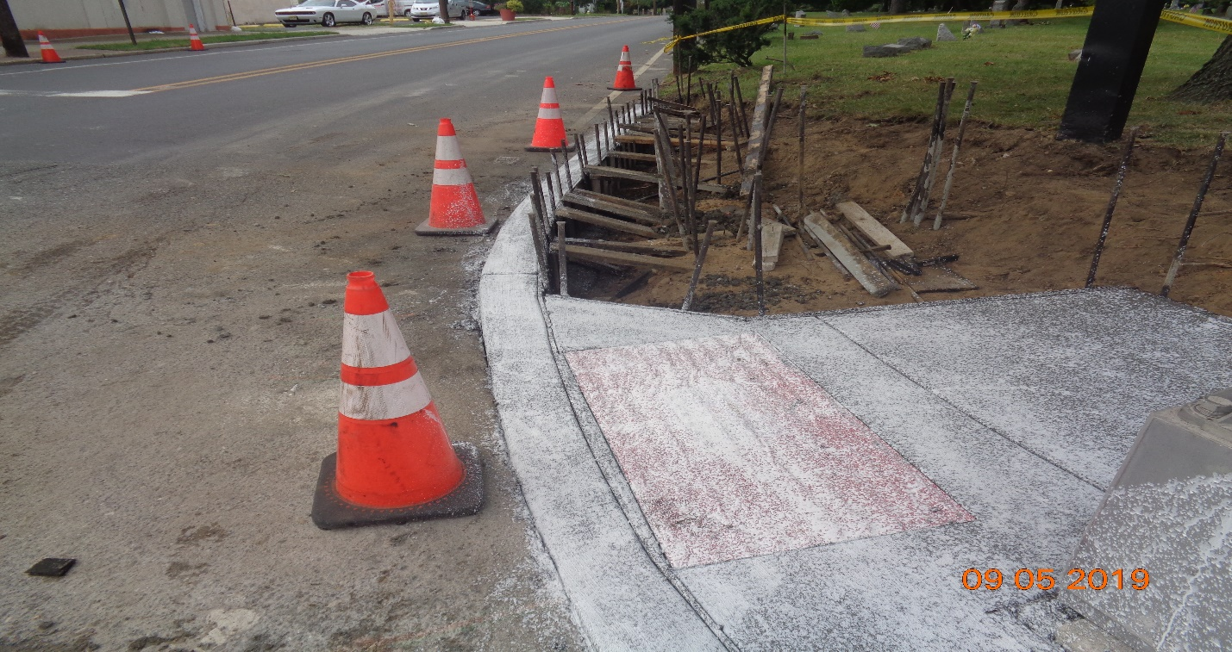
Figure 4: Concrete Curb and Sidewalk along Cove Road, East

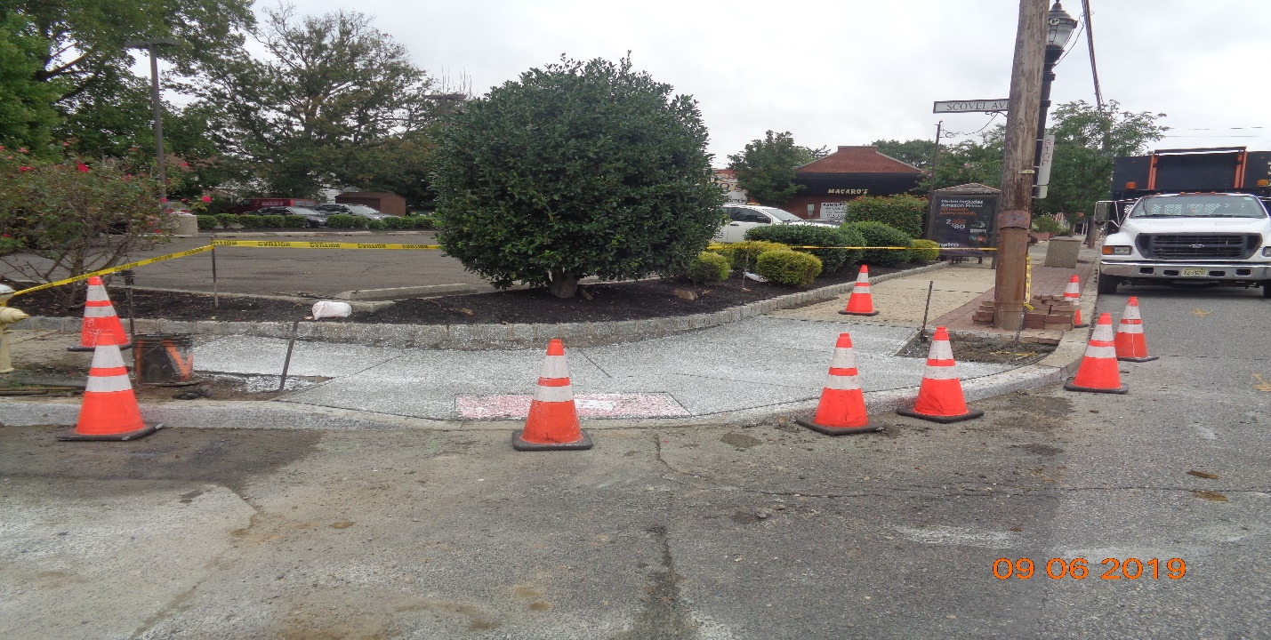
Figure 5: Concrete Curb and Sidewalk along Scovel Avenue, East

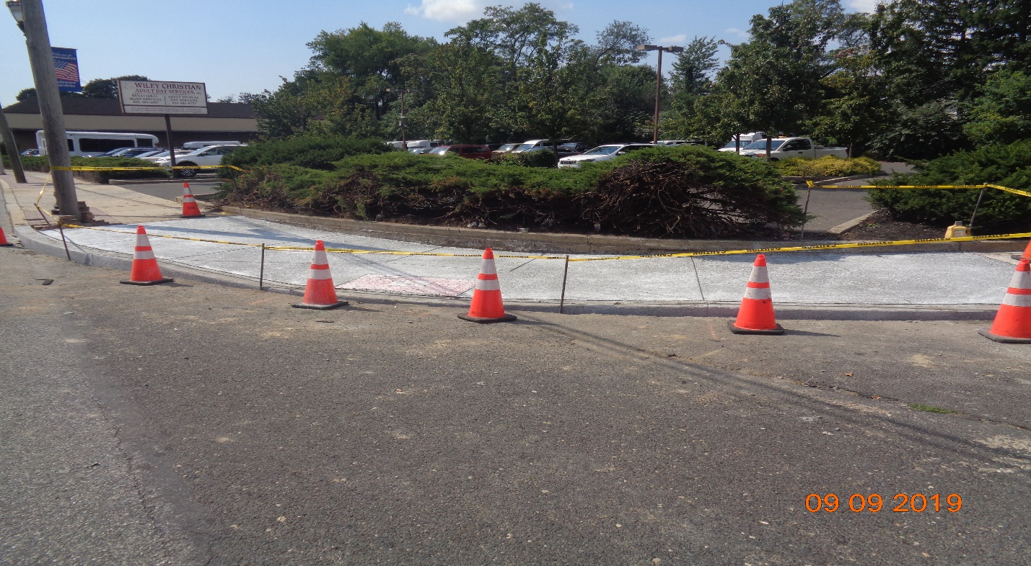
Figure 6: Concrete Curb and Sidewalk along Scovel Avenue, West

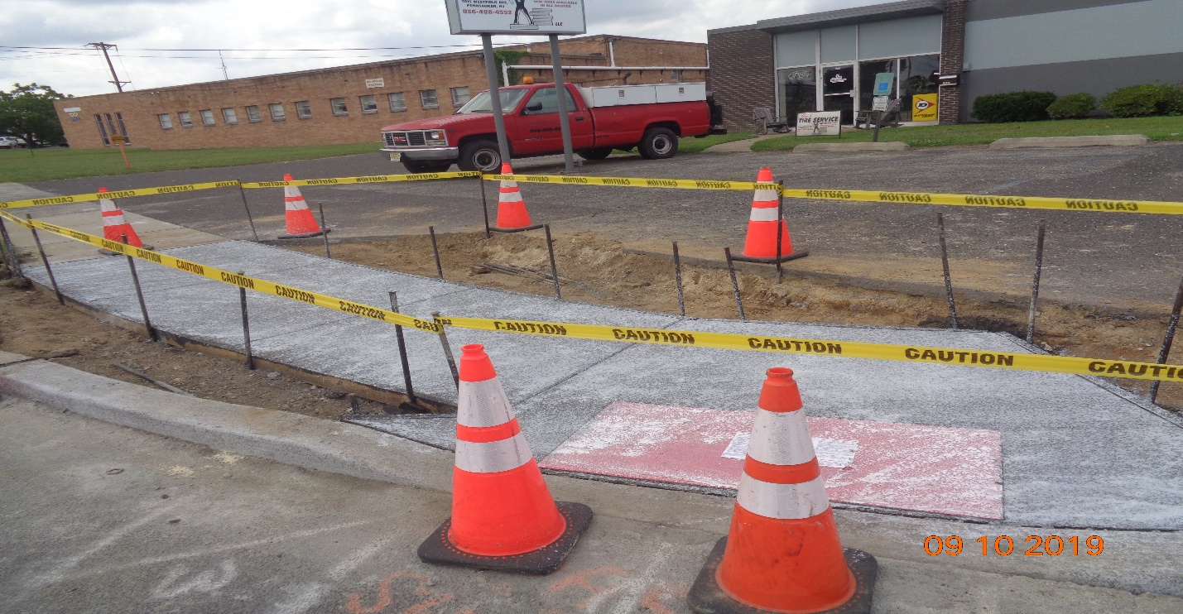
Figure 7: Concrete Curb and Sidewalk along Sherman Ave, West side

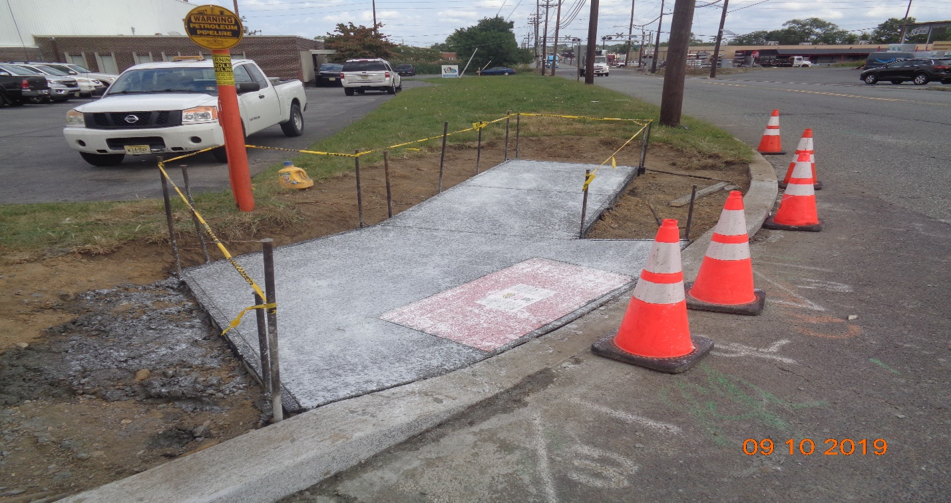
Figure 8: Concrete Curb and Sidewalk along Sherman Ave, East

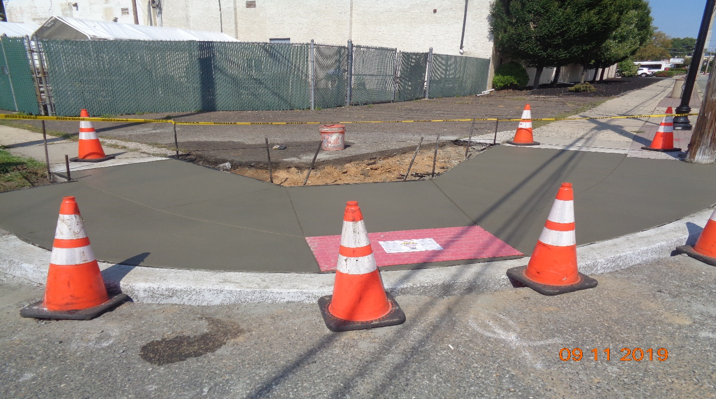
Figure 9: Concrete Curb and Sidewalk along Horner Ave, East

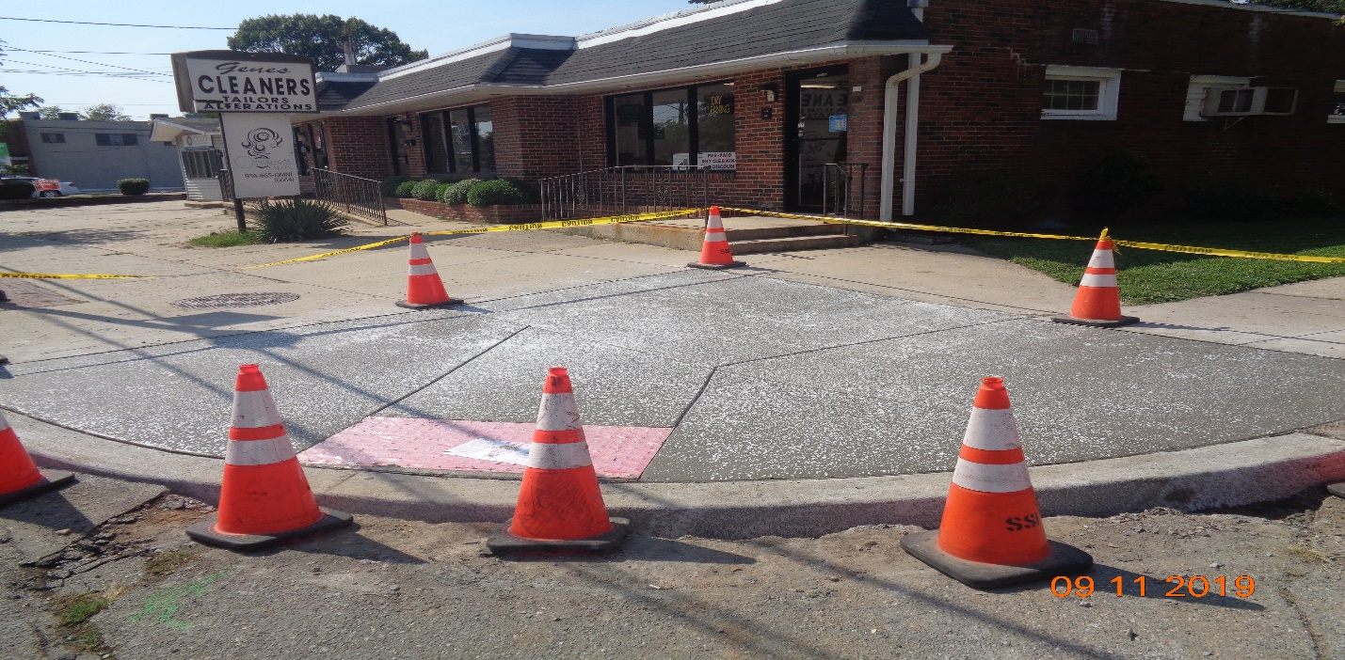
Figure 10: Concrete Curb and Sidewalk along Horner Ave, West
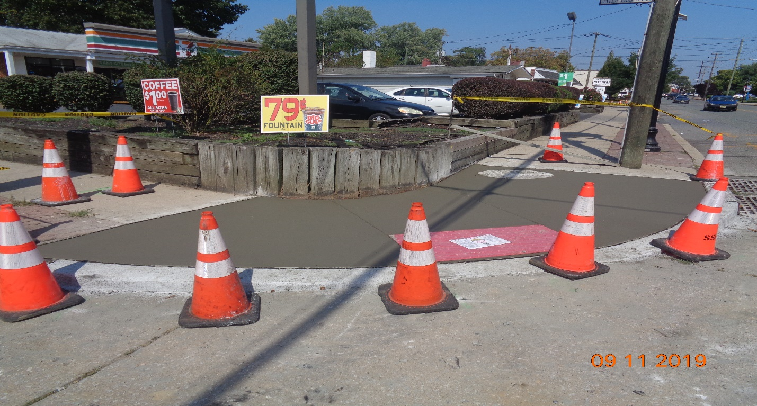Figure 11: Concrete Curb and Sidewalk Along Hollinshead Ave, East
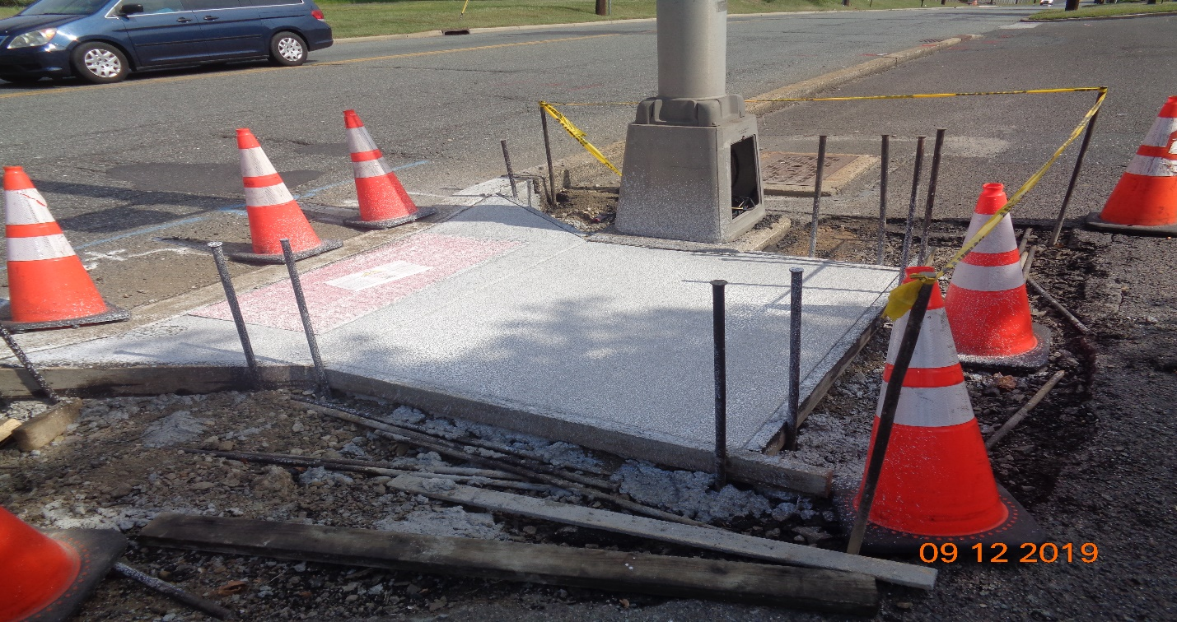
Figure 12: Concrete Curb and Sidewalk along Westfield Ave, STA 124+60 Right

