
Revised 8/02

Camden County Open Space, Farmland, Recreation, and Historic Preservation Trust Fund

Application for Open Space Preservation Funding

DATE ___________________

I. Applicant Information

Name of Applicant * _____________________________________________

Street Address __________________________________________________________

City ______________________________ State __________________ Zip__________

Phone # ______________ Fax # ______________ Best time to contact ____________

* Non-profit organizations must be conservation organizations to qualify for funding. Please
attach both IRS and New Jersey Charitable Registration letters.

Contact Person for Applicant:

Name _________________________________________________________________

Address ________________________________________________________________

City _______________________________ State ___________ Zip ________________

Phone # _______________ Fax # _________________ Best time to contact ________

Email _________________________________________________________________

Revised 8/02
II. Property Background

Name of property (if any) ________________________________________________

Address _______________________________________________________________

City __________________________ State ___________ Zip ____________________

Block Number(s) _______________ Lot Number(s) _____________
Block Number(s) _______________ Lot Number(s) _____________
Block Number(s) _______________ Lot Number(s) _____________

Deed Book ____________________ Page Number ______________

(If available, please include a copy of the deed with the application)

The Applicant:

_____ owns the property _____ leases the property. (Attach a copy of lease)

______ does not own or lease the property.

Owner, if other than applicant: *

Name ____________________________________________________________

Address __________________________________________________________

City ______________________State ___________ Zip ___________________

Phone # ________________________ Fax # _____________________

* If the property has multiple owners, or is otherwise owned by an entity or organization, including but not limited to: a company, corporation, partnership, trust or estate, please list all individuals having an interest in the property and their complete address below.

Name Address % Ownership

________________________ ______________________________ __________

________________________ ______________________________ __________

________________________ ______________________________ __________

Revised 8/02

Individuals (con’t)

Name Address % Ownership

________________________ ______________________________ __________

________________________ ______________________________ __________

________________________ ______________________________ __________

Lessor, if different from the owner:

Name ____________________________________________________________

Address__________________________________________________________

City _____________________State ____________ Zip ___________________

Phone # ____________________ Fax # __________________

Holder of any Mortgages or Liens on the property, if any:

Name_____________________________________________________________

Address __________________________________________________________

City ______________________State ___________ Zip ___________________

Phone # ____________________ Fax # __________________

Amount of Mortgage or Lien $________________

List any easements or right-of-ways on the property (attach copy):

________________________________________________________________________

________________________________________________________________________

Revised 8/02

III. Land Use

A. Present Land Use:

_____ Open Space _____ Farmland
_____ Recreation _____ Commercial/Industrial

B. Proposed Land Use: ____ Passive Recreation / ____ Conservation

- Total Acreage to be Dedicated to Passive Recreation and/or Conservation: ________ Acres

- Total Acreage to be Dedicated to Active Recreation or Other Development: ________ Acres

NOTE: All monies provided through the Camden County Open Space Preservation Trust Fund
for the acquisition of open space are limited to funding only the acquisition of those acres that will be dedicated to conservation or passive recreation. The acquisition of any acreage to be dedicated for active recreation shall not be funded through the Trust Fund.

IV. Development Pressure

- Applicant’s Ownership Status:

_____ Corporation or Partnership - (circle as applicable)
Formal / Informal
General / Limited
_____ Estate - expected settlement date _______________
_____ Foreclosure
_____ Individual / Resident Ownership
_____ Other (i.e. municipality; tax exempt non-profit organization)

Revised 8/02

B. Market Availability

      - Is the property listed for sale?
___ Yes ___ No

2. If the property is for sale, has there been an offer to purchase?
___ Yes ___ No

Name of Party or Group Making Offer ___________________________

Address ____________________________________________________

City _____________________ State ___________ Zip _____________

Phone # ______________________ Fax # ________________________

Amount of Offer $ ______________________

3. What is your “asking price” to the Camden County Open Space
Preservation Trust Fund Program for the property?

NOTE: If partial funding is being requested, please indicate both the total
cost of acquisition for the property and the amount being requested from
the Trust Fund.

Total Cost $ ____________ Amount Requested $ ___________

4. Are you interested in tax saving options? ___ Yes ___ No

C. Suitability for Development

1. Has the property been approved for subdivision? ___ Yes ___ No

2. Has an application for subdivision been filed? ___ Yes ___ No

3. Are there any impediments to the approval of a subdivision?

___Yes ___ No

______ Minor impediments ______ Major impediments

If yes, please explain, _________________________________________

___________________________________________________________

Revised 8/02

4. Are there any pending plans to subdivide the property?
___ Yes ___ No

If yes, please explain, _________________________________________

______________________________________________________

D. Infrastructure Availability

1. Which of the following infrastructure improvements are available to, or on, the property?

______ Roads ______ Public Water ______ Sewer

V. Environmental Factors

- Proximity to Wetlands:

1. Are there wetlands on the property? ___ Yes ___ No

If yes, how many acres? ___________________

2. Is there a wetlands buffer area on the property? ___ Yes ___ No

If yes, how many acres? ___________________

3. Is the property adjacent to a wetlands buffer? ___ Yes ___ No

B. Riparian Corridor / Water Frontage

1. How many linear feet of waterfront does the property have? ______

Name of water body ___________________________________

2. Does the property protect a water frontage? ___ Yes ___ No

If yes, please explain, _________________________________________

Revised 8/02

C. Presence of Woodlands:

1. How many acres of mature woodlands are on the property? ______

2. How many acres of immature woodlands are on the property? ______

D. Contamination:

1. Is there any known hazardous waste contamination on site?
___ Yes ___ No

If yes, please explain, _______________________________________

_________________________________________________________

_________________________________________________________

2. Is there any suspected hazardous waste contamination on site?
___ Yes ___ No

If yes, please explain,__________________________________________

____________________________________________________________

____________________________________________________________

- Are there any storage drums, underground storage tanks or other
possible sources of hazardous waste contamination located on site?

___ Yes ___ No

E. Endangered or Threatened Species Habitat:

1. What endangered or threatened species, if any, are known to inhabit this property? (Please provide documentation)

___________________________________________________________
(Documentation Required)

2. What endangered or threatened species, if any, are suspected to inhabit this property? (Please provide documentation)

___________________________________________________________
(Documentation Required)

Revised 8/02

3. What, if any, investigation is ongoing or proposed with respect to endangered or threatened species?

____________________________________________________________

____________________________________________________________

VI. Greenway/Open Space Characteristics

- Proximity to protected greenway/protected open space:

1. Is the property contiguous to a protected greenway or other protected open space? ___Yes ___ No

If yes, please explain, __________________________________________
____________________________________________________________

2. Is the property within a 0.5-mile radius of an existing protected greenway or other protected open space? ___Yes ___ No

If so, which property(ies), ______________________________________

____________________________________________________________

3. Is the property contiguous to unprotected open space?
___Yes ___ No

If so, which property(ies), ______________________________________

____________________________________________________________

4. Is the property within a 0.5-mile radius of unprotected open space? ___ Yes ___ No

If so, which property(ies), ______________________________________

____________________________________________________________

Revised 8/02

- Proximity to Farmland:

1. Is the property contiguous to protected farmland? ___Yes ___ No

If so, which farm(s), __________________________________________

2. Is the property within a 0.5-mile radius of protected farmland?
___ Yes ___ No

If yes, please explain, __________________________________________

____________________________________________________________

3. Is the property contiguous to unprotected farmland?
___ Yes ___ No

If yes, please explain, __________________________________________

____________________________________________________________

4. Is the property within a 0.5-mile radius of unprotected farmland?
___ Yes ___ No

If yes, please explain, __________________________________________

____________________________________________________________

C. Proximity to Scenic Views:

1. Does the property contain a scenic view? ___ Yes ___ No

If yes, please explain, __________________________________________

____________________________________________________________

2. Does the property compliment a scenic view? ___ Yes ___ No

If yes, please explain, __________________________________________

____________________________________________________________

Revised 8/02

VII. Ease of Acquisition and Conservation

A. Check any other sources of funding which have been sought *

Please include copies of the appropriate application(s)

_____ Green Acres _____ Farmland Preservation
_____ Community Development Block Grant _____ Rails-To-Trails _____ Matching municipal funds or services _____ Other (name)____________
_____ Historic Preservation

* A minimum 25% cost share is required for all municipal and non-profit applications

B. Public Support *

1. This application has been endorsed by the host municipality’s governing body. (If yes, please provide proof of endorsement.)

___ Yes ___ No

* It is strongly suggested that applicants request a letter or resolution from the host municipality supporting the sale of the property identified herein to the Camden County Open Space Preservation Trust Fund Program.

VIII. Narrative

Please explain how you feel the acquisition of this property will benefit the residents of the local municipality and Camden County as a whole. (Please limit your response to no more than 250 words)

Revised 8/02

Acting as duly authorized representative for the applying organization, I am submitting this request for assistance from the Camden County Open Space, Recreation, Farmland and Historic Preservation Trust Fund. (PLEASE NOTE, SIGNATURE MUST BE NOTARIZED.)

______________________________________________ ______________________
Signature of Individual Date

_______________________________________________________ ___________________________
Name of Individual (typed or printed) Title

Notary:

(OP-APPL-OPSP)

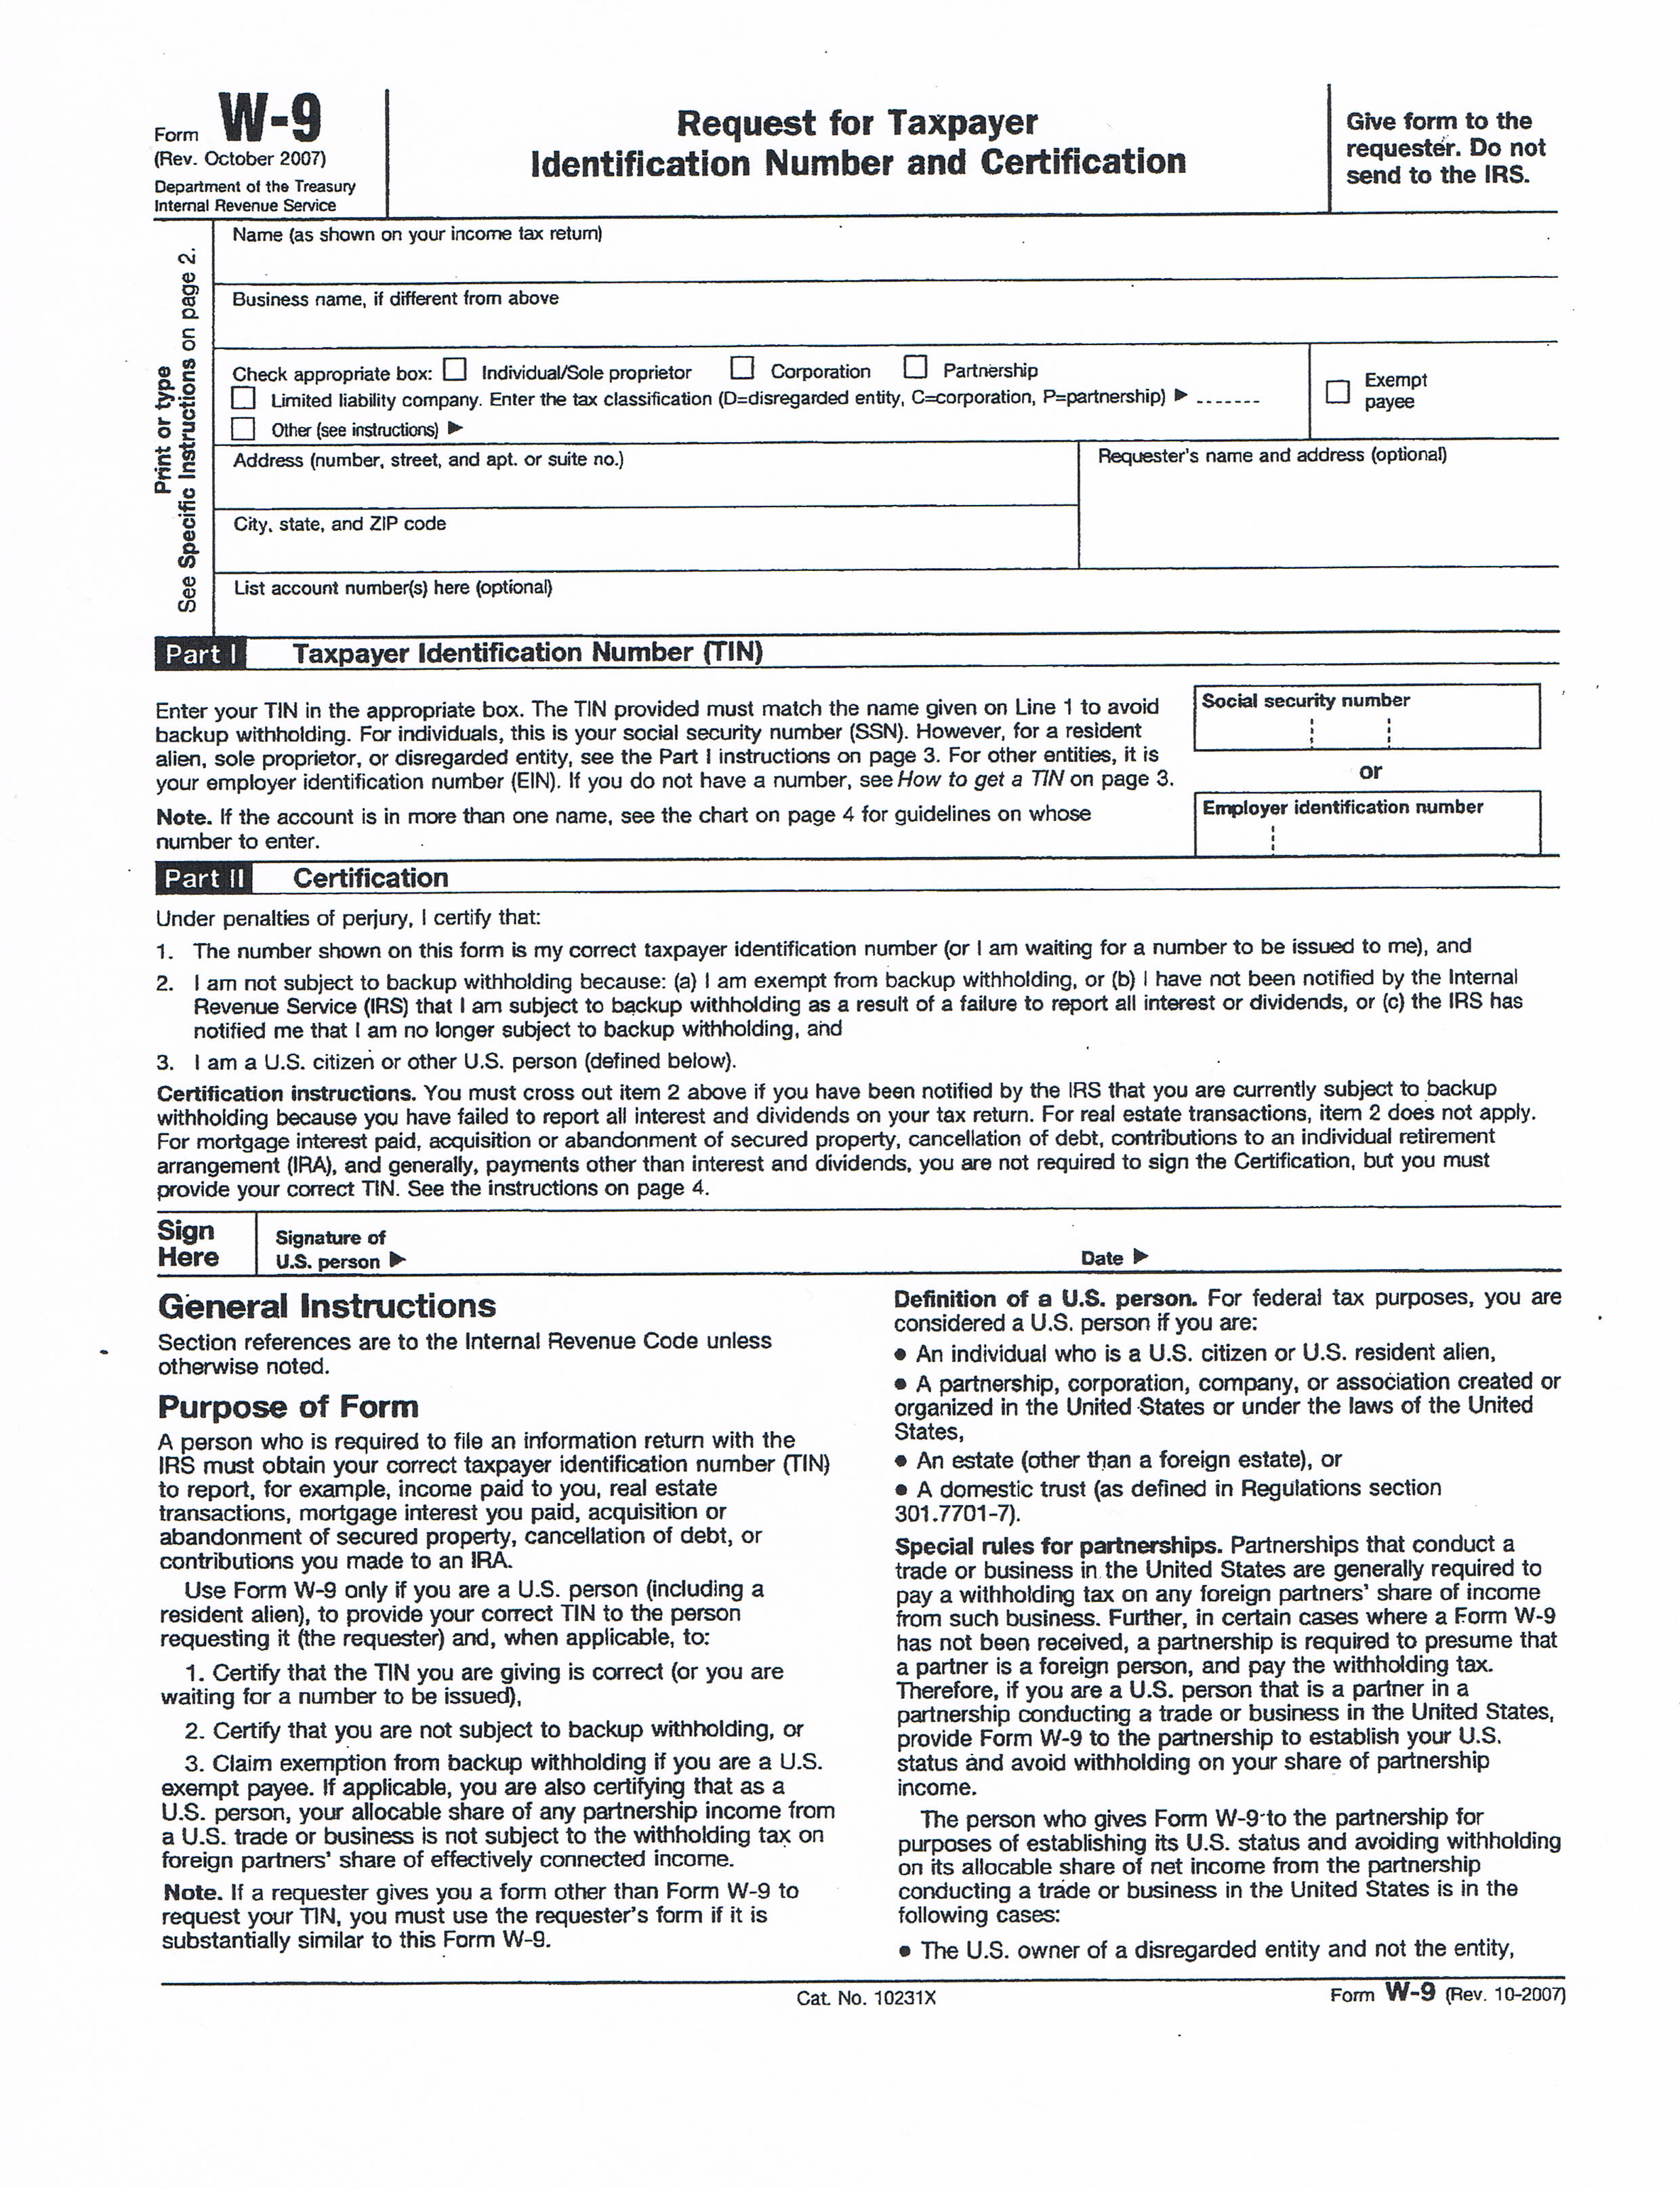
Camden County Open Space, Farmland, Recreation, and Historic Preservation Trust Fund

Please return the attached application & W9 form to:

Camden County
Division of Open Space and Farmland Preservation
1301 Park Blvd.
Cherry Hill, NJ 08002

Phone: (856) 858-5241
Fax: (856) 216-7156

