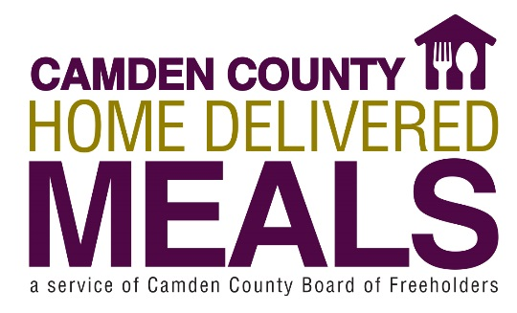
PROGRAM GUIDELINES

INDIVIDUAL RESPONSIBILITY FOR HOME DELIVERED MEAL PROGRAM
- You must be home to accept your meal delivery and make contact with the driver.
- Your driver cannot leave your meal.
- If you have a medical appointment or will be away, please call 856-374-MEAL (856-374-6325) 48 hours/two days in advance. Meal delivery will be suspended temporarily and resumed the next day or when we are notified, should you be away from your home for an extended period (hospital or rehabilitation stay).
- At times, you may not hear the door. If this happens and you find an Attempted Delivery tag left by the driver, please call the office at 856-374-6325 immediately to request re-delivery.
- If we do not hear from you, we will stop your meal delivery and may call the police for a wellness check to ensure your safety.

Camden County Home Delivered Meals is a program designed to enable homebound adults to remain in their community with independence and dignity.

ELIGIBILITY CRITERIA
To be eligible for home delivered meals, you must:
- Reside in Camden County
- Be age 60 years or older and living alone
- Be homebound (unable to drive, very ill, unable to leave your home without assistance)
- Receive home care assistance no more than 4 hours during the day
- Not require a special diet
- Not receive MLTSS services (Managed Long-Term Services & Supports)
- Client must supply a doctor’s note with diagnosis code and a reason for requesting meals. No meals will be delivered until all documentation is returned (application and proper doctor’s note).
- Assessment date: __________. Due date in 30 days is: _____________. Doctor’s note may be returned in the following ways:
- Fax 856-401-6405
- Mail CC Home Delivered Meals
Felicia Buzard
512 Lakeland Road
Blackwood NJ 08012

Home Delivered Meals will conduct an in-home interview to determine program eligibility. Re-assessments may occur every six (6) months for continuation in the Home Delivered Meals program, as well as to determine eligibility for other services that may benefit you.

How it Works
- A nutritious meal is delivered directly to your home. An effort is made to deliver the meal at approximately the same time each day. We do not guarantee specific delivery times.
- This well-balanced meal provides one-third (1/3) of the recommended daily nutrients for an adult.
- Each meal consists of an entrée (3 ounces meat, ½ cup of potato, ½ cup vegetable or equivalent), 1 cup milk, 1 slice of bread, 4 ounces of juice, and 1 dessert serving.

Hot Meal Plan
- Consists of one (1) hot, ready to eat meal that is delivered every weekday, Monday-Friday, between the hours of 9:00 am – 4:00 pm.

Weekend Meals
- High nutritional risk individuals may apply for a 2-pack of frozen meals to be delivered each week for the weekend.

Cost
- Camden County Home Delivered Meals program relies on donation.
- Each month you will receive a donation envelope and a copy of the planned menu. We welcome contributions from those able to contribute.
- Voluntary donations can be mailed in the self-addressed donation envelope. When possible, please enclose a check rather than cash. Checks should be made payable to: Camden County Treasurer.
- Please do not offer your driver a tip; drivers are not permitted to accept tips.

Emergency Preparedness
- Basic food supplies must always be kept in your home.
- You may not receive a meal as planned on any given day as meal deliveries may be suspended due to hazardous weather conditions or unforeseen circumstances.
- If uncertain whether a delivery will be made, please call Home Delivered Meals at 856-374-MEAL (374-6325) between the hours of 8:30 a.m. and 4:00 p.m. Monday-Friday.

________________________________ _____________________________ _____________
Participant’s PRINTED Name Participant’s Signature Date

