SURROGATE’S COURT
CAMDEN COUNTY
Michelle A. Gentek-Mayer  SURROGATE  Adam K. Rosen, Esquire  DEPUTY SURROGATE | 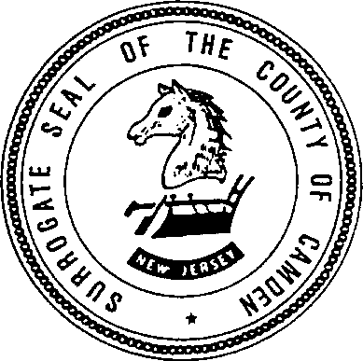 | 509 Lakeland Road Blackwood, New Jersey 08012 (856) 225-7282  (856) 225-7562 fax  www.camdencounty.com
December 2023
Dear Sir/Madam:

This letter will outline what documents are needed to begin your probate proceedings. Our court is open by appointment which you may schedule via the home page for the Camden County Surrogate at https://www.camdencounty.com/service/surrogate-court/ or our online portal https://camconj.powerappsportals.us/scheduling/. You may also mail documents by regular mail, Fed Ex or UPS to the main office: Camden County Surrogate Court, 509 Lakeland Road, Blackwood, NJ 08012 or hand deliver to our secure drop box at the same location. The drop box is a large PURPLE MAILBOX located to the right of the main door. Pick up is daily. Please note we do not accept credit cards or debit cards; check, cash and money order are the only forms of payment acceptable. Payment will be due at the time of service.

Attached is the Estate Information Sheet which must accompany your documents.

PROBATE (Will): Please submit:
- The ORIGINAL WILL you wish to probate.
- The death certificate WITH A RAISED SEAL for the decedent.
- A copy of your personal identification as EXECUTOR (such as drivers license)
- List of names and addresses of all immediate next of kin.

Telephone number and email address for follow-up questions.

ADMINISTRATION (No Will): Please submit:
- The original death certificate WITH A RAISED SEAL for the decedent.
- A copy of your personal identification as ADMINISTRATOR (such as drivers license)
- List of names and addresses of all immediate next of kin.

List of all assets in the decedent’s name ONLY, along with their dollar value.
If this includes Real Estate, we will need the fair market value (if accessible). If a mortgage is outstanding on the property, we will need a copy of the statement showing the balance due.
- Motor Vehicles – we need the make, model and approximate mileage for each vehicle.

Telephone number and email address for follow-up questions.

  - PLEASE ALLOW A FEW DAYS AFTER SUBMISSION OF YOUR DOCUMENTS FOR THE COURT TO CONTACT YOU.

CAMDEN COUNTY SURROGATE COURT
509 Lakeland Road
Blackwood, NJ 08012 ESTATE INFORMATION SHEET

Decedent’s Name

Address

Date of Birth Date of Death SS#

Name, your Relationship to Decedent and Address of Executor/Administrator (no will):

Address

Telephone/Email

Names of Next of Kin Relationship Address Age of Minors

Date of Will No pages

List of Assets of Decedent and Value

Estimated Value of Probate Estate:

Attorney’s
Name Address

Telephone/Email

FOR USE AS FACT SHEET TO BE MAILED OR BROUGHT ALONG WITH A CERTIFIED DEATH CERTIFICATE, ORIGINAL WILL AND CODICIL (if applicable)

Please note we do not accept credit cards or debit cards; check, cash and money order are the only forms of payment acceptable

IF NO WILL A LIST OF ALL DEBTS AND ASSETS WITH THEIR VALUE ALONG WITH A CERTIFIED DEATH CERTIFICATE MUST BE MAILED OR BROUGHT TO THE OFFICE

PLEASE ALLOW A FEW DAYS AFTER SUBMISSION FOR THE COURT TO CONTACT YOU.

