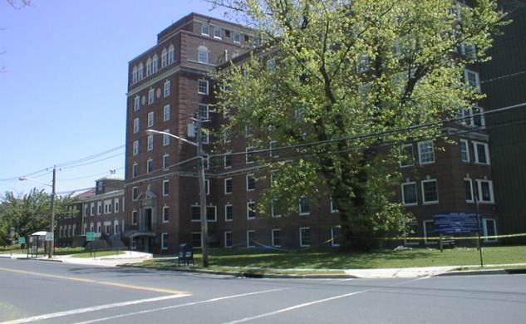**ANNUAL REPORT**

**2022**

CAMDEN COUNTY DEPARTMENT OF HEALTH AND HUMAN SERVICES

Community Health Services

Environmental and Consumer Health Services

Public Health Emergency Preparedness

DiPiero Building

512 Lakeland Road

Blackwood, New Jersey 08012

856-374-6037

[www.camdencounty.com](http://www.camdencounty.com)



Dear Citizens:

I am very pleased to present the 2023 Annual Report for the Camden County Department of Health and Human Services. The Department is among the oldest County Health Agencies in South Jersey, being established in 1968. Camden City and Cherry Hill Township were originally independent health departments that joined the County Health Department in our early history. That being accomplished all 36 municipalities are served by a single health agency.

I am pleased to inform you that the County Health Department became the first to be accredited by the Public Health Accreditation Board in New Jersey. This is a great achievement from the long and tedious work performed by the staff of the Health Department. Oftentimes, the role and services that the Health Department provides are overshadowed by more visible programs within County Government. Compared to other agencies, public health is critical to servicing and assessing the needs of Camden County constituents.

If we look at the 21st century, we see tremendous gains in health and longevity associated with sanitation, hygiene, development of antibiotics, vaccines, healthy water supply all of which have been contributed by public health. The Camden County Health Department was instrumental in saving lives in our most recent COVID-19 Pandemic. County Government stood at the forefront of the Pandemic working countless hours to provide the best service to the community.

Historically, Public Health prevention and programs have not been appropriately valued, since often we look at medical remedies to create good health. Frequently we overlook the fact that often good health can be effectively achieved by personal behavior, a healthier environment, progressive health policy and availability of health care access for all people.

The challenges today in 2023 have not disappeared but evolved and changed over the decades. The challenges today include overall reduction of health care costs through education and personal behavior, structural changes that will create cost reductions and operational efficiency for our County Public Health Agency assessing the impact of public health played out with increases in years of healthy living by all our residents.

Program changes focus on collaboration with community resources to reduce chronic diseases, empowering individuals to have a healthy lifestyle, developing sound public health policy and continuing our success in controlling infectious diseases.

The Annual Report will highlight the goals and accomplishments of the Camden County Health Department. Please take a moment to review and comment regarding our findings. We can be reached at [Caryelle.Lasher@camdencounty.com](mailto:Caryelle.Lasher@camdencounty.com) or [Virginia.Betteridge@camdencounty.com](mailto:Virginia.Betteridge@camdencounty.com)

Sincerely,

Virginia Betteridge, Commissioner

Department of Health and Human Services

Mission Statement

The Mission of Camden County Government is to improve the Quality of life for all Camden County residents by providing and assuring access to quality services and programs which are cost effective and responsive to local needs.

# *Public Health*

_____________________________________________________________________________

## What is Public Health?

Public Health views its patient as the entire Community and seeks to reach people before they become ill. The major distinction between public health and health care is that the public health focus is on preventing or delaying disease while health care treats disease. Public Health encompasses the entire community, small or large, and strives to create a healthier community that reduces health care cost and adds to years of active life.

## Core Public Health Functions

* Assess and monitor the health of communities and at-risk populations to identify health problems and priorities.
* Formulate public health policies with community and government leaders to address local and national public health programs and priorities.
* Provide all populations with access and appropriate cost effective care including health promotion, disease prevention and follow-up evaluation.

## Why should we invest in Public Health?

In 1999, the Center for Disease Control and Prevention (CDC) published a list of the top 10 public health achievements of the 20th century. These finding show that public health advances have been largely responsible for increasing life span of populations; over twenty five of the thirty years of increased longevity can be credited to public health initiatives. These public health initiatives include development of antibiotics, vaccines, clean water and a safer food supply. Medical advances account for less than 4 years of increased longevity for the 20th century. Since 1900 findings show the average life expectancy for Americans has increased by about 30 years. This has made a dramatic reduction in mortality for young children.

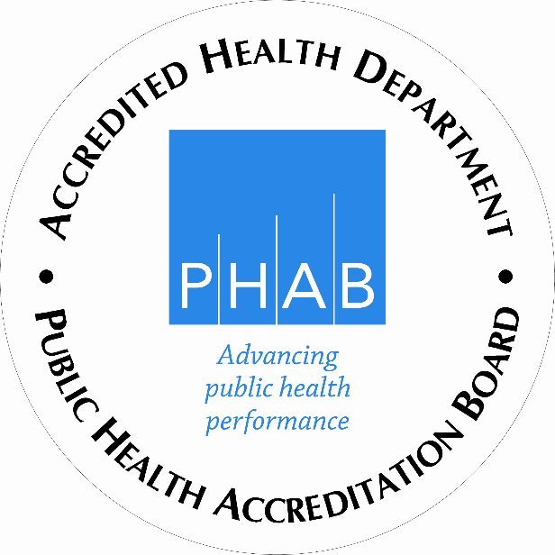

**Public Health Accreditation**

**The First County in the State of New Jersey**

The purpose of the accreditation process is to improve and protect the health of the public by advancing the quality and performance of the Camden County Department of Health. Camden County Health Department achieved accreditation by the Public Health Accreditation Board (PHAB). The national accreditation status sends an important message to our partners and community that our organization meets national standards and provides services in a manner that all residents should come to expect from their health departments. The national standard seeks to advance the quality and performance of all health departments. Our participation in this program indicates our commitment to the continuous improvement of our health department’s services. (U.S. Department of Health & Human Services)

## Quotes from two well-known and respected Public Health Leaders

“*Public health programs help keep disease rates down, which in turn keeps health care costs down.  It’s going to be hard to get the economy healthy again if our workers and our health care system are both sick*.”--**Jeff Levi, PhD, Executive Director of TFAH, 2010.**

*“The financial crisis makes it more important than ever for the country to make prevention a top priority.  Even in these troubled times, prevention is an investment we can count on to deliver a big payoff—sparing millions of people from developing preventable diseases while saving billions in health care costs.”--***Risa Lavizzo-Mourey, MD, MBA President & CEO Robert Wood Johnson Foundation.**

# *Ten Essential Health Services*

______________________________________________________________________________

1. Monitor health status to identify community health problems.
2. Diagnose and investigate health problems in the community.
3. Inform, educate, and empower people regarding health issues.
4. Mobilize community partnerships to identify and solve health

problems.

1. Develop policies and plans that support individual and

community health efforts.

1. Enforce the laws and regulations that protect health and ensure

safety.

1. Link people to needed personal health services and ensure

healthcare when it is otherwise unavailable.

1. Ensure a competent local public health system and a competent

personal healthcare workforce.

1. Evaluate effectiveness, accessibility, and quality of personal and

population-based health services.

1. Research innovative solutions to health problems.

# *Programs and Services provided by Camden County*

# *Department of Health & Human Services*

______________________________________________________________________________

**Office of Mental Health and Addiction**

* Prevention
* Education
* Adolescent/Adult
* Treatment
* Women

**Communicable Disease**

* Disease Field Investigations
* Epidemiology
* HIV/AIDS
* Rabies Control
* Reportable Diseases
* STD Program (Sexually Transmitted Diseases)
* TB Program (Tuberculosis)

**Public Health Nursing**

* 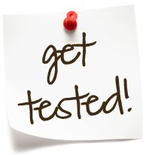Adult Health
* Child Lead Case Management
* Infant and Preschool
* Influenza Immunizations
* Maternal Child Health
* Preventive Screenings
* Special Child Health Case Management

**Health Education Promotion & Disease Prevention**

* Community Health Needs
* Health Education/Risk Communication
* Mobile Health Van/Health Connection-Health Screenings, Counseling, and Education
* Public Health & Community Planning
* Smoking Cessation/Cancer Prevention
* Annual Women’s Health Conference
* Mobilizing Action through Planning and Partnership (MAPP)
* Matter of Balance
* Chronic Disease Self-Management Program
* New Jersey Poison Information Education System

# *Environmental Health Services*

**______________________________________________________________________**

* Retail Food - Hazardous Materials Complaints
* Recreational Bathing - Hazmat Emergency Response
* Body Art - Integrated Pest Management
* Tanning Salons - Pesticide Enforcement
* Public Health Nuisance - Swimming Pool Discharge
* Multiple Dwelling Units - Vapor Recovery
* Pet Shops & Kennels - Idling
* Right-To-Know - Air Quality
* Residential UST - Private Wells
* Noise - Individual Sewage
* Solid Waste Facilities - Public Health Emergency

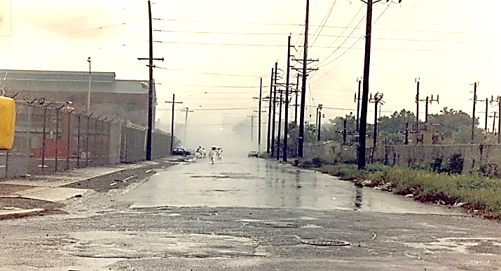

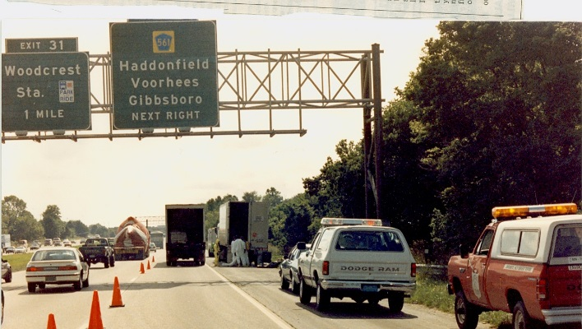

Stabilizing leaking containers in a box truck. Response to a Plastic Chemical

Fire in Camden County

***Office of Mental Health & Addiction***

______________________________________________________________________________________________________

**Office of** **Mental Health & Addiction 2018**

|  |  |
| --- | --- |
| **Office of Mental Health & Addiction** | **2022** |
| SERVICE / ACTIVITY |  |
| Calls to the unit - information / referral | 3100 |
| Addiction Warmline (24-hour, 7 day-a-week) | 89 |
| Prevention/Education Services | 343 |
| Patient Family Education | 228 |
| Treatment Enhancements | 28 |
| Outpatient (including Methadone) | 60 |
| Intensive Outpatient Treatment | 147 |
| Halfway House | 29 |
| Outpatient Counseling Adults | 204 |
| Sub-Acute Detox | 14 |
| Residential Rehab | 12 |
| Transportation | 76 |
| Recovery Supports | 719 |
| Case Management Recovery Support | 350 |
| Medication Assisted Treatment | 52 |
| Sober Living | 451 |
| Certified Peers in Sober Living | 211 |
| Certified Peers in Homeless Shelters | 238 |
| Certified Peers Outreach | 200 |
| Emergency Shelter Placement | 31 |
| Substance Abuse Vocational Education | 93 |
| Recovery Mentor Services | 980 |
| Overdose Reduction Kits (distributed) including fentanyl test strips | 680 |
| Narcan Education/ Training | 160 |
| Narcan Kits | 962 |
| Municipal Alliance Programs Scheduled/Provided** APPROXIMATELY 97 EVENTS |  |
| IDRC- 12 (scheduled) | 1686 |
| IDRC- 48 (attended) | 113 |
| Total Served by County/Grant Funding - Substance Abuse |  |
| Addiction Awareness Task Force Funded Programs |  |
| OPERATION SAL - admission line (as of Dec. 2022) (see above) | 192 |
| Project SAVE Referrals submitted in 2022 (as of Dec. 2022) | 1403 |
| Project SAVE Enrolled via 2022 submitted referrals (as of Dec. 2022) | 630 |
| Post Overdose Grief Support HALO | 19 |
| Events held by the County | 50 |
| REMEMBRANCE AND HOPE MEMORIAL | 1000 |
| Outreach events attended by the county … | 1000 |
| REAL SPORTS** | 960 |
| SOBER SOFTBALL TOURNAMENT | 150 |
| Street Outreach - Community members connected | 2100 |
| Total Residents Served | 18741 |
| MENTAL HEALTH |  |
| Oaks Wrap Around Services Program: | 228 |
| MHASWNJ Boarding Home Residents Socialization Program: | 1398 |
| Oaks Mentally Ill Shelter Services Program: | 105 |
| *OF THESE # referred into treatment | 87 |
| Oaks Payee and Financial Planning Services Program: | 22 |
| Total Served by County Funding – Mental Health | 1713 |
| Total # of Residents Served by Office of Mental Health & Addiction/AATF Funded programs/Activities | 20472 |

**[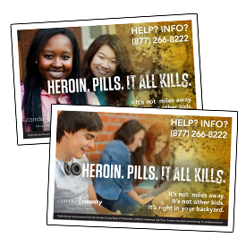](http://addictions.camdencounty.com/wp-content/uploads/2014/10/11x17.png)SERVICE SNAPSHOT**

**Mental Health, Alcohol and Substance Abuse**

* Information and Referral
* Community Substance Abuse Planning
* Education/Prevention
  + Evidenced based education/prevention
  + Student Assistance Counselor services

**Early Intervention**

* In-jail assessments and referral
* Second Chance didactic substance abuse intervention/education

**Treatment and Recovery Supports**

* Withdrawal Management
* Short-term Residential
* Intensive Outpatient
* Outpatient
* Opiate Maintenance
* Recovery Specialists
* Recovery Mentors
* Vocational Support
* Sober Living
* Patient / family substance abuse education
* Boarding Home Socialization
* Wrap-around Services
* Emergency Shelter Placement
* Payee Services
* Intoxicated Driver Resources (12-hour, 48-hour)

***Office of Mental Health & Addiction: 2022 in Review***

At the start of the year, we were still in the middle of Covid19 Pandemic. Vaccinations were ongoing. Every agency subcontracted to provide substance abuse and mental health services was impacted by covid19. The effects began in 2020 and continued through 2022. As a result, we saw exponentially fewer expenditures charged to the county. There are several factors that influenced changes in the utilization of services. All face-to-face services were affected by covid19. Outpatient treatment service utilization decreased. Education and prevention programming was reduced. However, there were other factors that influenced these number reductions. For example, bail reform, legalization of marijuana in NJ, and covid19, impacted referrals into the treatment system.

For safety reasons, subcontracted peers responding to overdoses had difficulty entering emergency rooms.

Overdoses and naloxone administrations decreased. We know because of fentanyl, there was a corresponding increase in fatalities. Additionally, through the year, there was a threat posed by the introduction of xylazine. Xylazine is a horse tranquilizer that is being cut with fentanyl. The effect is this drug is resistant to naloxone and it can cause necrosis. Sadly, while the overdoses decreased, there was a statistically significant increase in the number of overdose related fatalities.

In 2022, we had staffing changes. We secured a full-time purchaser/biller, financial assistance, and we said goodbye to our Municipal Alliance Coordinator but secured a new Municipal Alliance Coordinator. We were able to hire a full-time Assistant Director for the unit.

We have a stronger relationship with Crisis and are working to build upon that. Considering the devastating impact covid19 had on our society, suicides did not increase in the county. In 2022, there were 37 suicides.

We secured three additional grants; 200,000.00 for the mobile van, 150,000.00 for the Public Health & Safety Team (PHAST from CDC Foundation), and 72,971.00 for the Division of Mental Health Addiction Services Leadership Grant (DMHAS) for prevention/education.

We began planning for the utilization of lawsuit settlement funds.

The area where we continued to realize most significant growth was in sober living environments. We created a program to be able to keep clients in sober living environments longer. This assisted in reducing relapses. It also provided clients with a stronger sense of security. There are 50 SLEs in Camden County today.

We began a Street Outreach Program in collaboration with the Camden County Police Department, and two vendors. With Community Events and through the Camden County Addiction Awareness Task Force we launched a fentanyl awareness campaign.

Our grant from the National Association of County and City Health Officials (NACCHO) which covered the cost of 2 Certified Peer Recovery Specialists (CPRS) in two of Camden County’s shelters was ending so we reallocated our Innovation Grant funds to cover the cost of this service.

Our Overdose Fatality Review Team (OFRT) was extended. In the case of the OFRT, we were able to review decedent forty cases in 2022. The grant comes from the NJ Department of Health. The Innovation Grant is awarded by the NJ Division of Mental Health and Addiction Services (October 22 – September 23).

We resumed distributing fentanyl test strips. We have continued to work with Camden County Police and the Camden County Prosecutor’s Office to have outreach events and ensure we are out in public doing what we can to reduce overdoses. We held a successful collaborative walk in May 2023 during Mental Health Awareness Month.

There was one resignation and no retirements on the unit. However, we were able to fund services to approximately 20,454 people including prevention / education, early intervention, treatment and recovery support.

**Via the Addiction Awareness Task Force (AATF), Programs advanced by the AATF included:**

**Project SAVE**

**R.E.A.L. Sports**

**Annual Candlelight Vigil**

**Operation SAL**

**Certified Peer Recovery Specialists Program**

**Annual Recovery Softball Tournament**

**Fentanyl Test Strips, and other programs throughout the year.**

***Mental Health Services*** ***Boarding Home Socialization***

The county secures services to enhance the therapeutic milieu experience for residents of

boarding homes. These services include socialization, outside activities and assist the residents

with mental illness who live in boarding homes to engage and participate in normal everyday

activities.

***Wrap-around Services***

For persons with serious and persistent mental illness the county pays for a comprehensive list of

wrap-around services which may include anything from the purchase of a bed to a security

deposit for an apartment.

***Emergency Shelter Placement***

The county provides emergency funding for up to a week of shelter placement for folks who are homeless with serious and persistent mental illness.

***Payee Services***

The county also offers ‘payee’ services to protect persons with serious and persistent mental illness.

## Childhood Lead Poisoning Program

|  |  |
| --- | --- |
| Lead Case Management Services | 60 |
| Lead Inspections | 0 |
| Lead Screenings | 6 |
|  |  |

## Immunization Program

|  |  |
| --- | --- |
| Child Immunizations | 2229 |
| Adult Immunizations | 304 |
| Influenza Program/County Flu Shots | 1756 |
|  |  |

## South Jersey Regional Chest Clinic (Tuberculosis Program)

|  |  |
| --- | --- |
| TB Clinic Visits | 576 |
| New Cases | 17 |
| Direct Observation Therapy | 2130 |
|  |  |

The Southern Regional Specialty Chest Clinic was initiated in 2008 by Camden County Health Department at the request of New Jersey Department of Health and Senior Services. The program is staffed by both County Health Department and Cooper University Hospital. Cooper University Hospital provides Infectious Diseases Specialists who are well versed in the treatment of Active Tuberculosis of the Lungs and non-pulmonary sites. This group is headed by Henry Fraimow, MD, who is a member of the State TB Medical Advisory Board.

The TB Nurse Case Manager, for Cooper University Hospital, acts as a liaison between the State TB Program, Cooper University Hospital, and the Camden County DHHS. The Case Manager provides nursing assessment, teaching and monitoring of the patient with TB. She also conducts contact investigations, to provide early detection of new TB cases and treatment to exposed clients with latent TB infection. The County Health Department provides additional staffing for nursing and support services. All those seen in the Southern Regional Specialty Chest Clinic benefit from a “one stop shopping” model, as we provide Mobile x-ray services, on site lab technician, Sputum Induction booth, Physician and nursing assessments, and provision of needed medications.

The Regional Clinic provides expert TB Consultation to surrounding counties who may have drug resistant TB or extra-pulmonary TB, or clients who have difficulties during their treatment.

The Regional Clinic provides service to patients and case managers from Atlantic Co., Atlantic City, Gloucester, Burlington, Salem, Cumberland, Ocean, Cape May, Mercer and Middlesex counties, in addition to our own cases here in Camden County. The patients receive their medications daily by DOT, Directly Observed Therapy. In addition, they are monitored closely for medication tolerance and side effects. This enables a thorough treatment plan and ensures that treatment is completed as the Standards of Care require. The TB clinic also provides medical assessment to those new immigrants who have been flagged by the CDC for evaluation once in our country.

***Community Health Services Division***

***Community Health***

* Camden County Health Connection
* Mobilizing Action through Planning
* South Jersey Community Health Needs Assessment Collaborative
* Health Promotion and Disease Prevention Programs

***Southern Region Specialty Chest Clinic***

* Special Child Health Program

***Division of Environmental and Consumer Health Services***

* Emergency Response for Hazardous Materials
* Food Surveillance
* Multiple Dwelling Housing Inspections

***Office of County Health Officer***

* County Bioterrorism Response Program

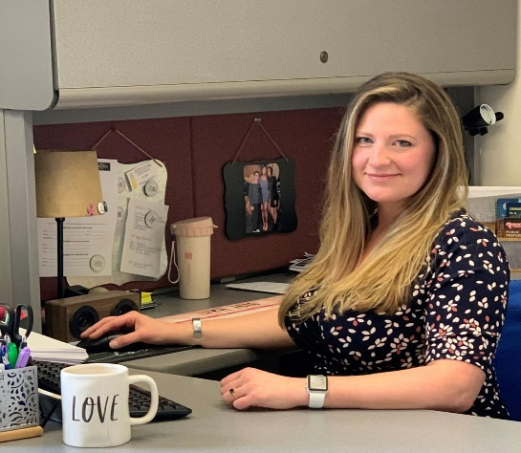****

Camden County Department of Health and Human Services Director, Caryelle Lasher and Camden County Health Officer, Dr. Paschal Nwako

***Health Education Unit***

Camden County Health Connection

The Camden County Health Connection promotes community wellness on site at county workplaces, health fairs, senior centers, public housing complexes, homeless shelters, nutrition sites, shopping centers and community organizations. The Camden County Health Connection is a mobile unit, which enables our Health and Human Services Department to extend the reach and availability of our health screening and disease risk assessment services provided at our health centers. The Camden County Health Connection houses an experienced staff of a registered nurse and health educators to provide a wide range of health-education and lifestyle-management programs that empower children and adults to take control of their health and improve their well-being. The mobile unit enables the Health Department to increase access to health promotion, disease prevention and early detection programs for cancer, heart disease, diabetes and stroke in Camden City and southern Camden County. These services include the following:

• Blood sugar screenings

• Blood pressure screenings

• Cholesterol screenings

• Osteoporosis screenings

• Chronic Disease Management Training programs

• Stroke Risk Assessment Screenings

• Referrals for community health care services

• Health education, support and counseling

• Follow-up health care services

Support groups such as the Chronic Disease Self-Management Program, tobacco treatment and counseling, health seminars and skills-building workshops are also conducted upon request.

These services do not replace regular visits to a primary care physician, but rather emphasize the importance of annual check-ups and help arrange care for people who need them. The overall goal of the Camden County Health Connection is to link this region to needed health services such as health insurance, health care, social services and community health resources. The Camden County Health Connection serves as a health education resource center composed of videos, books, brochures and web-based action-oriented tools to assist residents of all ages in the importance of preventive care.

**Mobilizing for Action through Planning and Partnership: Approach to Public Health in Camden County (MAPP)**

Mobilizing for Action through Planning and Partnership (MAPP) is a community health assessment process developed by the National Association of County and City Health Officials and federal Centers for Disease Control and Prevention (CDC). MAPP is intended to help local public health system entities work collaboratively to assess and improve community health and quality of life. The local public health system includes academic institutions, community nonprofit organizations, foundations, health care institutions and providers, libraries, religious and fraternal organizations, schools, social service agencies and other entities that provide public health services and share information about health issues with community residents.

Camden County Health Department collaborated with hospitals, health systems and health departments within Gloucester, Camden and Burlington counties, to: 1) identify, analyze and address health problems; 2) assess applicable data; 3) develop measurable health objectives and indicators; 4) inventory community health assets and resources; and 5) develop and implement coordinated strategies to improve health. This effort was entitled the Tri-County Community Health Needs Assessment (CHNA) Collaborative. The CHNA is conducted every three years.

Through collaborative efforts, the community health needs assessment built on prior work of the Camden County MAPP Coalition, local health systems, hospitals, Senior Services Division, Environmental Health and Community Health Services Divisions, and community, emergency and public health preparedness partners. The assessment was also conducted to comply with requirements set for the in the Affordable Care Act, as well as to further the health department’s commitment to community health population health management. The CHNA collaborative was built on existing community relationships and developed strategic partners and increased its collaborative approach to community health improvement. In the 2019 CHNA, findings from this community health needs assessment was utilized by the South Jersey Health Collaborative to prioritize public health issues and develop a community health implementation plan focused on meeting the identified community needs. See the current CHNA here: [https://www.camdencounty.com/wp-content/uploads/2022/09/2022-needs-assesment.pdf](https://gcc02.safelinks.protection.outlook.com/?url=https%3A%2F%2Fwww.camdencounty.com%2Fwp-content%2Fuploads%2F2022%2F09%2F2022-needs-assesment.pdf&data=05%7C01%7CCasey.Baker%40camdencounty.com%7Cb5486736f3b04b7b03fe08db50900ce1%7Cb3dba8a792024cd499e53c10de8f99ec%7C0%7C0%7C638192351851210124%7CUnknown%7CTWFpbGZsb3d8eyJWIjoiMC4wLjAwMDAiLCJQIjoiV2luMzIiLCJBTiI6Ik1haWwiLCJXVCI6Mn0%3D%7C3000%7C%7C%7C&sdata=q9uAhVlSf652MM4zXL0kTi0ciVETgRRZ893xFOR79sI%3D&reserved=0)

**Health Education and Promotion Programs**

*Take Control of Your Health: Chronic Disease Self-Management Program*

The Chronic Disease Self-Management Program (CDSMP), developed at Stanford University, is an effective self-management education program for people with chronic health problems or people who take care of others with chronic health problems. In Camden County, the CDSMP is known *as Take Control of Your Health.* New Jersey Department of Health and Senior Services (NJDHSS) provide statewide guidance and oversight for CDSMP. In collaboration with community partners, the Health Department presents a series of workshops, which are given once a week for six weeks, in community settings such as senior centers and housing sites throughout the County. This program, is facilitated by two trained leaders, one or both of whom have chronic diseases themselves. These sessions enables people with chronic illnesses to learn ways to self-manage their condition and take charge of their life.

Topics covered include: 1) techniques to deal with problems such as frustration, fatigue, pain and isolation, 2) appropriate exercise for maintaining and improving strength, flexibility, and endurance, 3) appropriate use of medications, 4) communicating effectively with family, friends, and health professionals, 5) designing and maintaining a healthy eating and exercise plan and 6) learning how to evaluate new treatments. In addition, program participants learn decision-making, action planning, and problem-solving skills. Each participant in the workshop also receives a copy of the companion book, Living a Healthy Life with Chronic Conditions, and an audio relaxation tape, Time for Healing.

**A Matter of Balance: Managing Concerns About Falls**

Many older adults experience a fear of falling. People who develop this fear often limit their activities, which can result in physical weakness, making the risk of falling even greater. A Matter of Balance: Managing Concerns About Falls is a program designed to reduce the fear of falling and increase activity levels among older adults.

A Matter of Balance includes eight two-hour sessions for a small group led by a trained facilitator. This nationally recognized program was developed at Boston University.

During the class, participants learn to:

* View falls as controllable
* Set goals for increasing activity
* Make changes to reduce fall risk at home
* Exercise to increase strength and balance

A Matter of Balance is a program that emphasizes practical strategies to manage falls.

Classes are held 2 times a week for 4 weeks for 2 hours each or 1 time per week for 8 weeks. This program is based on Fear of Falling: A Matter of Balance. Used and adapted by permission of Boston University, **A Matter of Balance has been modified to be facilitated virtually during the pandemic.**

**Other initiatives include:**

**New Jersey Poison Information and Education Program** helps participants identify poisonous substance found in the home as well as help reduce the number of unintentional poisons that occur in the home.

**Move Today,** an exercise program for older adults to improve balance, posture, muscle strength and flexibility.

**QPR Question, Persuade, Refer**

Suicide Prevention Gatekeeper Training which teach professionals and non-professionals alike, using the simple technique of “Question Persuade and Refer”, to recognize the warning signs of a suicide crisis, and how to get the person at risk the assistance they need.

In 2022, Health Education staff held 7 QPR presentations at the following locations:

* Ann Mullen Middle School
* Regan Center Transitional Living
* Rutgers nursing students 2022
* Camden City Service Workers X 2 sessions
* Voorhees School Administration
* Morgan Village

**Screening, Brief Intervention and Referral to Treatment (SBIRT)**

This training provides a comprehensive, integrated, public health approach to the delivery of early intervention and treatment services for persons with substance use disorders, as well as those who are at risk of developing these disorders.

## Food Trust Partnership Camden County Department of Health and Human Services

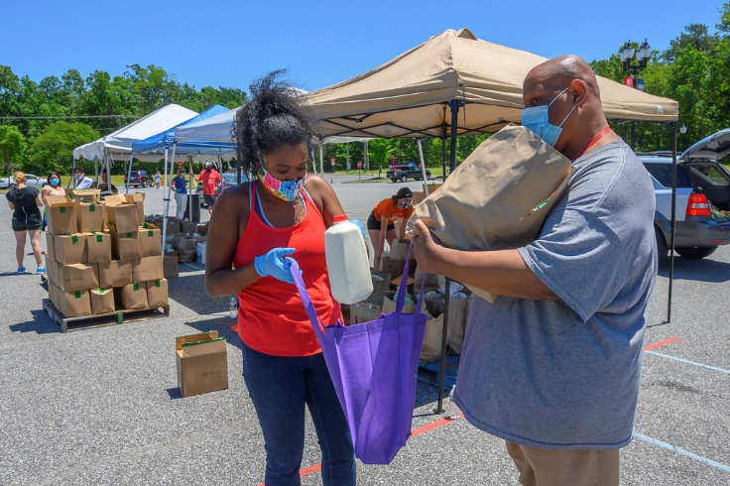The goal of The Food Trust’s Healthy Corner Store Initiative is to expand the sale and marketing of affordable, nutritious food in corner stores in lower-income communities, which often have the lowest access to healthy foods and the highest rates of diet-related disease. The Food Trust and the Camden County Health Education Unit brings valuable health education services and health screenings to Camden City residents. Although services were halted during height of the pandemic, we were finally able to provide health screenings during the ladder part of 2021.

**Total stores participated during 2022:**

* Riverfront Supermarket, 130 Dr. Martin Luther King Drive Blvd, Camden NJ (10)
* Camden Food Market, 700 Pine Street, Camden NJ (10)
* Greatown Deli, 1200 Morton Street, Camden NJ (10)
* Litwins Supermarket, 801 Elm St, Camden NJ (10)
* Juniors Supermarket, 2926 Federal Street, Camden NJ (10)

**Total number of individual participants reached**: 215

**Gender:**

* Female 80
* Male 135

**Age: Range** = 18 -73 years of age

* Black- 92
* White - 28
* Hispanic - 88
* Other - 5
* Blank - 2

**Lack health insurance** - 58.

**Lack a health provider** – 64.

**Community Health Screenings**

|  |  |  |  |  |  |  |
| --- | --- | --- | --- | --- | --- | --- |
| Month | **Blood Pressure** | **Cholesterol** | **Diabetes Fasting Blood Sugar** | **Health Education Counseling** | **Lung Age**  **Test & Counseling** | **Body Mass**  **Index** |
| **Jan** | 0 | 0 | 0 | 0 | 0 | 0 |
| **Feb** | 0 | 0 | 0 | 0 | 0 | 0 |
| **Mar** | 21 | 5 | 0 | 21 | 0 | 21 |
| **April** | 18 | 6 | 0 | 18 | 0 | 18 |
| **May** | 21 | 4 | 0 | 21 | 0 | 21 |
| **June** | 35 | 7 | 1 | 35 | 0 | 35 |
| **July** | 19 | 6 | 2 | 19 | 0 | 19 |
| **August** | 24 | 8 | 0 | 24 | 0 | 24 |
| **Sept** | 30 | 2 | 0 | 30 | 0 | 30 |
| **Oct** | 30 | 0 | 0 | 30 | 0 | 30 |
| **Nov** | 7 | 0 | 0 | 7 | 0 | 7 |
| **Dec** | 10 | 0 | 0 | 10 | 0 | 10 |
| **Totals**  **2022** | **215** | **38** | **3** | **215** | **0** | **215** |
| **Referrals** | **49** | **0** | **2** | **0** | **0** | **20** |

**Health Education Topics # of persons who received education and counseling**

* Nutrition 215
* Diabetes Risk Assessment 215
* Weight Management 215
* Exercise 155
* Cholesterol 135
* Hypertension 135
* Stress management 98
* Tobacco 98
* Substance Use Disorders 69
* Medication Management 69
* Access to Care 198
* Cancer Risk and Screenings 215

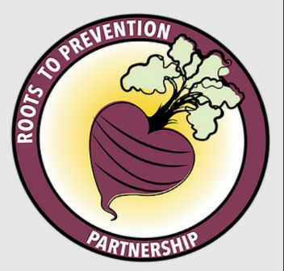As a core partner of Roots to Prevention (RTP), Camden County’s Health Education team helps guide RTP’s main goal of increasing access to fresh fruits and vegetables, which contribute to health and wellness, and create new income opportunities through urban farming, by providing health education materials and resources necessary for those to succeed. Camden County’s Health education team also continues to incorporate COVID-19 education and emergency preparedness topics as it relates to food and stocking certain foods during a pandemic. RTP is a collaboration of residents, nonprofits, farmers, and public health organizations.

During 2022, Camden County’s Health Education team partnered with iCreate, Roots to prevention, and Camden City families to film nutritionally smart cooking shows right here on campus in our Sustainability Building kitchen! Monday, August 29th was our first film produced for the TeaSpoon of Love Cookbook challenge. Since then, we have filmed 4 days, (October, November, December, January-) each day consisting of about 7 chefs! The food items were donated by Roots to Prevention/PBCIP. Our health education team provided nutrition education and explained the benefits of eating well balanced, healthy meals. The cooking shows were filmed and edited by Camden’s own, iCreate. iCreate is a film production company that is dedicated to helping early-stage startups to large enterprises succeed in the digital world. iCreate is consistent in producing one-of-a-kind quality content with outstanding visual techniques.

***COVID-19 Hotline***

In January 2022 there were 1460 calls in the month of January and continued to decline over 2022. There were 349 calls in December to the Hotline. Although the numbers of using the COVID and Information Hotline have diminished, it still serves as an information portal that is vital to Camden County residents to receive up to date information regarding COVID vaccine availability and site information. Parents, who were having difficulty in finding a site that would administer COVID vaccines to children 6 months to 3-year-olds, were able to call the Hotline to receive information that the Camden County Health Hub was open for the younger children and walk-ins were welcome.

In addition, the Hotline provided information on flu shots, child and adult immunizations and other services and was a gateway to connect the community to Camden County programs. The Camden County Homebound Vaccine Program continues to provide COVID vaccines utilizing the Hotline for individuals to register. The Camden County COVID-19 Health Hub and the Hotline Staff worked closely together to assure the residents were able to make and change appointments as necessary.

The COVID Hotline’s goal is to promptly respond to the callers, by monitoring not only the live call center itself, but also voicemails in a timely manner. The functioning of the Hotline is monitored on a regular basis with IT, to fix any caller issues, to ensure user satisfaction and maintain accurate information when COVID Hub information changes.

## *Health Promotion Initiatives in Tobacco Control*

Reviewed: 12/9/2022

The mission of the Camden County Tobacco Control Unit is to eradicate tobacco use as a major public health problem by eliminating exposure to environmental tobacco smoke and preventing the onset of tobacco use through community mobilization advocacy, and education, enforcement and public policy development for the community and workplace while supporting smokers who want to quit with cessation services and resource information.

In 2022, Camden County Department Health initiated the Tobacco Free Signage Campaign to Municipalities. New Jersey Prevention Network (NJPN) supplied updated Tobacco Free Signsthat include the Smoke Free Air Act Law 26: D-55, which designates Parks and Beaches Smoke-free from tobacco smoke, cannabis, and vaping. Through this successful campaign, five hundred signs were distributed to municipalities throughout Camden County.

**The Tobacco Control Unit covers the following:**

* **Adult and Youth Tobacco Education and Resources:**

The Unit identifies tobacco control issues or opportunities by providing education, solutions and resources including quit information, to individuals, municipalities and schools, colleges, and workplaces.

* **Tobacco Complaints and Compliance**

The Unit works along with Environmental Health Housing Complaints, in the investigation and follow-up of tobacco control complaints. After gathering information from the complainant to identify any possible violations, the Environmental Health Housing and Tobacco Control unit develop a plan which can include, possible onsite inspections, follow-up with to housing management and housing ownership on compliance and resolution of the complaint.

* **Collaboration with Regional Partners**

The Health Department has a strong, unique, and reciprocal partnership with New Jersey Prevention Network/Tobacco Free for a Healthy New Jersey on tobacco control issues in Camden County. This includes our membership in their statewide New Jersey Strategic Advisory Group on Tobacco serving both the Communication and Health Equity Workgroups whose priorities.

include the promotion of point-of-sale policies, smoke free multi-unit housing, tobacco free worksites, tobacco free college campuses, youth tobacco and vaping use prevention and smoke free outdoor ordinances.

* **Municipal Smoke Free Ordinances**

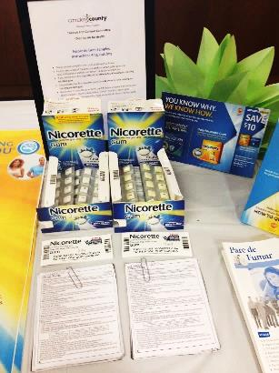The Tobacco Control educates the municipalities on the adoption of smoke free/ tobacco free ordinances and programs that can be adopted on the local level, such as: ordinance instituting 100% smoke and/or tobacco-free outdoor spaces, a point-of-sale ordinance,smoke-free housing ordinance. Towns are encouraged to support tobacco-free businesses and instituting a youth tobacco/vaping education and outreach program.

**Collaboration with Regional Partners**

* The Health Department collaborates with (NJPN) New Jersey Prevention Network and Tobacco Free for a Healthy New Jersey (TFHNJ) Collaborative in the southern region on several tobacco control initiatives. We work hand-in- hand with TFHNJ Southern Regional Coordinators in local identification of tobacco control issues or opportunities by providing education, solutions and resources to individuals, municipalities and schools, colleges, and workplaces.

Quit Survival Kits, and Nicotine Replacement Therapy information for Camden County employees.

* The community initiatives include Tobacco Product Point of Sale, Tobacco-Free Worksites, Smoke-Free Housing Tobacco -Free Campus, Merchant Education and Youth.

***Special Child Health Case Management Unit***

|  |  |
| --- | --- |
| Average active caseload | 1025 |
| Unduplicated number of children served | 3560 |
| New referrals | 1706 |
| New SSI referrals | 1010 |
|  |  |
| **Grant Year Camden County Constituents Catastrophic Award** | **116,185.00** |

The Special Child Health program is County based and provides Case Management.  The Unit is funded in part through the New Jersey Department of Health and the Camden County Board of Commissioner’s. Services are provided regardless of financial status. The Special Child Health Case Management Program assists families with children who have developmental delays and health needs. Any child through the age of 21 who has a birth defect, a serious illness, has difficulty walking, talking, and understanding or is at risk of developing a disabling condition,

is eligible for services.

Case managers work with both children and their parents. These professionals assist families through the maze of the health services system and other related systems for the purpose of meeting individual needs. Specifically, the case managers assist with obtaining hearing aids and orthotics; payment of catastrophic bills; support groups; home nursing care; education and other needs.

**NJ Birth Defects History and Purpose**

The Registry is a comprehensive, confidential database that provides data that can be used for epidemiological and statistical purposes for children with specific birth defects.  New Jersey legislation, NJSA 26:8-40.2 mandates reporting to the Registry all children diagnosed with a birth defect from birth through five years of age.  The Registry was upgraded from paper to a state-of-the-art electronic system in 2009, allowing the entities mandated to report conditions an improved and expedited process of registering and referring infants and children.

Once a child is registered, a copy of the registration is sent to the Special Child Health Services Case Management Unit in the child’s county of residence to promote access to preventive and primary care for Children and Youth with Special Health Care Needs (CYSHCN).

**Early Hearing Detection and Intervention (EHDI)**

EHDI is a national public health initiative that supports the '1-3-6' Guidelines: screening every newborn for hearing loss prior to **one** month of age, completing diagnostic audiologic evaluation prior to **three** months of age for infants that do not pass their hearing screening, and early intervention enrollment by no later than **six** months of age for children diagnosed with hearing loss. In 2002, New Jersey passed a law requiring hearing screening for all newborns.  The New Jersey EHDI program offers technical support to hospitals on their newborn hearing screening and follow-up programs.  New Jersey EHDI tracks the number of infants screened and how many children are identified with hearing loss in a timely manner. New Jersey EHDI works with health care providers, local and state agencies that serve children with hearing loss, and families to ensure that infants and toddlers receive timely hearing screening and diagnostic testing, appropriate habilitation services, and enrollment in intervention programs designed to meet the needs of children with newly identified hearing loss. Special Child Health Case Management Unit is a key communicator between and among diagnosticians, family, Early Intervention and State.

**Newborn Bloodspot Screening**

[New Jersey law](https://www.njleg.state.nj.us/2016/Bills/S1500/1283_I1.PDF) requires that every baby born in New Jersey be screened for disorders that can cause serious health problems. All babies born in New Jersey are required to be tested for sixty (60) disorders within 48 hours of birth. One heel prick provides enough blood to test for all fifty-nine disorders.

Newborn bloodspot screening is a comprehensive program that includes laboratory testing, follow-up of results, and if necessary, examination and treatment by a qualified specialist. Early detection and treatment of the disorders on the newborn screening panel can prevent lifelong disabilities, including intellectual and developmental disabilities, and life-threatening infections. Any child testing positive is referred to the Special Child health Case Management Unit for follow up and support.

[New Jersey to Begin Newborn Screening for Spinal Muscular Atrophy (SMA) on January 31, 2022](https://www.nj.gov/health/fhs/nbs/documents/letter%20to%20physicians_SMA_Jan2022.pdf)

**Screening for CCHD in New Jersey** New Jersey was one of the first states to require CCHD screening in newborns.  Beginning August 31, 2011, birthing hospitals in New Jersey need to screen newborns for CCHD before discharge to home. Serious problems can be prevented or addressed if CCHD is found shortly after birth. These children are referred to Special Child Health Case Management Unit.

**Autism Registry** The primary purpose of the Autism Registry is to link families to special child health case management services, which are county based coordinated service providers that have many years of experience and knowledge of local, county, and statewide resources available to families of children with special health care needs. Most recently (2021) Autism New Jersey formed a partnership with the NJ Department of Health’s Special Child Health Services (SCHS) Case Management Units (CMU) as the designated Autism Resource Specialist.

## 

## *2022 Annual Local Boards of Health Summit*

**Role of a Local Board of Health?**

In New Jersey, by law, every municipality is charged with establishing a local board of Health which is responsible for ensuring the development and implementation of public health policy and programs in the community.

**2022 Local Boards of Health Summit:**

The Camden County Department of Health and Human Services and the Camden County Board of Commissioners invited members of the Local Boards of Health, Green Teams, Planning Boards and other community representatives to attend the Camden County Local Boards of Health held at the Camden County Boat House at Cooper River on November 21, 2022. This year’s presentation was entitled, “Making it Better Together”: Comprehensive Approaches to Public Health for Better Community Outcomes”.

The guest speaker, Paul David Roman, NJ Local Boards of Health President, addressed the towns on the importance of advocating for the Legislature to restore Public Health Priority Funding (PHPF) to at least 10 million dollars. If PHPF funding is reenacted as part of the proposed budget, the State would be able to provide direct funding to all local health departments to support local public health programs on the municipal level.

The Environmental Health Services Housing Unit presented a new initiative which bridges the gap between the enforcing agencies, tenants, and landlords with a comprehensive approach to services. It was evident, while answering complaints, that constituents and landlords were asking about other health resources, not knowing where to go and who to contact. To address this need, inspectors, when investigating the complaint, would also connect the person/family to Health Department resources such as Mental Health and Addiction, Special Child Services, Senior and Disabled Services, Communicable Disease and more, guiding them to where they can get the help. The Environmental Health and Food Inspection Unit gave an overview on the New Jersey Department of Community Affairs (DCA) 2021 Lead Based Paint Hazard Law and the Lead-Based Paint Inspections in Rental Dwelling Units Programs and its requirements for the municipalities and landlords.

The Health Department presented the 2021 Annual Report and County Health Rankings. This year, The South Jersey Health Collaborative comprised of Cooper University Health Care, Jefferson Health, and Virtua Health along with Burlington, Camden and Gloucester Health Departments, conducted the 2022-2025 Community Health Needs Assessment (CHNA). Like past assessments, the four main areas of need are Chronic Disease, Behavioral Health and Maternal and Child Health. Planning efforts will focus on social determinants of health as it is a primary approach to achieving health equity.

## *Public Health Emergency Preparedness Program*

The Camden County Public Health Emergency Preparedness Unit has been in existence for over 20 years. Currently the program is led by our Public Health Emergency Notification Systems Coordinator (PHENS) and includes a Health Education/Risk communicator (HERC), Medical Reserve Corps (MRC) Coordinator, and more recently a COVID Generalist, COVID Social Support Coordinator, COVID Epidemiologist, and COVID Coordinator. The purpose of the program is to ensure immediate and adequate response to any acts or threats of bioterrorism, infectious disease outbreak, and other public health threats or emergencies. On a scheduled basis the Unit acts to keep response plans up to date, provides education and ongoing training to all department staff, and uses response drills to improve timeliness and evaluate our proficiency. Planning, training, and exercising for an all-hazards approach allows us to prepare for a wide range of emergencies. Response drills exercise various aspects of our work which include, but not limited to monitoring disease patterns, communicating risk, providing information to contain the spread of disease, prophylaxis for at risk persons using oral medications or immunizations, receiving and distributing supplies and medicines to our medical community and partners. Partners include County Emergency Management, local Hospitals, County Prosecutor’s Office, County Office of Education, and Regional County Health Departments along with several others. For 2021, the Unit was crucial in COVID-19 vaccination planning and preparedness.

## *Camden County Medical Reserve Corps*

Our Medical Reserve Corps (MRC) of approximately 331 volunteers receives regular training on topics such as family preparedness; Personal Protective Equipment (PPE); Pet Disaster Preparedness; Question, Persuade, Refer (QPR); Incident Command System (ICS); Hurricane Preparedness; Fixed Facilities; Psychological First Aid, Compassion Fatigue; Self Care; Human Trafficking; Mass Dispensing; Vaccine Safety and Handling; and “You are the Help Until Help Arrives.”

The goals and objectives of the MRC are to have all volunteers current with documentations and core trainings; focus on volunteer retention and volunteer engagement; introduce and implement new volunteer recruitment methods; and seek new funding opportunities to sustain and grow the MRC unit. The mission of the Camden County MRC is to provide a cadre of both professional and community volunteers to assist the county in times of a public health crisis. For 2021, the MRC helped in many aspects of the COVID-19 pandemic response. We had over 100 volunteers dedicate over 4,888 hours of help. Not only did they help the Camden County Department of Health and Human Services’ vaccination site at Camden County College, but for other sites within the county as well including Rowan School of Osteopathic Medicine, Cooper University Hospital, and other partners. Volunteers were not only vaccinators, but they also helped fill other needed roles such as greeters, ushers, and observers after people received their vaccination.

Below is a breakdown of some of the volunteers we have on board…

| **Volunteer Type** | **Count** |
| --- | --- |
| Acupuncturist | 1 |
| Advanced Practice Nurse | 16 |
| Laboratory Director | 1 |
| Dentists | 6 |
| Doctor of Osteopathy | 6 |
| EMTs | 2 |
| LPNs | 7 |
| Medical Doctor | 28 |
| Pharmacist | 10 |
| Physician Assistants | 5 |
| Podiatrist | 1 |
| Registered Nurse | 120 |
| Veterinarian | 2 |
| Non- Public Health/Non-Medical | 126 |

## Communicable Disease Prevention and Control

The Communicable Disease Unit offers services to prevent the spread of disease. There are specific programs dealing with AIDS/HIV, Tuberculosis Control, Sexually Transmitted Diseases, Rabies Control, and Reportable Diseases.

**Hepatitis A**

Beginning in 2019 New Jersey experienced increased cases of hepatitis A leading to the declaration of a statewide outbreak. While cases declined and the outbreak was declared over in June 2021, we have again seen increasing cases caused by the hepatitis A virus (HAV) beginning in September 2021.

* Camden County held 10 Hepatitis A post-exposure prophylaxis (PEP) clinics vaccinating 800 individuals

**Disease Investigation**

Communicable Disease epidemiology is a cornerstone of public health practice to prevent illness and protect the public’s health. The Camden County Department of Health and Human Services’ Communicable Disease program is responsible for county-wide surveillance and investigation of more than 70 disease conditions reportable to public health by laboratories, health care providers and facilities. Reports of communicable disease are investigated and tracked to identify outbreaks or trends that require public health action or community education. Investigations aim to identify the source of infection so public health control measures can be implemented to prevent further disease spread. The data collected through our investigations about the local burden of disease, risk factors, and disease trends is used to develop appropriate education, guidance, and infection control recommendations to be shared with our residents, health care providers, schools and community partners.

**AIDS/HIV** **Program**

Free and anonymous/confidential HIV counseling and testing is offered at both of our two Health Clinics. HIV Counselors provide risk reduction education and referrals to PrEP services.

**Sexual Health Clinics**

The Camden County Sexual Health Clinics provide free and confidential testing and treatment of all sexually transmitted infections. Last year we provided sexual health services to nearly 1,000 residents. Clinic staff work alongside Health Educators to provide sexual health education and promotion presentations for health care providers, community organizations, and health fairs.

**Rabies Control**

Rabies is a deadly disease caused by a virus found in the saliva of a rabid animal. Rabies infection can occur when infected saliva from a rabid animal contaminates a bite or open wound, a scratch, or a mucous membrane. There is no known effective treatment for human rabies once symptoms develop, but rabies can be prevented if rabies post exposure prophylaxis is given shortly after exposure. Communicable Disease staff work closely with local Animal Control Officers to investigate domestic and wild animal bites, coordinate rabies testing, and provide technical assistance to residents, veterinarians, physicians, and municipal officials.

The Camden County Department of Health and Human Services provides rabies vaccine to support 35 rabies vaccination clinics throughout the county.

## *Communicable Disease and Surveillance*

***Reports from Laboratories, Hospitals, Medical Providers, Public Health. Counts include Confirmed, Probable and Possible cases as defined by the New Jersey Department of Health Communicable Disease Service***

|  |  |
| --- | --- |
| **DISEASE NAME** | **Counts** |
| ALPHA-GAL SYNDROME | 125 |
| AMOEBIASIS | 2 |
| BABESIOSIS | 37 |
| BORRELIA MIYAMOTOI | 0 |
| BOTULISM - INFANT | 0 |
| BRUCELLOSIS | 0 |
| CAMPYLOBACTERIOSIS | 84 |
| CHLAMYDIA TRACHOMATIS INFECTION 200 | 3,324 |
| CHOLERA - NON O1/O139 | 0 |
| CHOLERA - O1 | 0 |
| CREUTZFELDT-JAKOB DISEASE | 0 |
| CRYPTOSPORIDIOSIS | 10 |
| CYCLOSPORIASIS | 0 |
| DENGUE FEVER - DENGUE | 1 |
| EASTERN EQUINE ENCEPHALITIS(EEE) | 0 |
| EHRLICHIOSIS/ANAPLASMOSIS - ANAPLASMA PHAGOCYTOPHILUM (PREVIOUSLY HGE) | 7 |
| EHRLICHIOSIS/ANAPLASMOSIS - EHRLICHIA CHAFFEENSIS (PREVIOUSLY HME) | 17 |
| EHRLICHIOSIS/ANAPLASMOSIS - EHRLICHIA EWINGII | 0 |
| FOODBORNE INTOXICATIONS - CIGUATERA | 0 |
| FOODBORNE INTOXICATIONS - MUSHROOM POISONING | 0 |
| FOODBORNE INTOXICATIONS - SCOMBROID | 0 |
| GIARDIASIS | 15 |
| GONORRHEA | 1,295 |
| GONORRHEA - UNCOMPLICATED 300 | 2 |
| HAEMOPHILUS INFLUENZAE | 14 |
| HEPATITIS A | 22 |
| HEPATITIS B | 82 |
| HEPATITIS B - ACUTE | 12 |
| HEPATITIS B - CHRONIC | 102 |
| HEPATITIS B - PERINATAL | 15 |
| HEPATITIS C | 93 |
| HEPATITIS C - ACUTE | 5 |
| HEPATITIS C - CHRONIC | 515 |
| HEPATITIS C - PERINATAL | 0 |
| INFLUENZA, HUMAN ISOLATES - TYPE 2009 H1N1 | 29 |
| INFLUENZA, HUMAN ISOLATES - TYPE A (SUBTYPING NOT DONE) | 8154 |
| INFLUENZA, HUMAN ISOLATES - TYPE A H1 | 0 |
| INFLUENZA, HUMAN ISOLATES - TYPE A H3 | 118 |
| INFLUENZA, HUMAN ISOLATES - TYPE B | 0 |
| LEGIONELLOSIS | 34 |
| LEPROSY (HANSEN DISEASE) | 0 |
| LISTERIOSIS | 0 |
| LYME DISEASE | 396 |
| MALARIA | 16 |
| MONKEYPOX | 43 |
| MULTISYSTEM INFLAMMATORY SYNDROME (MIS) | 0 |
| MEASLES | 0 |
| MENINGOCOCCAL DISEASE (NEISSERIA MENINGITIDIS) | 0 |
| MUMPS | 0 |
| NOVEL CORONAVIRUS - 2019 NCOV | 57438 |
| PERTUSSIS | 2 |
| POWASSAN | 0 |
| SALMONELLOSIS - NON TYPHOID | 62 |
| SALMONELLOSIS - PARATYPHOID FEVER | 0 |
| SALMONELLOSIS - TYPHOID FEVER | 0 |
| SHIGA TOXIN-PRODUCING E.COLI (STEC) | 12 |
| SHIGA TOXIN-PRODUCING E.COLI (STEC) - NON O157:H7 | 0 |
| SHIGA TOXIN-PRODUCING E.COLI (STEC) - O157:H7 | 1 |
| SHIGELLOSIS | 29 |
| SPOTTED FEVER GROUP RICKETTSIOSIS | 11 |
| STD OTHER - PARTNER SERVICES | 112 |
| STREPTOCOCCUS AGALACTIAE (GBS) | 3 |
| STREPTOCOCCUS PNEUMONIAE | 55 |
| STREPTOCOCCUS PYOGENES (GAS) | 3 |
| STREPTOCOCCUS PYOGENES (GAS) - WITH TOXIC SHOCK SYNDROME | 0 |
| STREPTOCOCCUS PYOGENES (GAS) - WITHOUT TOXIC SHOCK SYNDROME | 59 |
| SYPHILIS - CONGENITAL 790 | 9 |
| SYPHILIS - PRIMARY 710 | 40 |
| SYPHILIS - SECONDARY 720 | 97 |
| SYPHILIS -ALL OTHER STAGES | 203 |
| TULAREMIA | 0 |
| VANCOMYCIN-INTERMEDIATE STAPHYLOCOCCUS AUREUS (VISA) | 0 |
| VARICELLA | 11 |
| VIBRIO INFECTIONS (OTHER THAN V.CHOLERAE SPP.) | 1 |
| WEST NILE VIRUS (WNV) | 3 |
| YERSINIOSIS | 5 |
| ZIKA VIRUS - INFECTION, NON-CONGENITAL | 0 |
| **TOTAL** | **72725** |

# Division of Environmental Health and Consumer Health Services

## Emergency Response (Hazardous Materials)

## *County Environmental Health Act (CEHA)*

Camden County Department of Health is certified by NJDEP to perform investigation, enforcement, and regulation of air pollution, solid waste disposal, recycling enforcement, emergency, and terrorism response, hazardous waste storage and disposal, underground storage tanks, surface and ground water pollution, and noise. In addition to directly providing these services, Camden County coordinates Hazardous Materials Emergency Response services through inter-local agreements with five local fire/hazmat units.

Camden County’s Hazardous Materials Response Unit is responsible for development and maintenance of standardized hazardous materials (*Hazmat*) and CBRNE (*Chemical, Biological, Radiological, Nuclear, and Explosive*) emergency response capability, capacity, and competence. Camden County Department of Health and Human Services has highly trained and equipped personnel that respond to Hazmat and CBRNE emergencies and conduct environmental investigations in coordination with the N J Department of Environmental Protection (*NJDEP*), the NJ Department of Health and Senior Services (*NJDHSS*), and the N J State Police (*NJSP*) Special Operations Section.

The Hazardous Materials Response Unit provides exceptional hazardous materials and environmental response services to the citizens of Camden County. The unit handles a broad range of complaints each year from private citizens, business interests, industrial facilities, and other public agencies. They vary in nature from small residential spills of household chemicals and heating oil to large-scale industrial spills, fires, illegal dumping and over the road accidents involving cargo spills or releases of motor vehicle fluids. Our hazmat unit is available to respond to any Hazmat/CBRNE incident in Camden County on a 24 hour per day /365 day per year.

The Hazmat Unit continues to be involved in domestic preparedness planning for the county. The Unit Director regularly participates in planning meetings with Camden County OEM. Based on planning initiatives, response protocols may be revised to improve our response capabilities. Coordination with the county OEM and Fire Marshall has resulted in an integrated network of primary and secondary departments for mutual aid including Hazmat/CBRNE response and mass decontamination.

Inspection totals for 2022 CEHA – 1,161

## CEHA Unit Septic and Well

All individual sewage disposal system plan review, installation, repair, and compliance certificate are accomplished by our Septic and Well section. This group also is responsible for the review of private potable wells results & Private Well Testing Act information distribution. Recently our staff has begun a thorough evaluation of Public Non-community water systems within our County to ensure the proper compliance with Federal and State Regulations.

**SEPTIC SYSTEMS:**

* New Constructions – 5
* Repairs – 25
* Alternation Without Expansions – 155

**WELL SYSTEMS:**

* Inspections – 85

**Food Surveillance**

The Food Surveillance Unit’s purpose is the prevention of food borne illness which may derive from retail food establishments. To deliver this purpose this unit focuses its inspection efforts to facilities that may present a greater risk of food borne illness. This approach and enforcement of NJAC 8:24 are known as Risk-Based Inspection. Retail establishments must be inspected as least once during each year, school facilities are inspected twice each year. Additionally, a 24/7 Non-Hazardous Emergency Response system is in place to respond to fire and/or natural disasters involving food and/or health care facilities where a potential for contamination of food products exists. Annually retail food inspections are performed utilizing tablet computers. Inspection findings are captured and recorded during the course of each inspection and uploaded in real-time to our web-based inspection system.**

*Benefits of Digital Inspections*

* Increased Productivity and Accountability.
* Electronic Record Management and Access.
* Provides Public Records Request (OPRA).
* Standardized Inspection Methods and Reporting.
* Improved Compliance.
* Reduction in Enforcement Actions.

Constituent Benefits

* Educates consumer on inspection process and outcomes.
* Reports inspection results on facilities of consumer interest i.e. child’s day care or school, local market, favorite restaurant, etc.
* Reports on emerging food related events i.e. food related bioterrorism, food recalls, facility closures, and food related outbreaks.

Industry Benefits

* Standardized inspection format easy to read, interpret, and translate.
* Critical violations are printed first with timelines for correction.
* Establishment with a good inspection history will see increased business.

## 

## Multiple Dwelling Housing Inspections

State Local Cooperative Housing Inspection Program (SLCHIP)

The Camden County Health Department’s Multiple Dwelling Housing Unit is an authorized agent of the NJ Department of Community Affairs Bureau of Housing Inspections. As an authorized agent the Unit is responsible for ensuring that hotels, motels and multiple-family buildings of three or more dwelling units operating within Camden County are properly maintained and do not pose a threat to the health, safety and welfare of their residents, nor the community in general.

These objectives are achieved by licensed multiple dwelling inspectors conducting five year cyclical and compliance inspections of all hotels, motels and multiple dwellings. Condominiums, Cooperatives and Mutual Housing Corporations fall within the definition of multiple dwelling, and as such, are subject to its provisions.

In addition to the Environmental Programs highlighted above the following services are also provided: *Air Pollution Control, Community Noise Control, Pet Shop & Kennel Inspections, Public Health Nuisance Complaints, Right To Know (RTK), Public Recreational Bathing & Youth Camps, Residential Underground Storage Tank, Pesticide Investigation, Solid Waste Program, Tobacco Enforcement, Body Art, and Water Quality.*

**Environmental Health Inspections**

|  |  |  |  |  |
| --- | --- | --- | --- | --- |
| Retail Food | 3,596 |  | Hazardous Materials Complaints | 32 |
| Recreational Bathing | 366 |  | Hazmat Emergency Response | 71 |
| Body Art | 58 |  | Integrated Pest Management | 20 |
| Tanning Salons | 11 |  | Pesticide Enforcement | 50 |
| Tobacco/Vapor Retail Establishment | 10 |  | Youth Camp Pre-Operational Inspection | 22 |
| Public Health Nuisance | 1,464 |  | Swimming Pool Discharge |  |
| Multiple Dwelling Units | 273 |  | Vapor Recovery |  |
| Pet Shops & Kennels | 95 |  |
| Right-To-Know | 290 |  | Air Quality | 10 |
| Residential UST | 88 |  | Private Wells | 85 |
| Noise |  |  | Individual Sewage | 185 |
| Solid Waste Facilities |  |  | Regulated Tanks |  |

**Housing**

**DCA Housing Unit**

**\*Discontinued Department of Community Affairs Inspections June 2022**

**Total Inspections 273**

**Total Complaints Responses: 1,464.**

Contact Information

### Camden County Department of Health and Human Services

**Caryelle Lasher, MPH, REHS, HO, Director**

Office: 856-374-5124

Fax: 856-374-6358

[caryelle.lasher@camdencounty.com](mailto:caryelle.lasher@camdencounty.com)

### Camden County Health Officer

**Dr. Paschal Nwako, MPH, CHES®, REHS, DAAS**

856-374-6032

Fax: 856-374-6358

[paschal.nwako@camdencounty.com](mailto:paschal.nwako@camdencounty.com)

### Communicable Disease Unit

**Rianna DeLuca, BS, Director**

**Office of Administrative Services and**

**Community Health Services**

Office: 856-374-6051

Fax: 856-374-6358

[rianna.deluca@camdencounty.com](mailto:rianna.deluca@camdencounty.com)

### Environmental CEHA, Hazmat & Water Unit

**Christopher Costa, REHS, Supervisor Environmental Health Specialist**

**Camden County Department of Public Safety/Right to Know Coordinator**

Charles J. DePalma Complex, 2311 Egg Harbor Road, Lindenwold, NJ 08021

Office: (856) 783-4808 ext. 6001

Fax: (856) 603-4206

Cell: (609) 685-5258

[christopher.costa@camdencounty.com](mailto:christopher.costa@camdencounty.com)

### Public Health Emergency Preparedness

**Daniela Fumu, BS, CHES ® Public Health Emergency Notification System**

**Medical Reserve Core Coordinator**

856-374-6141

[daniela.fumu@camdencounty.com](mailto:daniela.fumu@camdencounty.com)

**Casey Baker, Health Educator/Risk Communicator**

856-374-2689

[casey.baker@camdencounty.com](mailto:casey.baker@camdencounty.com)

**Gabrielle Sweeney, MPH**

**COVID 19 Data Manager/Epidemiologist**

856-374-6015

[gabrielle.sweeney@camdencounty.com](mailto:lisa.mack@camdencounty.com)

**Kyisha Lingo, BS, DCA, REHS**

**Housing Supervisor**

856-374-6060

Kyisha.Lingo@camdencounty.com

**Joanna Barron, REHS**

**Registered Environmental Health Specialist**

856-374-6052

Joanna.barron@camdencounty.com

### Office of Mental Health & Addiction

### John D. Pellicane, MBA, Director

Office: 856-374-6320

Fax: 856-374-6381

[john.pellicane@camdencounty.com](mailto:john.pellicane@camdencounty.com)

### Health Education Unit

**Koren Norwood, MS, CHES ® Director**

Office: 856-374-6035

Fax: 374-6358

[koren.norwood@camdencounty.com](mailto:koren.norwood@camdencounty.com)

### Lynn Rosner, M.Ed., CTTS

Health Education Unit, Certified Tobacco Treatment Specialist

856-374-6363

[lynn.rosner@camdencounty.com](mailto:lynn.rosner@camdencounty.com)

### Public Health Nursing

**Claudia Whitcraft, RN, MSN, Director**

Office: 856-382-2694

Fax: 856-382-6034

[claudia.whitcraft@camdencounty.com](mailto:claudia.whitcraft@camdencounty.com)

### Camden County Clinic Services

**Bellmawr Regional Health Center**

35 Browning Road

Bellmawr, NJ 08031

Office: 856-931-2700

Fax: 856-9316970

