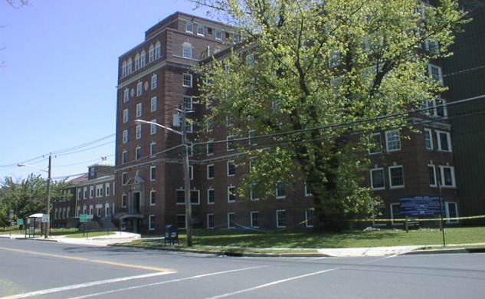
ANNUAL REPORT

2020

CAMDEN COUNTY DEPARTMENT OF HEALTH AND HUMAN SERVICES

Community Health Services
Environmental and Consumer Health Services
Public Health Emergency Preparedness

DiPiero Building
512 Lakeland Road
Blackwood, New Jersey 08012
856-374-6037

www.camdencounty.com

Dear Citizens:

I am very pleased to present the 2020 Annual Report for the Camden County Department of Health and Human Services. The Department is among the oldest County Health Agencies in South Jersey being established in 1968. Camden City and Cherry Hill Township were originally independent health departments that joined the County Health Department in our early history. That being accomplished all 37 municipalities are served by a single health agency.

This year am pleased to inform you that the Department became the first County Health Department to be accredited by the Public Health Accreditation Board in New Jersey. This is a great achievement from the long and tedious work performed by the staff of the Health Department. Often, the role and services that the Health Department provides are overshadowed by more visible programs within County Government. But there is no other agency that touches everyone to the extent and in the ways that Public Health does.

If we look at the 20th century we see tremendous gains in health and longevity associated with sanitation and hygiene, development of antibiotics and vaccines, and fluoridated water supplies all of which have been contributed by public health.

Historically, Public Health prevention and programs have not been appropriately valued, since often we look at medical remedies to create good health. Frequently we overlook the fact that often good health can be effectively achieved by personal behavior, a healthier environment, progressive health policy and availability of health care access for all people.

The challenges today in 2020 have not disappeared but evolved and changed over the decades. The challenges today include overall reduction of health care costs through education and personal behavior, structural changes that will create cost reductions and operational efficiency for our County Public Health Agency, and seeing the impact of public health played out with increases in years of healthy living by all our residents.

Program changes are focusing on collaboration with community resources to reduce chronic diseases, empowering individuals to have a healthy lifestyle, developing sound public health policy and continuing our success in controlling infectious diseases.

I encourage you to read through this report and please do not hesitate to contact us with your ideas and opinions.

Sincerely,

Carmen Rodriguez, Commission Liaison
Department of Health and Human Services

Mission Statement

The Mission of Camden County Government is to improve the Quality of life for all Camden County residents by providing and assuring access to quality service and programs which are cost effective and responsive to local needs.

Public Health
_____________________________________________________________________________

What is Public Health?

Public Health views its patient as the entire Community and seeks to reach people before they become ill. The major distinction between public health and health care is that the public health focus is on preventing or delaying disease while health care treats disease. Public Health encompasses the entire community, small or large, and strives to create a healthier community that reduces health care cost and adds to years of active life.

Core Public Health Functions

- Assess and monitor the health of communities and at-risk populations to identify health problems and priorities.
- Formulate public health policies with community and government leaders to address local and national public health programs and priorities.
- Provide all populations with access and appropriate cost effective care including health promotion, disease prevention and follow-up evaluation.

Why should we invest in Public Health?

In 1999, the Center for Disease Control and Prevention (CDC) published a list of the top 10 public health achievements of the 20th century. These finding show that public health advances have been largely responsible for increasing life span of populations; over twenty five of the thirty years of increased longevity can be credited to public health initiatives. These public health initiatives include development of antibiotics, vaccines, clean water and a safer food supply. Medical advances account for less than 4 years of increased longevity for the 20th century. Since 1900 findings show the average life expectancy for Americans has increased by about 30 years. This has made a dramatic reduction in mortality for young children.
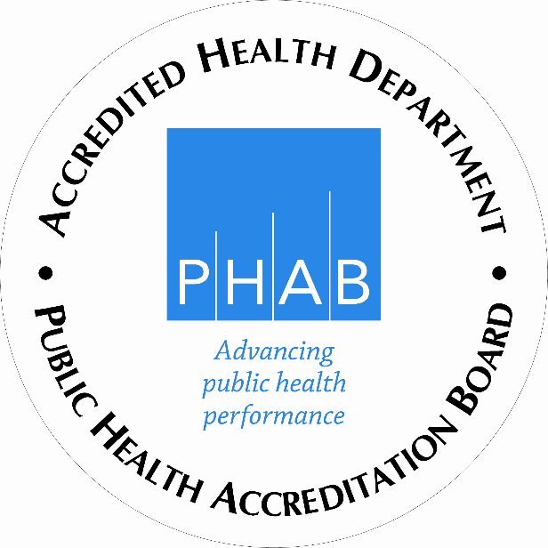
Public Health Accreditation
The First County in the State of New Jersey

The purpose of the accreditation process is to improve and protect the health of the public by advancing the quality and performance of the Camden County Department of Health. Camden County Health Department achieved accreditation by the Public Health Accreditation Board (PHAB). The national accreditation status sends an important message to our partners and community that our organization meets national standards and provides services in a manner that all residents should come to expect from their health departments. The national standard seeks to advance the quality and performance of all health departments. Our participation in this program indicates our commitment to the continuous improvement of our health department’s services. (U.S. Department of Health & Human Services)

Quotes from two well-known and respected Public Health Leaders

“Public health programs help keep disease rates down, which in turn keeps health care costs down. It’s going to be hard to get the economy healthy again if our workers and our health care system are both sick.”--Jeff Levi, PhD, Executive Director of TFAH, 2010.

“The financial crisis makes it more important than ever for the country to make prevention a top priority. Even in these troubled times, prevention is an investment we can count on to deliver a big payoff—sparing millions of people from developing preventable diseases while saving billions in health care costs.”--Risa Lavizzo-Mourey, MD, MBA President & CEO Robert Wood Johnson Foundation.

Ten Essential Health Services
______________________________________________________________________________

- Monitor health status to identify community health problems.

- Diagnose and investigate health problems in the community.

- Inform, educate, and empower people regarding health issues.

- Mobilize community partnerships to identify and solve health
problems.

- Develop policies and plans that support individual and
community health efforts.

- Enforce the laws and regulations that protect health and ensure
safety.

- Link people to needed personal health services and ensure
healthcare when it is otherwise unavailable.

- Ensure a competent local public health system and a competent
personal healthcare workforce.

- Evaluate effectiveness, accessibility, and quality of personal and
population-based health services.

- Research innovative solutions to health problems.

Programs and Services provided by Camden County

Department of Health & Human Services
______________________________________________________________________________

  - Alcohol and Substance Abuse Unit
- Prevention
- Education
- Adolescent/Adult
- Treatment
- Women

  - Communicable Disease
- Disease Field Investigations
- Epidemiology
- HIV/AIDS
- Rabies Control
- Reportable Diseases
- STD Program (Sexually Transmitted Diseases)
- TB Program (Tuberculosis)

  - Public Health Nursing
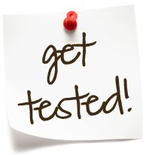
- Adult Health
- Child Lead Case Management
- Infant and Preschool
- Influenza Immunizations
- Maternal Child Health
- Preventive Screenings
- Special Child Health Case Management

  - Health Education/Promotion
- Community Health Needs
- Health Education/Risk Communication
- Mobile Health Van/Health Connection-Health Screenings, Counseling, and Education
- Public Health & Community Planning
- Smoking Cessation/Cancer Prevention
- Annual Women’s Health Conference
- Mobilizing Action through Planning and Partnership (MAPP)
- HealthEASE
- Matter of Balance
- Chronic Disease Self-Management Program
- New Jersey Poison Information Education System

Environmental Health Services
______________________________________________________________________

- Retail Food - Hazardous Materials Complaints

- Recreational Bathing - Hazmat Emergency Response

- Body Art - Integrated Pest Management

- Tanning Salons - Pesticide Enforcement

- Public Health Nuisance - Swimming Pool Discharge

- Multiple Dwelling Units - Vapor Recovery

- Pet Shops & Kennels - Idling

- Right-To-Know - Air Quality

- Residential UST - Private Wells

- Noise - Individual Sewage

- Solid Waste Facilities - Public Health Emergency

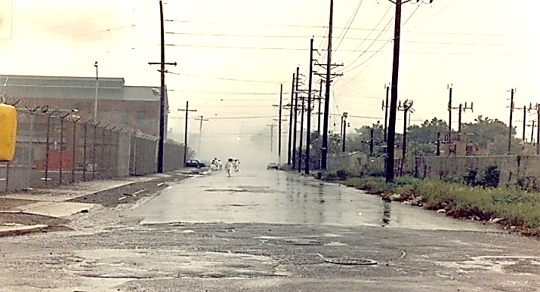

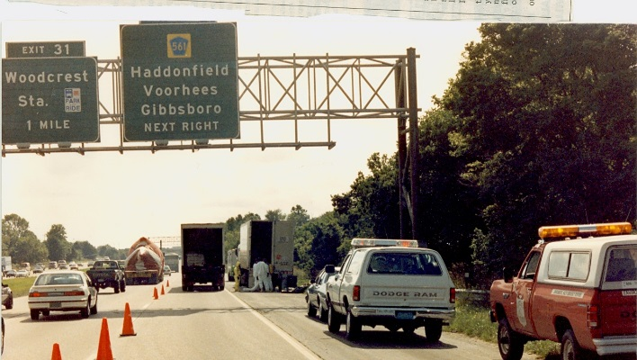

Stabilizing leaking containers in a box truck. Response to a Plastic Chemical
Fire in Camden County

Office of Mental Health & Addiction
______________________________________________________________________________________________________
Office of Mental Health & Addiction 2018

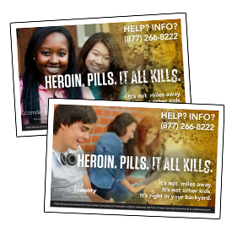
SERVICE SNAPSHOT
Mental Health, Alcohol and Substance Abuse
- Information and Referral
- Community Substance Abuse Planning
- Education/Prevention
  - Evidenced based education/prevention
  - Student Assistance Counselor services
Early Intervention
- In-jail assessments and referral
- Second Chance didactic substance abuse intervention/education
Treatment and Recovery Supports
- Withdrawal Management
- Short-term Residential
- Intensive Outpatient
- Outpatient
- Opiate Maintenance
- Recovery Specialists
- Recovery Mentors
- Vocational Support
- Sober Living
- Patient / family substance abuse education
- Boarding Home Socialization
- Wrap-around Services
- Emergency Shelter Placement
- Payee Services
- Intoxicated Driver Resources (12-hour, 48-hour)

Information and Referral
The unit provides information and referral to those seeking anything related to mental health
and/or substance abuse. Regardless of ability to pay, we provide information related to available
services. Because of the merger between mental health and substance abuse, the unit continues to
see an increase in the number of callers seeking mental health services.

We also pay for the 24-hour addiction information warmline provided by Center
for Family Services.

Substance Abuse Services/Community Substance Abuse Planning
The county is responsible to submit a Comprehensive Substance Abuse Plan (CSA) every 4
years and an annual Municipal Alliance Plan. These plans guide the activities and services
funded by the county. They are required by legislation. Both the county’s CSA and the
Municipal Alliance plan were approved by the New Jersey Division of Mental Health and
Addictions as well as the Governor’s Council on Alcohol and Drug Abuse. Every year the
county provides an update to those plans. 2019 was the last year of the 2016-2019 CSA plan.

Education/Prevention
The county is required to pay for evidenced based education and prevention programming. Programs generally derive from the National Registry of Evidenced Based Prevention programs.

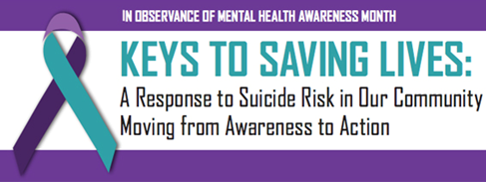

Treatment and Recovery Supports
Secondary to the opioid crisis, additional federal and state dollars became available to cover the
cost of services. However, South Jersey realized a significant increase in the number of inpatient treatment facilities providing services. The county did not exhaust its substance abuse annual
award.

The county procured additional services aimed at recovery. In addition to OORP, the county funded Certified Peer Recovery Specialists (CPRS) at the two homeless shelters (VOA and Joseph’s House).

The county pays for education, prevention, early intervention (24-hour information warmline),
outpatient, intensive outpatient, methadone, Vivitrol, sober living, halfway-house, and recovery
specialist services. Going forward, the biggest impacts in the county are propelled by state
initiatives. These include:

Some of the results of these changes are the county:
- Continued to increase its support for sober living, Recovery Mentors, Halfway House.
- Initiated a small program to evaluate pre-convicted inmates at the county jail and refer into treatment (those most at risk for overdose).
- Brought together psychiatric, substance abuse, Federally Qualified Health Centers (FQHCs), MAT providers and the Centers for Excellence to increase collaboration for the provision of MAT in the county.
- Oversaw the introduction of Project SAVE.
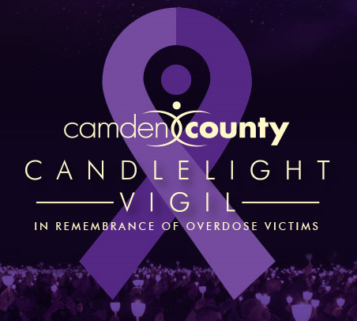

Via the Addiction Awareness Task Force:

Programs advanced by the AATF included:

Project SAVE, R.E.A.L. Sports, Annual Candlelight Vigil, Operation SAL, Certified Peer Recovery Specialists Program, the Annual Recovery Softball Tournament, Fentanyl Test Strips, and other programs throughout the year.

Lastly, the number of overdose and substance abuse related deaths continue to spiral out of control. The Office of Mental Health & Addiction is making every effort to harness every available resource to meet the challenge.

Mental Health Services
Boarding Home Socialization
The county secures services to enhance the therapeutic milieu experience for residents of
boarding homes. These services include socialization, outside activities and assist the residents
with mental illness who live in boarding homes to engage and participate in normal everyday
activities.

Wrap-around Services
For persons with serious and persistent mental illness the county pays for a comprehensive list of
wrap-around services which may include anything from the purchase of a bed to a security
deposit for an apartment.

Emergency Shelter Placement
The county provides emergency funding for up to a week of shelter placement for folks who are
homeless with serious and persistent mental illness.

Payee Services
The county also offers ‘payee’ services to protect persons with serious and persistent mental
illness.

Community Health Services Division
Community Health
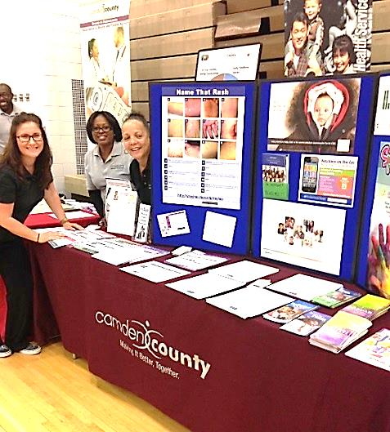
- Camden County Health Connection
- Mobilizing Action through Planning and
Partnership/Tri-County Community Health Needs Assessment Collaborative
- Health Promotion Programs

Southern Region Specialty Chest Clinic
- Special Child Health Program

Division of Environmental and Consumer Health Services
- Emergency Response for Hazardous Materials
- Food Surveillance
Community Health Services staff promote their exhibit “Name that Rash” on the importance of getting vaccinated to prevent disease.
- Multiple Dwelling Housing Inspections

Office of County Health Officer
- County Bioterrorism Response Program

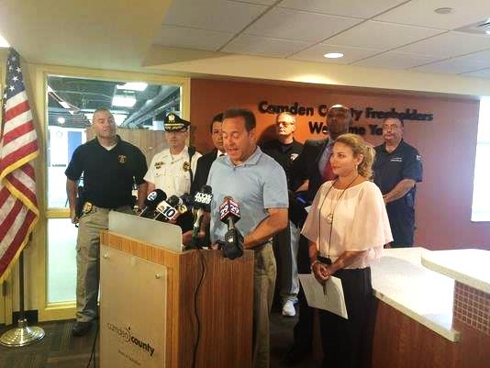
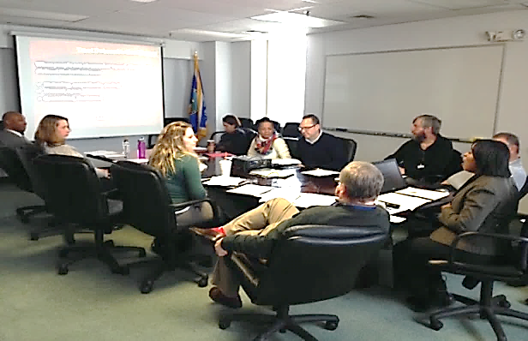

Members of Bioterrorism Team interact during a Public Information exercise/risk communication training.
Public Information staff addresses the public concerning an Ebola Virus case.

Health Education Unit
Camden County Health Connection

The Camden County Health Connection promotes community wellness on site at county workplaces, health fairs, senior centers, public housing complexes, homeless shelters, nutrition sites, shopping centers and community organizations. The Camden County Health Connection is a mobile unit, which enables our Health and Human Services Department to extend the reach and availability of our health screening and disease risk assessment services provided at our health centers. The Camden County Health Connection houses an experienced staff of a registered nurse and health educators to provide a wide range of health-education and lifestyle-management programs that empower children and adults to take control of their health and improve their well-being. The mobile unit enables the Health Department to increase access to health promotion, disease prevention and early detection programs for cancer, heart disease, diabetes and stroke in Camden City and southern Camden County. These services include the following:

• Blood sugar screenings
• Blood pressure screenings
• Cholesterol screenings
• Osteoporosis screenings
• Chronic Disease Management Training programs
• Stroke Risk Assessment Screenings
• Referrals for community health care services
• Health education, support and counseling
• Follow-up health care services

The “Camden County Health Connection” Mobile Health Unit
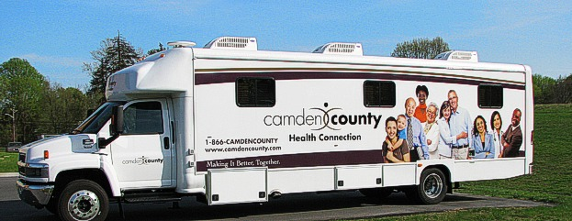

Support groups such as the Chronic Disease Self-Management Program, tobacco treatment and counseling, health seminars and skills-building workshops are also conducted upon request.

These services do not replace regular visits to a primary care physician, but rather emphasize the importance of annual check-ups and help arrange care for people who need them. The overall goal of the Camden County Health Connection is to link this region to needed health services such as health insurance, health care, social services and community health resources. The Camden County Health Connection serves as a health education resource center composed of videos, books, brochures, and web-based action-oriented tools to assist residents of all ages in the importance of preventive care.

Early in during the Pandemic response, Camden County Department of Health & Human Services knew that information would be important in the prevention of COVID-19. As a result, a health education information hub offering covid testing at Camden County College in Blackwood was organized. Packets filled with life-saving information on signs and symptoms, prevention, and testing were distributed to residents who drove through for covid testing. As the pandemic continued to evolve, partnerships with our community-based organizations became a priority.

As a part of the Roots to Prevention (RTP) collaboration, health education training was provided to growers on food safety and preparation with COVID-19 guidelines. Before the COVID-19 vaccine became available, the health education unit partnered with Camden Coalition to conduct a COVID-19 survey to gather information to determine the attitudes and beliefs about the vaccination among Camden City residents. Later, health education resources were arranged along with COVID-19 testing to take place in various Camden City locations and coupled testing with pop-up health education sites to distribute health education materials. Pop-up Public Information sites included shopping centers, parks, faith-based organizations, community centers and more. Our health department created a team to go door to door provide to health education, masks, sanitizer, and other resources such as mental health information, food resources, employment information, voting information for Camden City residents to help them know that they are not alone and to encourage trust and confidence in the health department.

We identified health education prevention information specific to schools as well as re-opening guidance materials from NJDOH and CDC. A Microsoft Teams platform was set up to engage school administrators and nurses during the COVID-19 response for the re-opening of Camden schools. Health Department staff were trained to respond to hotlines to answer covid testing questions from Camden residents. Throughout the pandemic, we assured that our messaging was consistent with NJDOH and CDC when so that our partners and residents had the most up to date information.

Mobilizing for Action through Planning and Partnership: Approach to Public Health in Camden County (MAPP)

Mobilizing for Action through Planning and Partnership (MAPP) is a community health assessment process developed by the National Association of County and City Health Officials and federal Centers for Disease Control and Prevention (CDC). MAPP is intended to help local public health system entities work collaboratively to assess and improve community health and quality of life. The local public health system includes academic institutions, community nonprofit organizations, foundations, health care institutions and providers, libraries, religious and fraternal organizations, schools, social service agencies and other entities that provide public health services and share information about health issues with community residents. Since 2007, workgroups have been formed to implement strategies to address the following six priority issues which emerged through that assessment process.

- Chronic Disease
- Co-occurring Mental Health and Addictions Disorders
- Access to Care

In 2013 the Camden County Health Department collaborated with hospitals, health systems and health departments within Gloucester, Camden and Burlington counties, to: 1) identify, analyze and address health problems; 2) assess applicable data; 3) develop measurable health objectives and indicators; 4) inventory community health assets and resources; and 5) develop and implement coordinated strategies to improve health. This effort was entitled the Tri-County Community Health Needs Assessment (CHNA) Collaborative. The CHNA was conducted from September 2012 to June 2013. The CHNA is conducted every three years.

Through collaborative efforts, the community health needs assessment built on prior work of the Camden County MAPP Coalition, local health systems, hospitals, Senior Services Division, Environmental Health and Community Health Services Divisions, and community, emergency and public health preparedness partners. The assessment was also conducted to comply with requirements set for the in the Affordable Care Act, as well as to further the health department’s commitment to community health population health management. The 2016 CHNA collaborative was built on existing community relationships and developed strategic partners and increased its collaborative approach to community health improvement.

Health Education and Promotion Programs
Take Control of Your Health: Chronic Disease Self-Management Program
The Chronic Disease Self-Management Program (CDSMP), developed at Stanford University, is an effective self-management education program for people with chronic health problems or people who take care of others with chronic health problems. In Camden County, the CDSMP is known as Take Control of Your Health. New Jersey Department of Health and Senior Services (NJDHSS) provide statewide guidance and oversight for CDSMP. In collaboration with community partners, the Health Department presents a series of workshops, which are given once a week for six weeks, in community settings such as senior centers and housing sites throughout the County. This program, is facilitated by two trained leaders, one or both of whom have chronic diseases themselves. These sessions enables people with chronic illnesses to learn ways to self-manage their condition and take charge of their life.
Topics covered include: 1) techniques to deal with problems such as frustration, fatigue, pain and isolation, 2) appropriate exercise for maintaining and improving strength, flexibility, and endurance, 3) appropriate use of medications, 4) communicating effectively with family, friends, and health professionals, 5) designing and maintaining a healthy eating and exercise plan and 6) learning how to evaluate new treatments. In addition, program participants learn decision-making, action planning, and problem-solving skills. Each participant in the workshop also receives a copy of the companion book, Living a Healthy Life with Chronic Conditions, and an audio relaxation tape, Time for Healing.

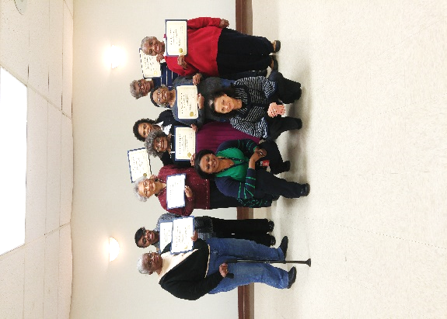
A Matter of Balance: Managing Concerns About Falls
Many older adults experience a fear of falling. People who develop this fear often limit their activities, which can result in physical weakness, making the risk of falling even greater. A Matter of Balance: Managing Concerns About Falls is a program designed to reduce the fear of falling and increase activity levels among older adults.
A Matter of Balance includes eight two-hour sessions for a small group led by a trained facilitator. This nationally recognized program was developed at Boston University.

During the class, participants learn to:
- View falls as controllable
Facilitators pictured with Seniors with certificates of completion from Matter of Balance class
- Set goals for increasing activity
- Make changes to reduce fall risk at home
- Exercise to increase strength and balance

A Matter of Balance is a program that emphasizes practical strategies to manage falls.
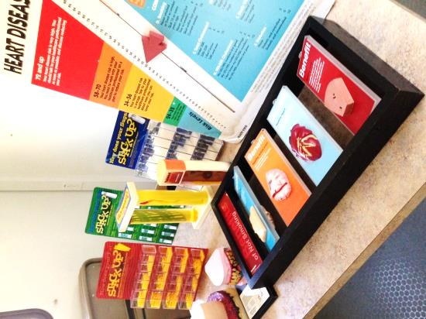
Classes are held 2 times a week for 4 weeks for 2 hours each or 1 time per week for 8 weeks. This program is based on Fear of Falling: A Matter of Balance. Used and adapted by permission of Boston University.

Health EASE was created in New Jersey to coordinate and expand health promotion and disease prevention services for older adults at the local level, with the goal of promoting, supporting and sustaining older adults in living healthier, more independent lives. HealthEASE targets older adults at all levels of the health spectrum, from those experiencing no health issues to those with multiple chronic diseases and physical limitations.

Wellness Series - “Action Steps to Better Health”
- Keeping Up the Beat: Heart Health
- Bone Up: Standing Tall Against Falls
- Your Health: Osteoporosis
- Keeping Your Mind Sharp
- Be Wise About Your Medications
- Move to Get F.I.T.
- Serving Up Good Nutrition
- Women’s Health
These one hour free programs engage community members in fun, interactive wellness activities to promote independent and healthy living.

Other initiatives include:

New Jersey Poison Information and Education Program helps participants identify poisonous substance found in the home as well as help reduce the number of unintentional poisons that occur in the home.

Move Today, an exercise program for older adults to improve balance, posture, muscle strength and flexibility.

QPR Question, Persuade, Refer
Suicide Prevention Gatekeeper Training which teach professionals and non-professionals alike, using the simple technique of “Question Persuade and Refer”, to recognize the warning signs of a suicide crisis, and how to get the person at risk the assistance they need.

Screening, Brief Intervention and Referral to Treatment (SBIRT)
This training provides a comprehensive, integrated, public health approach to the delivery of early intervention and treatment services for persons with substance use disorders, as well as those who are at risk of developing these disorders.

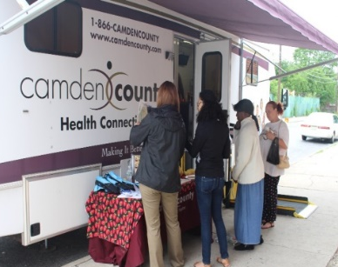
Food Trust Partnership
The goal of The Food Trust’s Healthy Corner Store Initiative is to expand the sale and marketing of affordable, nutritious food in corner stores in lower-income communities, which often have the lowest access to healthy foods and the highest rates of diet-related disease. The Food Trust and the Camden County Health Education Unit brings valuable health education services and health screenings to Camden City residents.
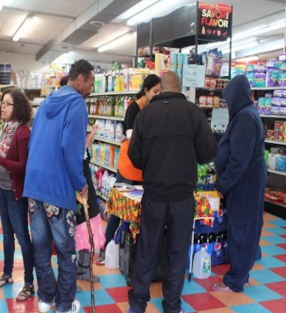
Health Education Unit teams up with The Food Trust’s “Healthy Corner Store Initiative – Heart Bucks Program” provide health screenings to city residents on the “Camden County Health Connection” Mobile Health Van parked in front of a local corner food store.

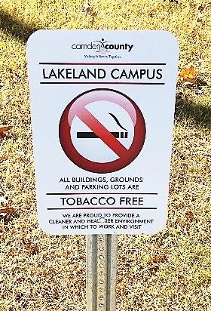
Health Promotion Initiatives in Tobacco Control

Camden County College Tobacco Free Task Force
- The Health Education Unit’s, Certified Tobacco Treatment Specialist serves as a member of the Camden County College Tobacco Free Task Force. Camden County College received and NJCUITS (NJ Colleges and Universities Implementing Tobacco and Smoke-free Policies) grant to revamp their tobacco free policy to update written policy language to include smoking and the use of all tobacco or tobacco like products including
e-cigarettes/vaping for all four campuses.
- Areas of development included are education, cessation, prevention initiatives and community resources.
Forty (40) promotional signs regarding the tobacco-free campus policy were placed at sites throughout the Lakeland Campus.

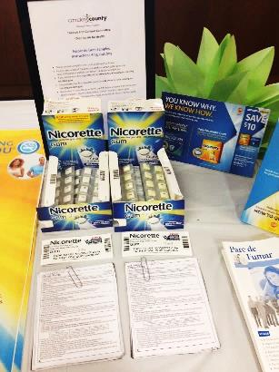
Collaboration with Regional Partners
- The Health Department collaborates with (NJPN) New Jersey Prevention Network and Tobacco Free for a Healthy New Jersey (TFHNJ) Collaborative in the southern region on several tobacco control initiatives. We work hand-in- hand with TFHNJ Southern Regional Coordinators in local identification of tobacco control issues or opportunities by providing education, solutions and resources to individuals, municipalities and schools, colleges, and workplaces.
- The community initiatives include Tobacco Product Point of Sale, Tobacco-Free Worksites, Smoke-Free Housing Tobacco -Free Campus, Merchant Education and Youth.
Quit Survival Kits, and Nicotine Replacement Therapy information for Camden County employees.

Special Child Health Services

The Special Child Health Services Program assists families with children who have developmental delays and health needs birth through age 21. This program was originally established in 1928 as the result of the Birth Defects Law (1926). The Crippled Children Program was created with the intent to treat orthopedic conditions. Since that time there have been a number of changes in the law that now include children identified under the State Birth Defects Registry and more recently (2007) the addition of children identified through the Autism Registration.

This program is County based and provides Case Management. The County Case Management Unit serves as the entry point into health care and related services to facilitate cooperation among agencies. Families often need assistance with multiple tasks from identifying their child’s basic needs to finding appropriate providers. Case managers work with both children and their parents. These professionals assist families through the maze of the health services system and other related systems for the purpose of meeting individual needs. Specifically, the case managers assist with obtaining hearing aids and orthotics; payment of catastrophic bills; support groups; home nursing care; education and other needs.

Any child under the age or 21 is eligible for services that has a birth defect, a serious illness, has difficulty walking, talking, and understanding or is at risk of developing a handicapping condition. Services are provided regardless of financial status.

Southern Regional Specialty Chest Clinic

The Southern Regional Specialty Chest Clinic was initiated in 2008 by Camden County Health Department at the request of New Jersey Department of Health and Senior Services. The program is staffed by both County Health Department and Cooper University Hospital. Cooper University Hospital provides Infectious Diseases Specialists who are well versed in the treatment of Active Tuberculosis of the Lungs and non-pulmonary sites. This group is headed by Henry Fraimow, MD, who is a member of the State TB Medical Advisory Board.

The TB Nurse Case Manager, for Cooper University Hospital, acts as a liaison between the State TB Program, Cooper University Hospital, and the Camden County DHHS. The Case Manager provides nursing assessment, teaching and monitoring of the patient with TB. She also conducts contact investigations, to provide early detection of new TB cases and treatment to exposed clients with latent TB infection. The County Health Department provides additional staffing for nursing and support services. All those seen in the Southern Regional Specialty Chest Clinic benefit from a “one stop shopping” model, as we provide Mobile x-ray services, on site lab technician, Sputum Induction booth, Physician and nursing assessments, and provision of needed medications.

The Regional Clinic provides expert TB Consultation to surrounding counties who may have drug resistant TB or extra-pulmonary TB, or clients who have difficulties during their treatment.
The Regional Clinic provides service to patients and case managers from Atlantic Co., Atlantic City, Gloucester, Burlington, Salem, Cumberland, Ocean, Cape May, Mercer and Middlesex counties, in addition to our own cases here in Camden County. The patients receive their medications daily by DOT, Directly Observed Therapy. In addition, they are monitored closely for medication tolerance and side effects. This enables a thorough treatment plan and ensures that treatment is completed as the Standards of Care require. The TB clinic also provides medical assessment to those new immigrants who have been flagged by the CDC for evaluation once in our country.

The challenge for 2020 was to keep all clinic services fully operational. We were able to do so without any decrease in hours or services. This posed a challenge due to staff being out sick and keeping up with the constant changes to proper policy and procedures. This also proved to be our biggest success. While other counties and services shut down during 2020, we still offered our full services while also working on the mass vaccination efforts.

Public Health Emergency Preparedness Program

The Camden County Bioterrorism (BT) Unit has been in existence for over 10 years. Currently the program is led by our Public Health Emergency Notification Systems Coordinator (PHENS) and also includes a Health Education/Risk communicator (HERC), an Epidemiologist and practicing pharmacist under the direction of the County Health officer. The purpose of the BT program is to ensure immediate and adequate response to any acts or threats of bioterrorism, infectious disease outbreak and other public health threats or emergencies. On a scheduled basis the Unit acts to keep response plans up to date, provides education and ongoing training to all department staff, and uses response drills to improve timeliness and evaluate our proficiency. Planning, training and exercising for an all hazards approach allows us to prepare for a wide range of emergencies. Response drills exercise various aspects of our work which include but not limited to monitoring disease patterns, communicating risk and providing information to contain the spread of disease, prophylaxis for at risk persons using oral medications or immunizations, receiving and distributing supplies and medicines to the hospitals and our medical community.

Our Medical Reserve Corp Management of approximately 387 volunteers receives regular training which includes Health Education, use of Health Alert Network, Risk Communication, Exercise/Train/Evaluation, Planning with County Partners. Partners include County Emergency Management, local Hospitals, County Prosecutor’s Office, County Office of Education, and Regional County Health Departments along with several others.

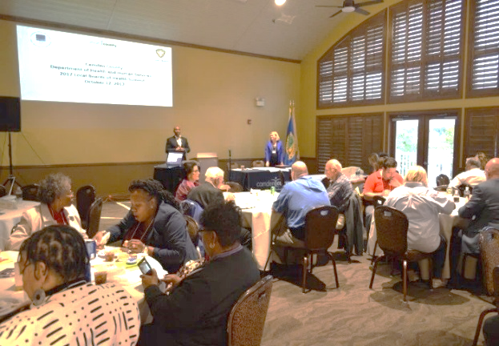
What is a Board of Health?
A Board of Health works in collaboration with the Health Officer to assure that organizational activities are meeting the needs of the community.

Camden County Medical Reserve Corps

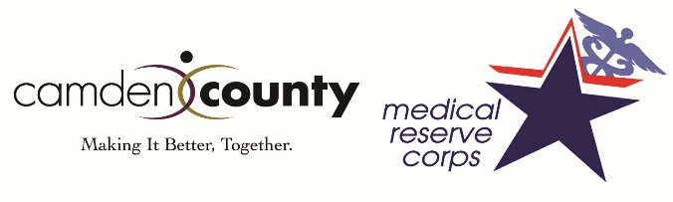
The goals and objectives of the MRC are to have all volunteers current with documentations and core training; focus on volunteer retention and volunteer engagement; introduce and implement new volunteer recruitment methods; seek new funding opportunities to sustain and grow the MRC unit. The mission of the Camden County MRC is to provide a cadre of both professional and community volunteers to assist the county in times of a public health crisis. During non-crisis times, we hope to train and exercise current and new volunteers to create a competent and deployable MRC unit. During 2020, the MRC was heavily involved in the COVID-19 hub production at Camden County College. Volunteers played a crucial role in safety assisting our Camden County constituents in receiving their covid-19 vaccines.

Communicable Disease Prevention and Control

The Communicable Disease Unite offers services to prevent the spread of disease. There are specific programs dealing with AIDS/HIV, Tuberculosis Control, Sexually Transmitted Diseases, Rabies Control, and Reportable Diseases.

Disease Investigation
Communicable Disease epidemiology is a cornerstone of public health practice to prevent illness and protect the public’s health. The Camden County Department of Health and Human Services’ Communicable Disease program is responsible for county-wide surveillance and investigation of more than 70 disease conditions reportable to public health by laboratories, health care providers and facilities. Reports of communicable disease are investigated and tracked to identify outbreaks or trends that require public health action or community education. Investigations aim to identify the source of infection so public health control measures can be implemented to prevent further disease spread. The data collected through our investigations about the local burden of disease, risk factors, and disease trends is used to develop appropriate education, guidance, and infection control recommendations to be shared with our residents, health care providers, schools and community partners.

AIDS/HIV Program
Free and anonymous/confidential HIV counseling and testing is offered at both of our two Health Clinics. HIV Counselors provide risk reduction education and referrals to PrEP services.

Sexual Health Clinics
The Camden County Sexual Health Clinics provide free and confidential testing and treatment of all sexually transmitted infections. Last year we provided sexual health services to nearly 1,000 residents. Clinic staff work alongside Health Educators to provide sexual health education and promotion presentations for health care providers, community organizations, and health fairs.

Rabies Control
Rabies is a deadly disease caused by a virus found in the saliva of a rabid animal. Rabies infection can occur when infected saliva from a rabid animal contaminates a bite or open wound, a scratch, or a mucous membrane. There is no known effective treatment for human rabies once symptoms develop, but rabies can be prevented if rabies post exposure prophylaxis is given shortly after exposure.

Communicable Disease staff work closely with local Animal Control Officers to investigate domestic and wild animal bites, coordinate rabies testing, and provide technical assistance to residents, veterinarians, physicians, and municipal officials.
The Camden County Department of Health and Human Services provides rabies vaccine to support 35 rabies vaccination clinics throughout the county.

Division of Environmental Health and Consumer Health Services

Emergency Response (Hazardous Materials)
  - County Environmental Health Act (CEHA)

Camden County Department of Health is certified by NJDEP to perform investigation, enforcement, and regulation of air pollution, solid waste disposal, recycling enforcement, emergency, and terrorism response, hazardous waste storage and disposal, underground storage tanks, surface and ground water pollution, and noise. In addition to directly providing these services, Camden County coordinates Hazardous Materials Emergency Response services through inter-local agreements with five local fire/hazmat units.
Camden County’s Hazardous Materials Response Unit is responsible for development and maintenance of standardized hazardous materials (Hazmat) and CBRNE (Chemical, Biological, Radiological, Nuclear, and Explosive) emergency response capability, capacity, and competence. Camden County Department of Health and Human Services has highly trained and equipped personnel that respond to Hazmat and CBRNE emergencies and conduct environmental investigations in coordination with the N J Department of Environmental Protection (NJDEP), the NJ Department of Health and Senior Services (NJDHSS), and the N J State Police (NJSP) Special Operations Section.
The Hazardous Materials Response Unit provides exceptional hazardous materials and environmental response services to the citizens of Camden County. The unit handles a broad range of complaints each year from private citizens, business interests, industrial facilities, and other public agencies. They vary in nature from small residential spills of household chemicals and heating oil to large-scale industrial spills, fires, illegal dumping and over the road accidents involving cargo spills or releases of motor vehicle fluids. Our hazmat unit is available to respond to any Hazmat/CBRNE incident in Camden County on a 24 hour per day /365 day per year.
The Hazmat Unit continues to be involved in domestic preparedness planning for the county. The Unit Director regularly participates in planning meetings with Camden County OEM. Based on planning initiatives, response protocols may be revised to improve our response capabilities. Coordination with the county OEM and Fire Marshall has resulted in an integrated network of primary and secondary departments for mutual aid including Hazmat/CBRNE response and mass decontamination.
The biggest challenge faced by the HAZMAT unit in 2020 was the ability to perform the roles of response specialists for HAZMAT related-incidents and environmental enforcement inspections during the COVID-19 pandemic. The challenges included logistics, equipment delays due to supplier issues, facility coordination for inspections, and performing other duties to assist with the COVID-19 pandemic.

Neutralizing an acid spill in Camden County
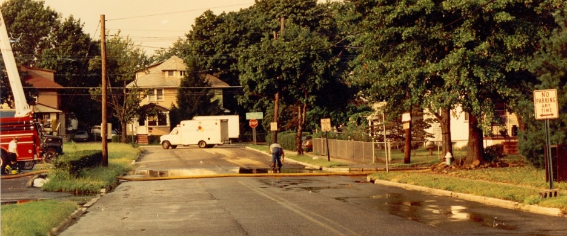

CEHA Unit Septic and Well

All individual sewage disposal system plan review, installation, repair, and compliance certificate are accomplished by our Septic and Well section. This group also is responsible for the review of private potable wells results & Private Well Testing Act information distribution. Recently our staff has begun a thorough evaluation of Public Non-community water systems within our County to insure the proper compliance with Federal and State Regulations.

Food Surveillance

The Food Surveillance Unit’s purpose is the prevention of food borne illness which may derive from retail food establishments. To deliver this purpose this unit focuses its inspection efforts to facilities that may present a greater risk of food borne illness. This approach and enforcement of NJAC 8:24 are known as Risk-Based Inspection. Retail establishments must be inspected as least once during each year, school facilities are inspected twice each year. Additionally, a 24/7 Non-Hazardous Emergency Response system is in place to respond to fire and/or natural disasters involving food and/or health care facilities where a potential for contamination of food products exists. Annually retail food inspections are performed utilizing tablet computers. Inspection findings are captured and recorded during the course of each inspection and uploaded in real-time to our web-based inspection system.

Benefits of Digital Inspections
- Increased Productivity and Accountability.
- Electronic Record Management and Access.
- Provides Public Records Request (OPRA).
- Standardized Inspection Methods and Reporting.
- Improved Compliance.
- Reduction in Enforcement Actions.

  - Constituent Benefits
- Educates consumer on inspection process and outcomes.
- Reports inspection results on facilities of consumer interest i.e. child’s day care or school, local market, favorite restaurant, etc.
- Reports on emerging food related events i.e. food related bioterrorism, food recalls, facility closures, and food related outbreaks.

  - Industry Benefits
- Standardized inspection format easy to read, interpret, and translate.
- Critical violations are printed first with timelines for correction.
- Establishment with a good inspection history will see increased business.

Multiple Dwelling Housing Inspections
  - State Local Cooperative Housing Inspection Program (SLCHIP)

The Camden County Health Department’s Multiple Dwelling Housing Unit is an authorized agent of the NJ Department of Community Affairs Bureau of Housing Inspections. As an authorized agent the Unit is responsible for ensuring that hotels, motels and multiple-family buildings of three or more dwelling units operating within Camden County are properly maintained and do not pose a threat to the health, safety and welfare of their residents, nor the community in general.
These objectives are achieved by licensed multiple dwelling inspectors conducting five-year cyclical and compliance inspections of all hotels, motels and multiple dwellings. Condominiums, Cooperatives and Mutual Housing Corporations fall within the definition of multiple dwelling, and as such, are subject to its provisions.
During covid-19, Camden County Department of Health and Human Services housing department was temporarily shut down. All inspections were completed via phone and email. During this time, the housing inspectors collaborated with our senior services unit to deliver meals on wheels to all eligible residents.

In addition to the Environmental Programs highlighted above the following services are also provided: Air Pollution Control, Community Noise Control, Pet Shop & Kennel Inspections, Public Health Nuisance Complaints, Right To Know (RTK), Public Recreational Bathing & Youth Camps, Residential Underground Storage Tank, Pesticide Investigation, Solid Waste Program, Tobacco Enforcement, Body Art, and Water Quality.

Contact Information

Camden County Health Officer
Dr. Paschal Nwako, MPH, CHES, REHS, DAAS
512 Lakeland Road, Suite 501
Blackwood, NJ 08012
856-374-6037
paschal.nwako@camdencounty.com

Communicable Disease Unit
Caryelle Lasher, MPH, REHS, HO
Supervisor
512 Lakeland Road, Suite 523
Blackwood, NJ 08012
856-374-5117, 856-382-2695
caryelle.lasher@camdencounty.com

Environmental Food
Matthew Grochowski, MS, Principal REHS
Supervisor
512 Lakeland Road, Suite 300
Blackwood, NJ 08012
856-374-6052
matthew.grochowski@camdencounty.com

Environmental CEHA, Hazmat & Water Unit
Christopher Costa, REHS
Senior Environmental Health Specialist
Camden County Department of Public Safety
Charles J. DePalma Complex, 2311 Egg Harbor Road, Lindenwold, NJ 08021
Office: (856) 783-4808 ext. 6001
Fax: (856) 603-4206
Cell: (609) 685-5258
christopher.costa@camdencounty.com

Housing
Rachel L. Honrychs, MPA, REHS
Supervisor
Camden County Department of Health and Human Services
512 Lakeland Road Suite 301
Blackwood, NJ 08012
Office: (856)-374-6025/6029
Fax: (856)-374-6212

Public Health Emergency Preparedness
Daniela Fumu, BS, CHES ®
Public Health Emergency Notification/ Medical Reserve Core Coordinator
512 Lakeland Road, Suite 525
Blackwood, NJ 08012
856-374-6141
daniela.fumu@camdencounty.com

Koren Norwood, Health Educator/Risk Communicator
koren.norwood@camdencounty.com

Lisa Mack, Public Health Epidemiologist
512 Lakeland Road, Suite 530
Blackwood, NJ 08012
856-374-6197
lisa.mack@camdencounty.com

Office of Mental Health & Addictions

John D. Pellicane, MBA, Mental Health Administrator/Alcohol and Drug Director
512 Lakeland Road, Suite 601
Blackwood, NJ 08012
856-374-6320
856-374-6381 fax
john.pellicane@camdencounty.com

Bettyann Cowling-Carson, Municipal Alliance Coordinator
bettyann.cowling@camdencounty.com

Health Education Unit
Koren Norwood, MS, CHES ®
Supervisor
512 Lakeland Road, Suite 522
Blackwood, NJ 08012
856-374-6035
856-374-6358
koren.norwood@camdencounty.com

Lynn Rosner, M.Ed., CTTS
Health Education Unit, Certified Tobacco Treatment Specialist
512 Lakeland Road, Suite 529
Blackwood, NJ 08012
856-374-6363
lynn.rosner@camdencounty.com

Public Health Nursing
Claudia Funaro, RN, MSN
Director of Nursing
512 Lakeland Road, Suite 539
Blackwood, NJ 08012
856-382-2694
(Fax) 856-382-6034
claudia.funaro@camdencounty.com

Special Child Health

Jeanne Borrelli, RN, BSN
Supervisor
512 Lakeland Road, Suite 539
Blackwood, NJ 08012
856-474-6021
jeanne.borrelli@camdencounty.com

Camden County Clinic Services
Bellmawr Regional Health Center
35 Browning Road
Bellmawr, NJ 08031
856-931-2700 (main), 856-756-2264 (tuberculosis)

Camden City Health Center
Administration Building
600 Market Street
Camden, NJ 08102
856-225-2266(main), 856-225-5128 (immunizations)

